**English**

You are going to creating me an information book this week – all about Meerkats.

Using your research about Meerkats, I would like you to make me an information book. Have a look on Oxford Owl for non-fiction books with your grown ups, use these to help you write your book. Look at the layout, page titles, subheadings.

Attached is a Meerkat activity. Have a look at the picture and answer the questions and complete the activities under the picture.

**Daily reading, remember to use Oxford Owl for free books.**

**Phonics**

Teach Your Monster to Read

Year 1 – Phase 5 games on Phonics Play

Receptions – Phase 2 and 3 games on Phonics Play

Look at the attached Pobble 365 work. Read through the questions, talk about it, answer them in your books.

**Science**

This week we are going to learn about Meerkats. I would like you to research these questions about Meerkats.

What is a meerkat habitat? How are the suited to their habitat?

What do they eat?

What do they look like?

Are they mammals, fish, reptiles etc?

Record the information in your writing book.

<https://www.natgeokids.com/uk/discover/animals/general-animals/meerkat-facts/>

**Willows**

**Home Learning   
Week 4**

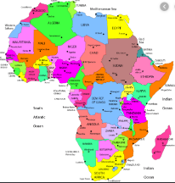

We’re Going on Safari

**Geography**

Using the attached sheet and map, can you plan a journey around Kenya? Remember what you learnt last week.

**PE**

Cosmic Kids Yoga on You Tube

**Art**

In an old cereal box, can you create a meerkat habitat? 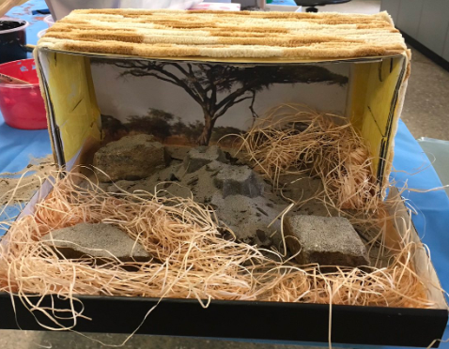

**Music**

Explore <https://www.classicsforkids.com/music.html>

There are lots of music activities and games.

**Computing**

Use the scratch link on the school website.

**Maths**

Daily Maths Whizz (30 minutes)

Daily practise counting in 2/3/5/10. Can you write multiplication number sentences?

Receptions, can you practise your counting and writing your numbers everyday.

Year 2

Each day I would like you to watch one of the videos from Summer Term Week 2 and then answer the questions <https://whiterosemaths.com/homelearning/year-2/>

Year 1 and Receptions.

Each day I would like you to watch one of the videos and then Year 1 answer the questions, Receptions you can answer the questions too if you would like.

<https://whiterosemaths.com/homelearning/year-1/>

The videos can we watched on tablets if you don’t have a laptop, and if you don’t have a printer, just write the answers down in your books.