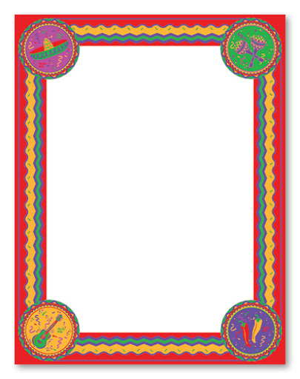

Spanish Greetings: can you practice some Spanish phrases for greeting people?



Week 3

**MATHS:**

Design and Technology:

Can you make quasadillas this week?

Write a review of the ease of the recipe and how much you and your family liked them.

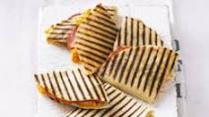

Please complete 30-40 minutes of Maths Whizz each day.

Spellings-word search this week.

**Science**

**Which leaves lose water fastest?**

**You have an experiment to carry out this week.**

**You could create a pic-collage or write up your experiment with a labelled diagram.**

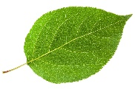

Write your own descriptive account about reaching the summit of a mountain. Use your 5 senses to describe what you could see and feel. Don’t forget to use similes and metaphors, powerful verbs and speech! (Thoughts)

Imagine you are an explorer. What would you need to pack to climb a mountain?

Draw and label your backpack.

Complete the diary sheet. 

Read Touching The Void. This extract contains suspense and excitement. How does the author create this? There is a comprehension sheet to answer.

The poem this week is called:

**Mountain Peak.**

* Did you like the poem?
* What similes or metaphors could you identify?
* This poem is set in Wales, can you remember where Wales is?

:

**The World’s Highest Mountains**-**Research** the world’s highest mountains. Use the report sheet to make notes. There is a sheet with some information on three mountains.Write your report .

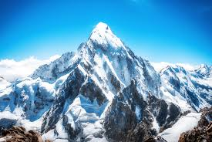

**Art:**

Mexican mirrors

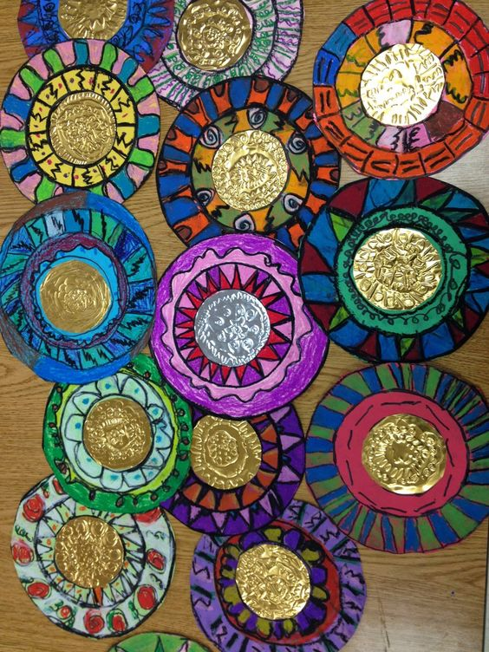

Make your own Mexican mirror.

**The Maya:**

**Can you cut out and order the Mayan timeline?**

**Write some questions which you would like to find out about the Maya.**