Crusty crabs

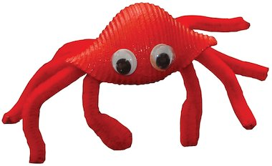
If you look at photographs of the wreck of the Titanic, you will see lots of little white spider crabs clinging to it. It is amazing that creatures such as these can live at such depths. You can easily make your own little crabs from large shells of pasta (conchiglioni rigati) available from the supermarket, and some pipe cleaners. Choose what colour you would like your crabs to be and paint the pasta shell all over. When it is dry, take two pipe cleaners of the same colour and cut each of them into four equal parts. Use PVA glue to stick four pieces of pipe cleaner on the underside of each end of the shell. When the glue is dry, bend the legs into shape and bend the two front pieces of pipe cleaner into claw-like shapes. Finish your crab by sticking on two googly eyes.

