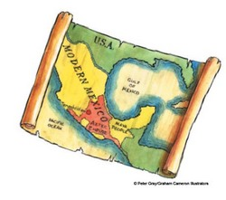

Invaders and settlers
The Aztecs were a wandering, warrior culture. In the 13th century, they moved into what is known today as Central Mexico, overthrowing the dominant Tepanecs. They settled and soon began to build a man-made island-city called Tenochtitlan, in Lake Texcoco, on the site of the present-day Mexico City. The settlement quickly expanded and became the capital city of an immense empire, which spread over the nearby islands and surrounding lands as the Aztecs conquered more peoples. Along with several other Aztec cities, Tenochtitlan was larger than most European cities of the time. By the 15th century, the Aztecs were very powerful and ruled over an estimated population of 15 million. At its largest, the empire contained around 500 cities. However, most of the occupants were not Aztecs and did not like being subjected to Aztec rule.

A structured society
The Aztecs had a highly structured society. They were ruled over by a supreme Emperor, who was appointed from the ‘royal’ family and was treated like a god. The Emperor had a team of advisors, led by a chief advisor, who controlled the general running of the society. Nobles supervised the Aztec provinces and were usually very rich. Ordinary people worked under the nobles as farmers and craftsmen. Slaves were considered to be in the lowest social class. They were bought at markets and worked on the land or as servants.The Aztecs possessed superb technological knowledge and fine craftsman. They had no iron to make hard, metal tools and so the craftsmen and builders relied on accessible materials such as feathers, bones, hides, wood, reeds, obsidian – similar to glass, gold and other precious stones and metals. The Aztecs did not use wheels, as they lived in predominantly marshy and jungle environments, and they travelled by foot and by boat.Aztec religion involved the worship of many gods, often associated with nature and their warrior values. Elaborate rituals, festivals and places of worship mark the value they placed upon religion in their society. Human sacrifice was frequent.
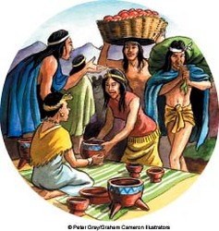

Activities: Time travellers
- Imagine that you are a researcher for a national museum. Your task is to travel to Mexico to find out about the Aztecs. Before you set out, you are challenged to carry out some initial research. Record your findings.
- You begin an investigation of a ruined Aztec temple, deep in the jungles of Central America. Just as you are about to climb the temple, you hear the beating of drums and the crash of gongs from behind the building. You follow the music around the corner of the temple and come face to face with an Aztec child. You have travelled back in time.

Write your time travel story-remember to include:
- Fronted adverbials
- Paragraphs
- Powerful verbs
- Direct and indirect speech
- Personification
- Similes and metaphors
- Punctuation-speech marks, commas, colons, semi colons, exclamation marks, question marks,
- Clauses
- Modal verbs
- Suspense
- Excitement
- Danger

