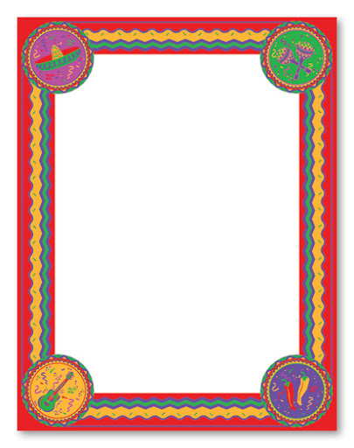

**Invaders and settlers**

A Time Travel writing task this week…

Week 6

**Volcanoes**

Lots of work on volcanoes this week.

What and where are the volcanoes of Mexico?

When did they last erupt?

Can you create a Top Trumps set of world volcanoes?

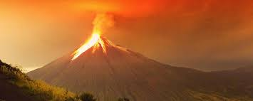

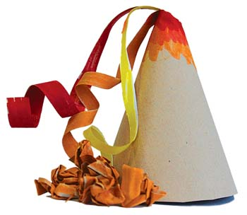

Can you make your own volcano? What did you use?

**Science:**

**Skeletons-can you label the skeleton?**

**Can you learn the names of the bones?** 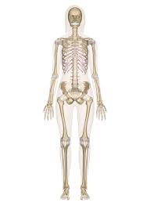

**Art:**

**Draw or paint your own volcano.**

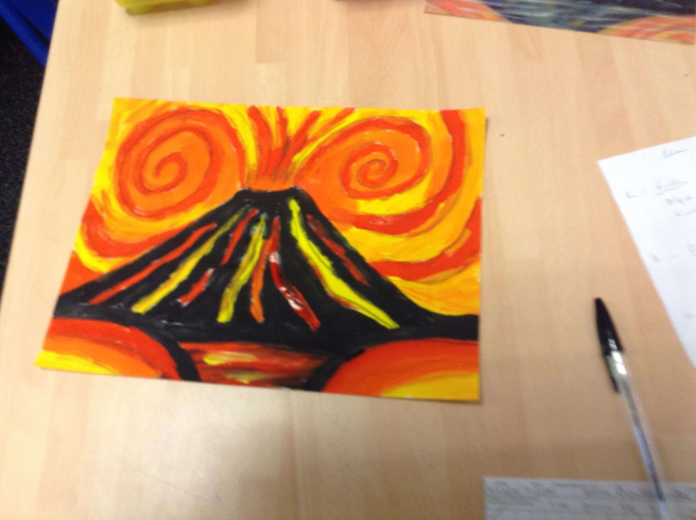

**Recipe-Guacamole.**

**Can you research how to grow a new plant from the seed of the avocado?**

**Maths: can you draw the reflected shapes?**

**Remember to plot the corners/vertices first.**

Food that magically regrows itself.

How did your tomatoes grow?

What else can you grow from itself?

**Can you complete**

**The true /false volcano fact booklet.**

**What other volcano facts can you find?**

**Spanish**

**Learn the words for the Spanish seasons.**

**And…30 minutes of Maths Whizz a day!**

**Poems:**

Pompeii

The Volcano

And three others.

Write down and find the definitions of the words which you don’t know.