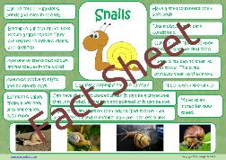

**Topic – Minibeast habitats**

Where do minibeasts live? Would you find a bumble bee under the ground? Or a worm living on a tree? Can you find out where different minibeasts live and complete the attached sheet?

**English**

Daily phonics or Grammar activities will be uploaded onto Tapestry – please check Tapestry everyday for these.

On BBC Bitesize they have daily English lesson, please complete these at home.

Daily reading – remember to use Oxford Owl for access to hundreds of free books.

This week we are going to be writing fact files about snails! What do you know about snails?

Here is a video from Espresso

<https://central.espresso.co.uk/espresso/modules/s1_microscope/video_snail.html>

Can you find out snail habitats, what they eat and how they survive?

Remember to put a picture of your fact file on Tapestry – you could even video yourself reading it!

**Willows**

**Home Learning   
Week 4**

**Down on the Ground**

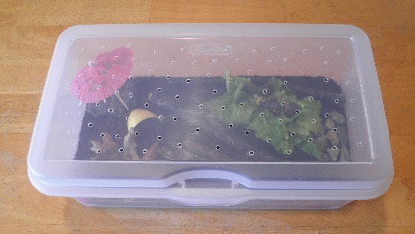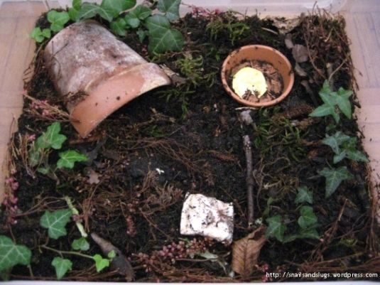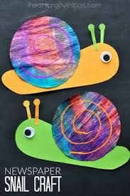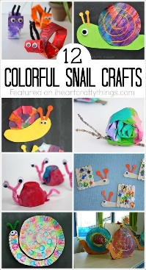

**Topic** – Snail habitat

Can you create a snail habitat and find a snail to live in it? An ice cream tub or a clear plastic tub makes a great habitat, but what does it need inside?

Don’t forget to have oxygen holes and to feed your snail.

**Art – snail art**

**Let’s be creative – how can you make snail art? I would love to see how creative you can be!**

**P.E.** Use Joe Wicks live PE session.

<https://www.youtube.com/channel/UCAxW1XT0iEJo0TYlRfn6rYQ>

**Topic – Wonderful Weather**

What changes when the weather changes? Do you wear the same clothes in winter and summer? What do you wear to the beach? Can you sort the clothes according to the season or weather?

**Computing**

**Espresso Coding –** use school log in

**Maths**

Year 1 and 2

Daily Maths Whizz sessions – please aim for 30 minutes a day

Reception

Daily counting and number writing to 20

Year 1 and 2

BBC Bitesize

On the BBC Bitesize they have daily maths lesson

<https://www.bbc.co.uk/bitesize/dailylessons>

Please use this. There are daily videos, activities and worksheets you can access. This will take the children through the maths curriculum.

Receptions

There are daily videos and activities here for Reception, but you are also welcome to access the Year 1 videos.

<https://www.bbc.co.uk/bitesize/subjects/zr99cqt>