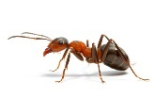

**English**

Daily phonics or Grammar activities will be uploaded onto Tapestry – please check Tapestry everyday for these.

On BBC Bitesize they have daily English lesson, please complete these at home.

Daily reading – remember to use Oxford Owl for access to hundreds of free books.

This week we are looking at the story of The Cautious Caterpillar – attached.

After reading the story, can you imagine you are a minibeast and write a diary of your day. Wht do you think you would see? What would you eat? How will you get around?

**Topic –** Research a minibeast life cycle

The changes a butterfly go through in their life is called metamorphosis. Can you research another minibeast that goes through metamorphosis, draw the lifecycle and write about the different stages?

**Willows**

**Home Learning   
Week 5**

**Down on the Ground**

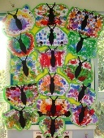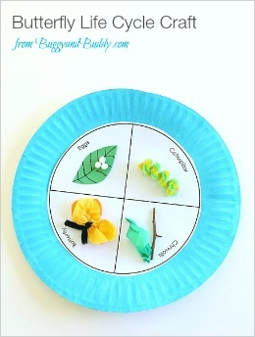

**Topic – Wonderful Weather**

This week I challenge you to become weather forecasters! You need to watch some weather forecasts, what information do they give us? Do you think you could write your own weather forecast or perhaps you could film yourself reading the weather and post it on Tapestry? You will need to draw a map of your local area and research which symbols you will need.

<https://www.youtube.com/watch?v=Uo8lbeVVb4M>

**P.E.** Use Joe Wicks live PE session.

<https://www.youtube.com/channel/UCAxW1XT0iEJo0TYlRfn6rYQ>

**Computing**

**Espresso Coding –** use school log in

**Art/DT – butterfly art**

**Can you create your own butterfly?**

**Can you make some butterfly cakes?**

**Topic** – **Butterfly life cycle**

Do you know the life cycle of a butterfly? There are 2 great videos here. <https://www.youtube.com/watch?v=O1S8WzwLPlM>

<https://www.youtube.com/watch?v=kVm5k99PnBk>

Once you have watched them, can you either complete the attached lifecycle sheet or in your exercise books draw and write about the lifecycle of a butterfly? You could even create the lifecycle out of junk modelling.

**Maths**

Year 1 and 2

Daily Maths Whizz sessions – please aim for 30 minutes a day

Reception

Daily counting and number writing to 20

Year 1 and 2

BBC Bitesize

On the BBC Bitesize they have daily maths lesson

<https://www.bbc.co.uk/bitesize/dailylessons>

Please use this. There are daily videos, activities and worksheets you can access. This will take the children through the maths curriculum.

Receptions

There are daily videos and activities here for Reception, but you are also welcome to access the Year 1 videos.

<https://www.bbc.co.uk/bitesize/subjects/zr99cqt>