

**Check your Times Table knowledge with The Day Of The Dead Times Tables.**

Make a pasta skeleton: 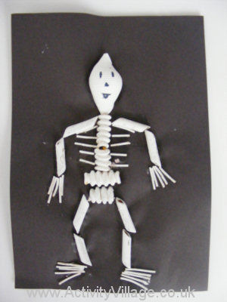

Poems:

Skeletons are In the Park(song)

Day of The Dead Poem

I’m a Dog Skeleton(song)

Watch The Visitor by Ian Serraillier at:

<https://www.bbc.co.uk/bitesize/clips/zh9b4wx>

Watch Funny Bones on You Tube:

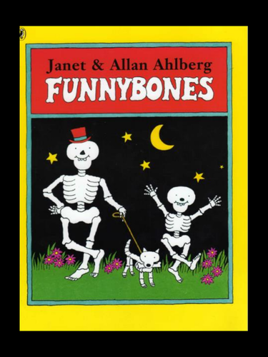

<https://www.youtube.com/watch?v=Fy1n2WLtQMc>

**Day of The Dead Bingo Game**

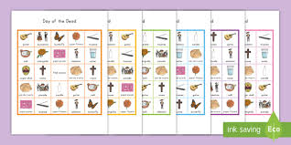

**Make Bread of The Dead**

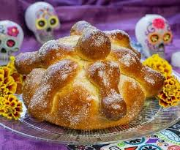

Day of The Dead Spanish

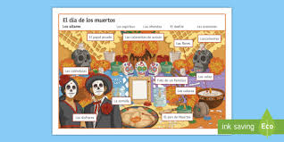

**Can you cut out and order the Aztec timeline?** 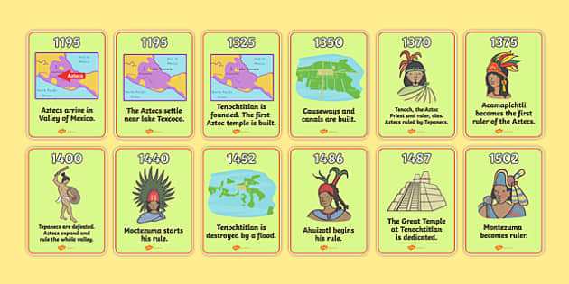

Art: Make and decorate your own sugar skeleton. 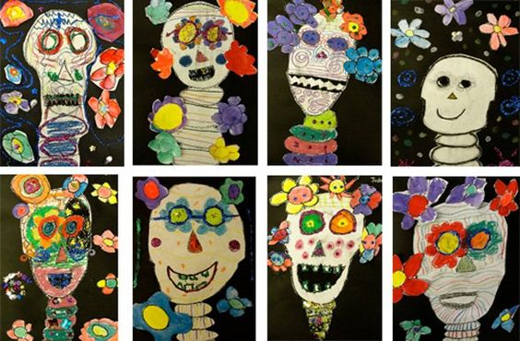

Watch this National Geographic clip:

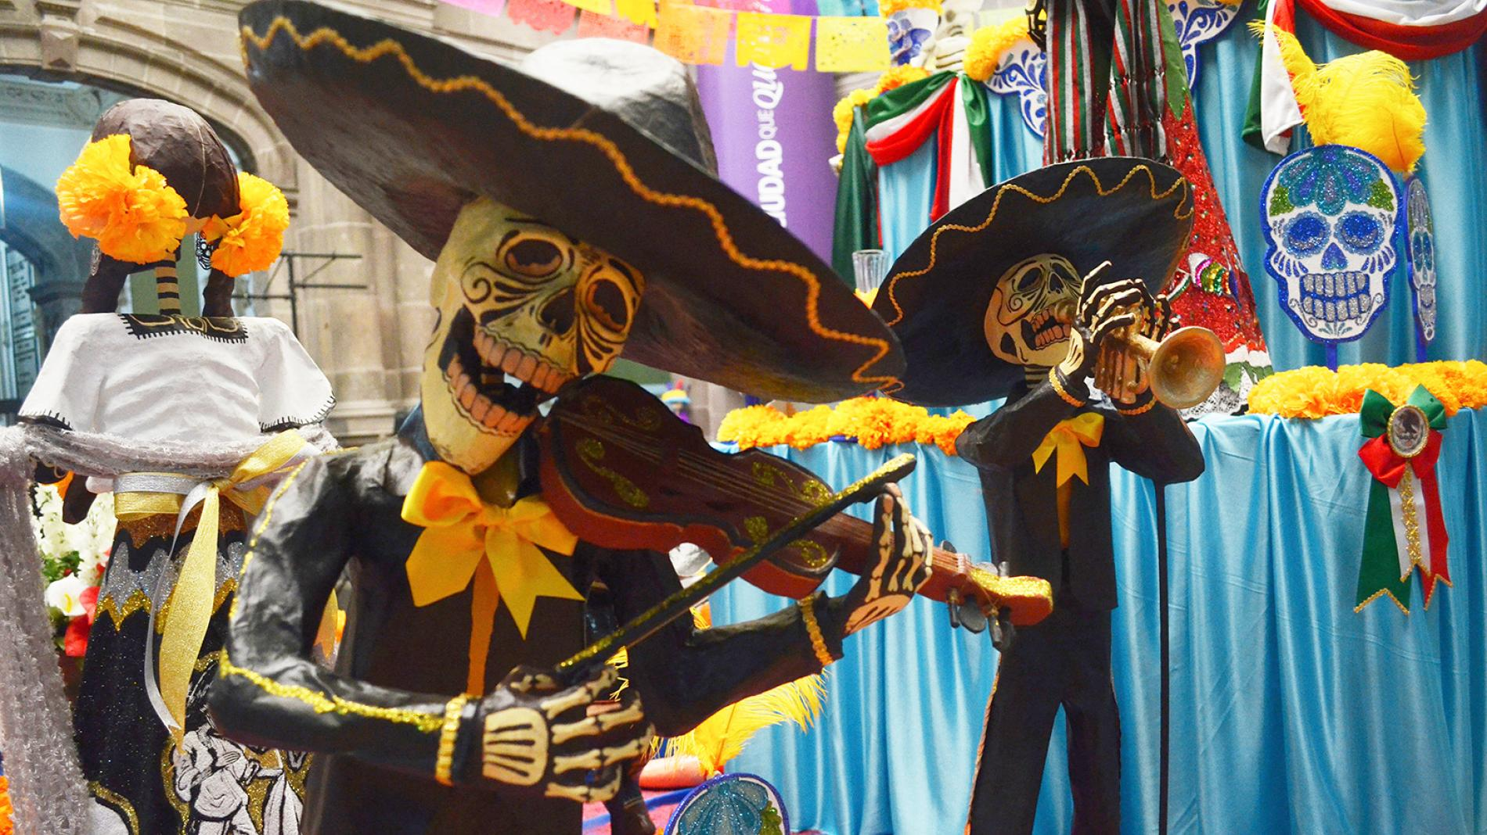

<https://www.youtube.com/watch?v=_sSawpU81cI>

Watch the clip on Literacy shed

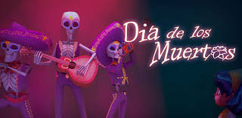

<https://www.literacyshed.com/day-of-the-dead.html>

Can you create an information text about The Day of The Dead?

**Watch the Powerpoint:** 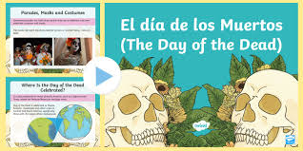

<https://www.twinkl.co.uk/resource/t2-g-336-mexican-day-of-the-dead-information-powerpoint>

