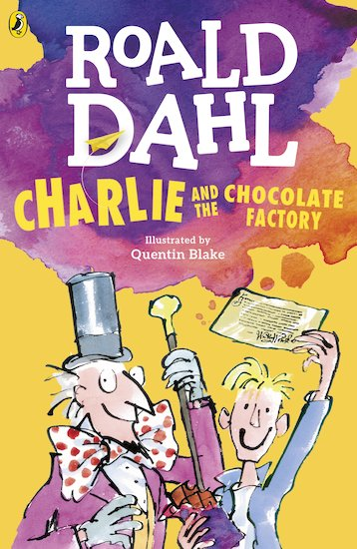

**ART:**

**Aztec sunstone.**

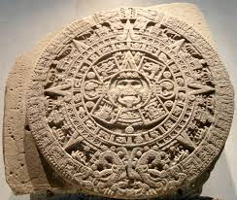

**MATHS WHIZZ!**

**Week 12 and a bit!**

**Can you solve the Ratio and proportion problems?**

Relying on the rainforest cards-Write comprehension questions for your family to answer based on these cards.

**Spanish Food**

Can you learn the Spanish names for food items?

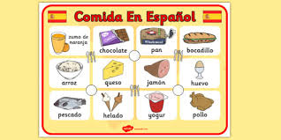

**Science: Matching sheet and your own experiments.**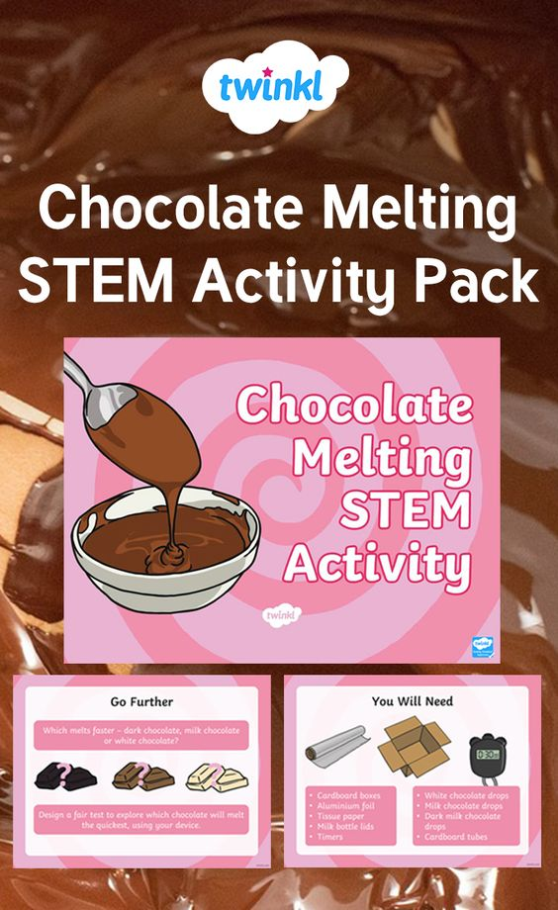

Compare the Aztec and the Maya civilizations.

<https://www.mexicolore.co.uk/aztecs/teachers/the-aztecs-and-the-maya>

<https://www.mexicolore.co.uk/aztecrs/the-aztecs-and-the-maya>

<https://www.twinkl.co.uk/resource/t-t-26703-the-history-of-chocolate-timeline-presentation>

Construct your own History of Chocolate Timeline. 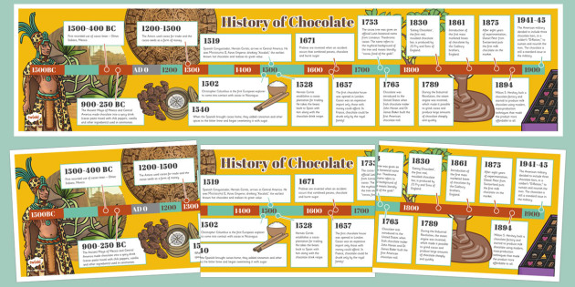

Websites:

<https://www.bbc.co.uk/bitesize/articles/zngsqp3>

<https://www.youtube.com/watch?v=CltsqNyVyE8>

From Bean To Bar

<https://www.teachwire.net/news/cocoa-cortez-and-columbus>

Cocoa, Cortez and Columbus

<https://www.youtube.com/watch?v=ibjUpk9Iagk>

**The History of Chocolate**

Powerpoint on Twinkl:

<https://www.twinkl.co.uk/resource/cfe-t2-t-16544-ks2-world-fair-trade-day-chocolate-information-powerpoint>

**Make notes and write an information text about chocolate**.

Maths: Problems and mysteries to solve-Good Luck! 

Poems:

**My Nan’s Chocolate Cake and comprehension activity.**

**Nasty –Nice**

**We are busy window shopping-Rap!**

**Listen to and read Charlie and The Chocolate Factory:** <https://www.youtube.com/watch?v=PaNzTzumZkQ>



**Chocolate brownie cake**

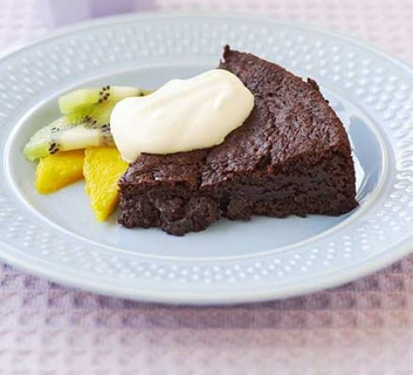

<https://www.bbcgoodfood.com/recipes/chocolate-brownie-cake-0>

