**English**

Daily phonics or Grammar activities will be uploaded onto Tapestry – please check Tapestry everyday for these.

On BBC Bitesize they have daily English lesson, please complete these at home.

Daily reading – remember to use Oxford Owl for access to hundreds of free books.

This week you are creating me your own minibeast.

<https://www.mylearning.org/resources/create-your--own-super-bug>

You need to sign up, but it is free and the activity is great.

This is a good game to see how much you have learnt about minibeasts.

<https://www.bbc.co.uk/games/embed/galaxy-pugs?exitGameUrl=http%3A%2F%2Fbbc.com%2Fbitesize%2Farticles%2Fzn7bscw>

**Topic – Minibeast fact file**

After designing your own minibeast, can you write me a fact file for it?

**Willows**

**Home Learning   
Week 7**

**Down on the Ground**

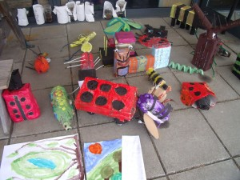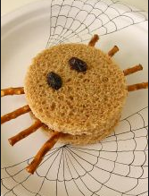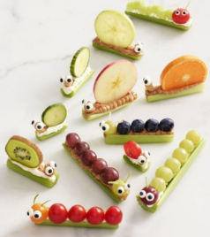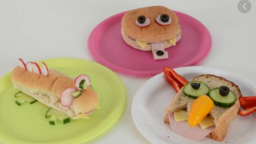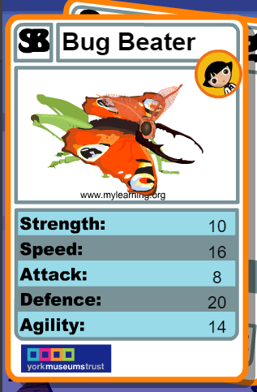

**Computing**

**Espresso Coding –** use school log in

**Art/DT – Can you craft me you own minibeast?**

Using junk modelling, can you make me your own minibeast?

**P.E.** Use Joe Wicks live PE session.

<https://www.youtube.com/channel/UCAxW1XT0iEJo0TYlRfn6rYQ>

**Topic** – Minibeast Feast

I would like you to make a minibeast feast for your lunch one day this week. Can you make you picnic look like minibeasts? Maybe you could pack it up go for a walk and find a nice place to sit for a picnic?

Wow! This is our last home learning sheet – next week we will be doing something a bit different.

I am so proud of you all, you have worked so hard and I have loved seeing it on Tapestry. I have missed you all.

Have an amazing Summer Willows.

**Maths**

Year 1 and 2

Daily Maths Whizz sessions – please aim for 30 minutes a day

Reception

Daily counting and number writing to 20

Year 1 and 2

BBC Bitesize

On the BBC Bitesize they have daily maths lesson

<https://www.bbc.co.uk/bitesize/dailylessons>

Please use this. There are daily videos, activities and worksheets you can access. This will take the children through the maths curriculum.

Receptions

There are daily videos and activities here for Reception, but you are also welcome to access the Year 1 videos.

<https://www.bbc.co.uk/bitesize/subjects/zr99cqt>