Oaks

Myles for a cheerful and positive attitude towards his work.

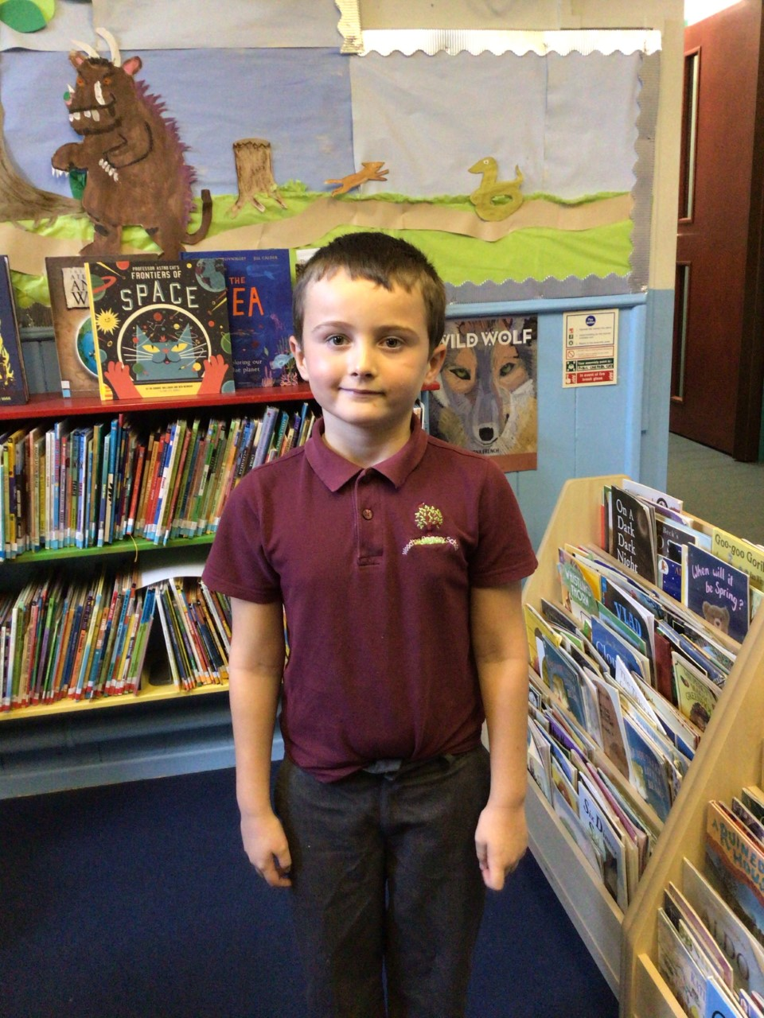

Willows

Ada for always pushing herself to achieve her best.

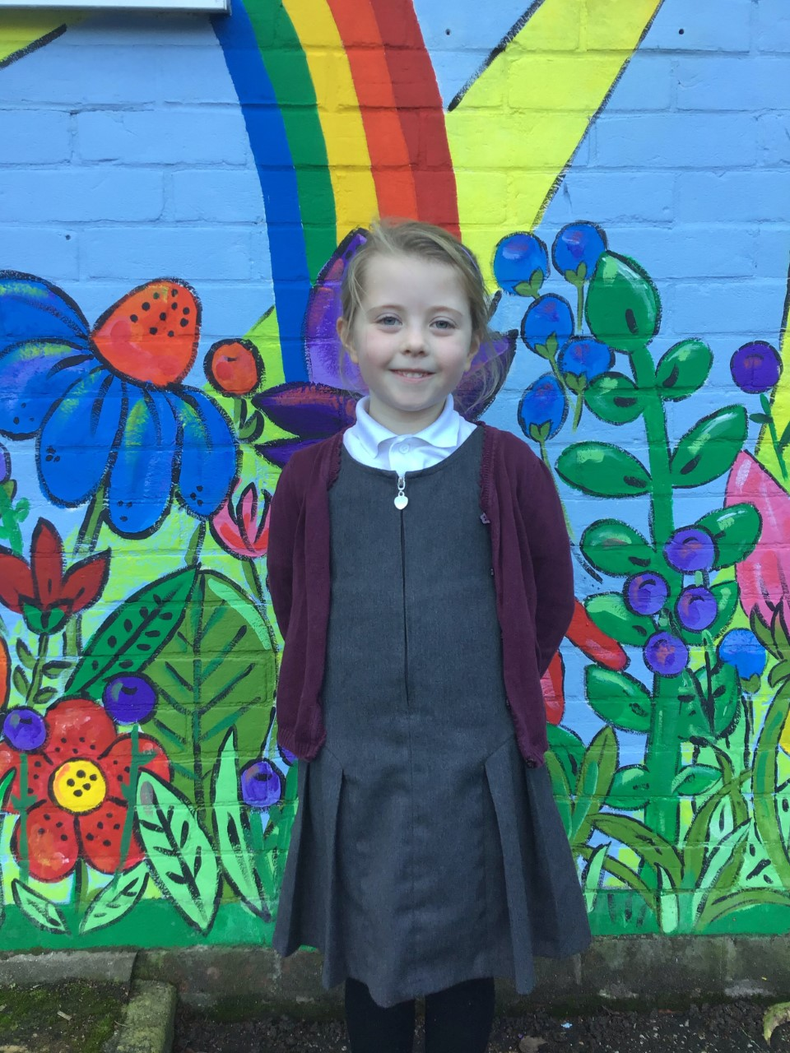

# Celebration Newsletter



**Star of the Week**

Maths Whizz Wonders

Amazing Usage – Willows – Simran, Lucy & Paige.

Oaks – Leila, Lily D & Phoebe.

Brilliant progressions - Willows – Olivia, Woody & Simran

Oaks – Lucas, Leila & Betty

Overall Winner for this week is **Willows**, congratulations.

Times Table Olympics

Congratulations to

Gold – Georgina

Bronze – Lucas, Leila & Phoebe

Level 9 – William Level 13 – Lily D

**House Points**

Benjamin Britten

8

Kelly Holmes

5

Beatrix Potter

3

Stephen Hawking

6

Reading Challenge

Congratulations to **Oaks** class for winning this week’s reading challenge.

Remember to keep reading at home and getting an adult to sign your reading diary to earn a gem for your class bottle.

# Celebration Newsletter

Congratulations to all our celebration superstars this week. Well done for all your amazing effort 😊