Oaks

Jessica for positive helpful attitude.

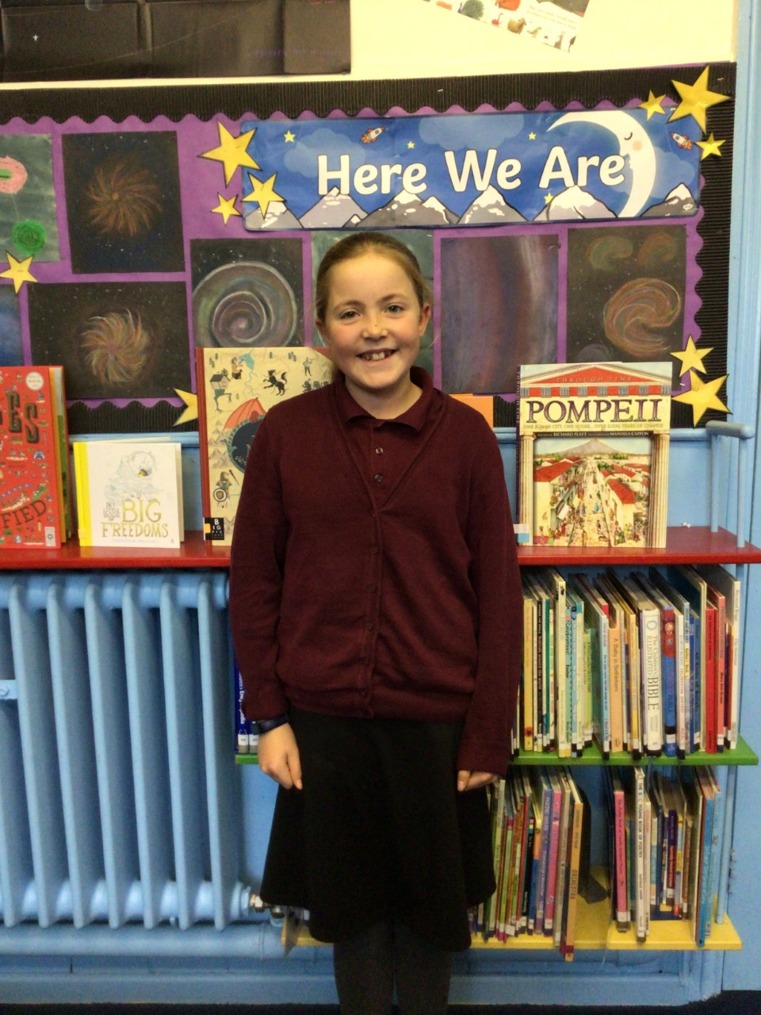

Willows

Kian and Jesse have both developed a love for learning and a positive attitude.  They always try their hardest in all their learning.

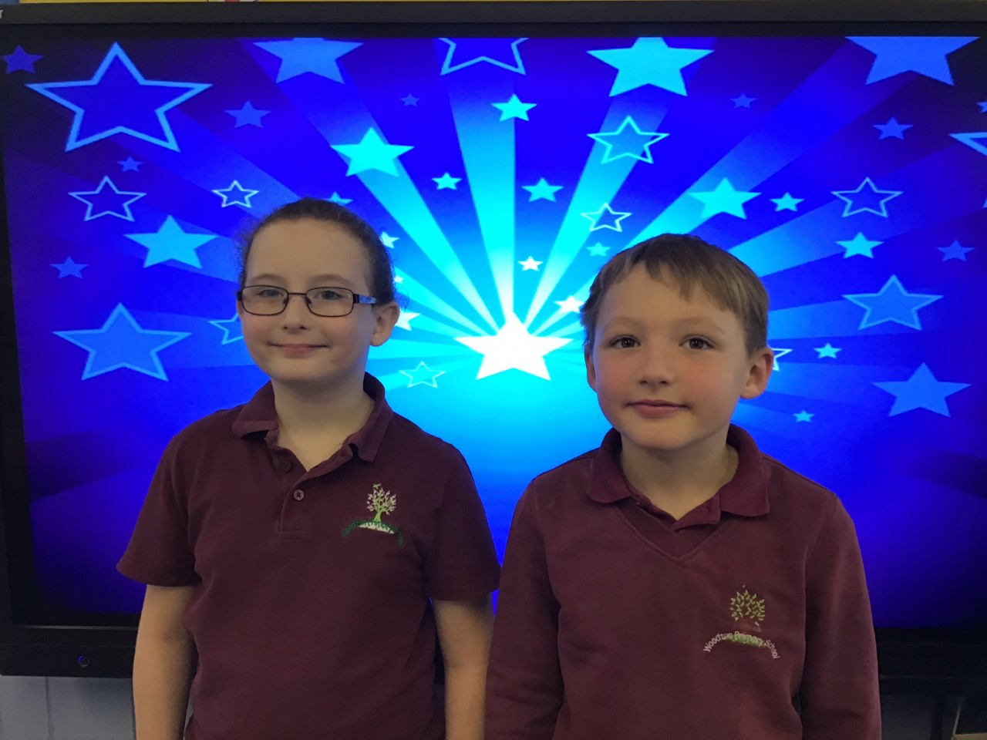

# Celebration Newsletter



**Star of the Week**

Maths Whizz Wonders

Amazing Usage – Willows – Charlie C, Hector & Anya.

Oaks – Leila, Illiana & Betty.

Brilliant progressions - Willows – Charlie C, Anya & Olivia L.

Oaks – Leila, Iliana & Betty.

Overall Winner for this week is **Willows**, congratulations.

Times Table Olympics

Congratulations to

Lacy for Silver award,

Jack for level 9 and Nora for Finalist.

**House Points**

Benjamin Britten

20

Kelly Holmes

33

Beatrix Potter

13

Stephen Hawking

20

Reading Challenge

Congratulations to **Willows** class for winning this week’s reading challenge.

Remember to keep reading at home and getting an adult to sign your reading diary to earn a gem for your class bottle.

# Celebration Newsletter

Congratulations to all our celebration superstars this week. Well done for all your amazing effort 😊