Oaks

Mylee for working hard all week and showing kindness to everyone.

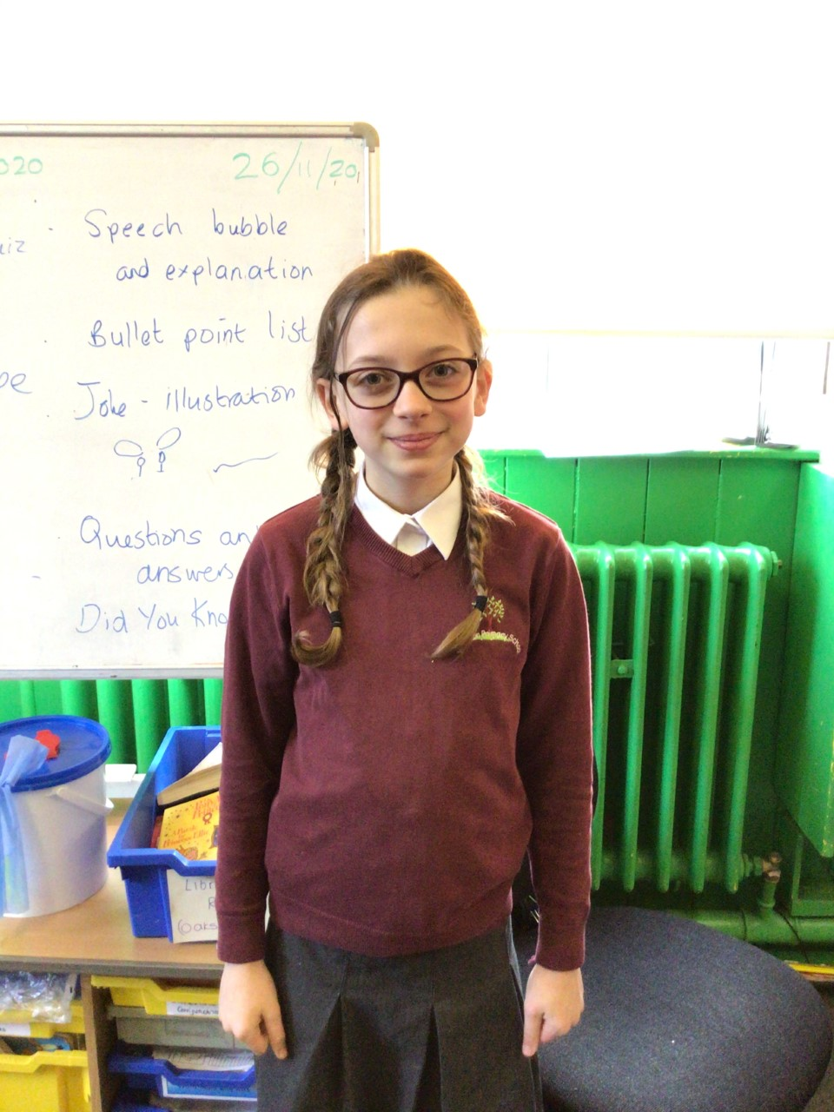

Willows

Anya for being a real star, showing us how kind and thoughtful she is. Helping in Willows class especially with the reception children. Anya has also shown a good understanding of measurement during maths.

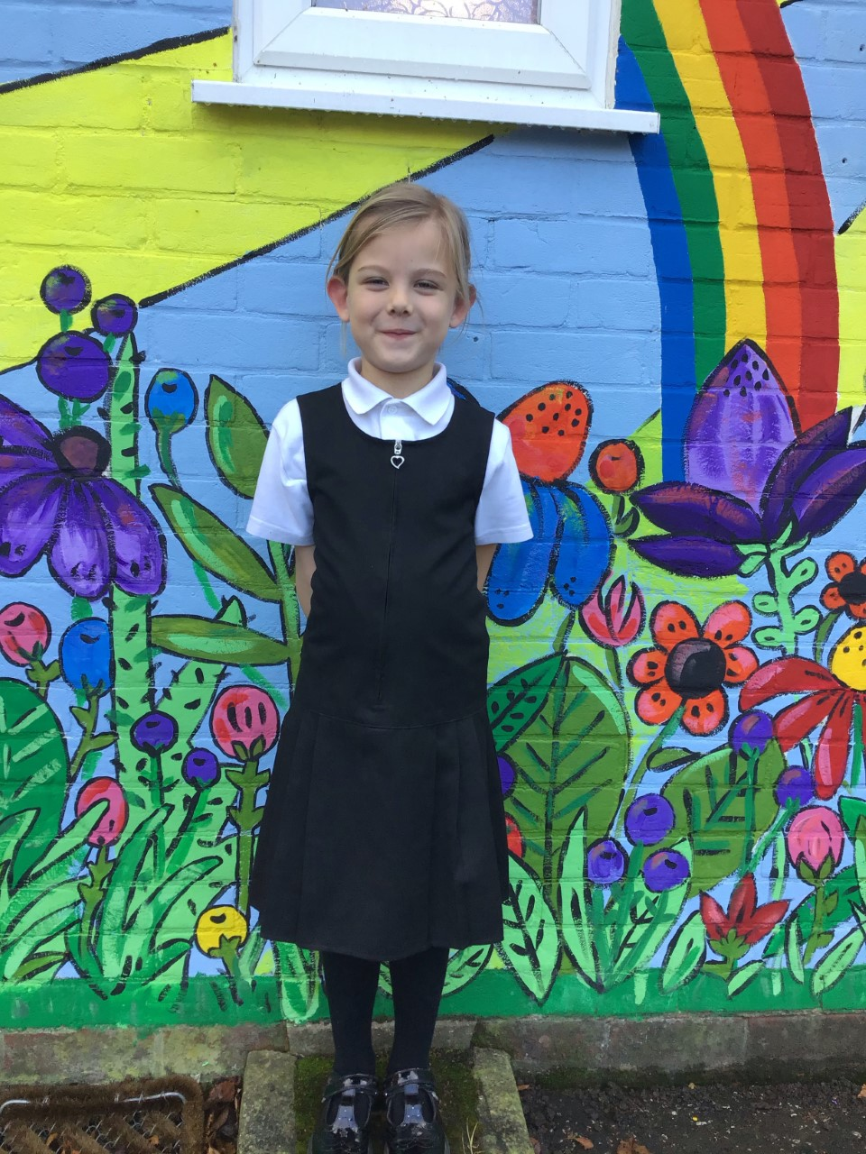

# Celebration Newsletter

Maths Whizz Wonders

Amazing Usage – Willows – Kian, Simran & Charlie C.

Oaks – Henry, Lily D & Leila.

Brilliant progressions - Willows – Charlie C, Woody & Simran.

Oaks – Henry, Leila & Nora.

Overall Winner for this week is **Willows** again, CONGRATULATIONS.

**Star of the Week**



**House Points**

Reading Challenge

Congratulations to **Oaks** class for winning this weeks reading challenge.

Remember to keep reading at home and getting an adult to sign your reading diary to earn a gem for your class bottle.

Benjamin Britten

27

Kelly Holmes

29

Beatrix Potter

17

Stephen Hawking

25

# Celebration Newsletter

Congratulations to all our celebration superstars this week. Well done for all your amazing effort 😊