Oaks

Lucas for being amazing.

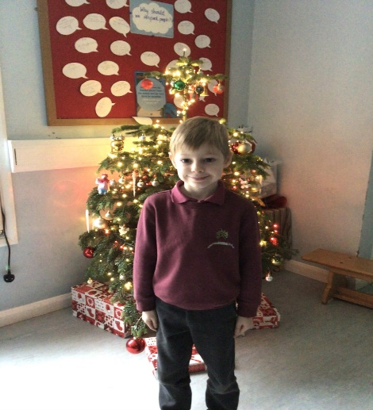

Willows

Maisy loves learning and sharing her knowledge.

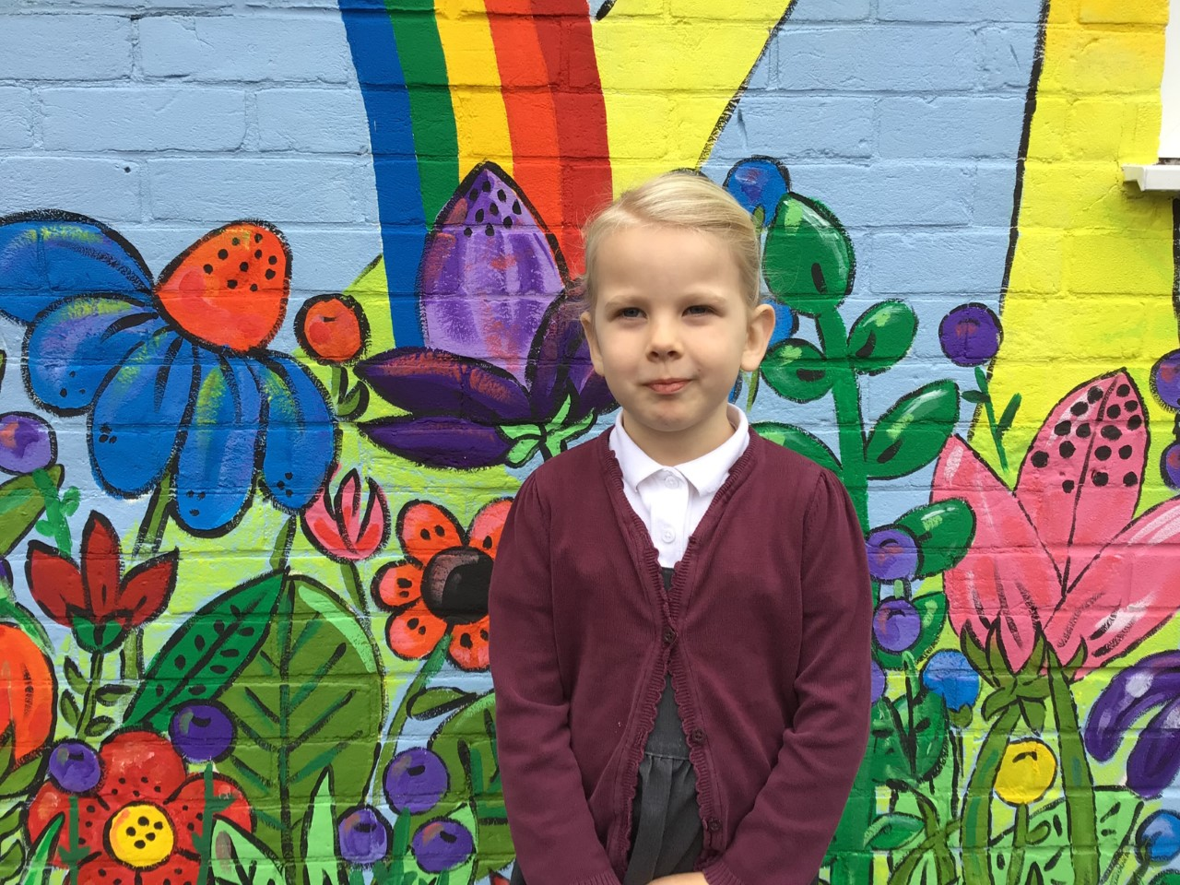

# Celebration Newsletter

Maths Whizz Wonders

Amazing Usage – Willows – Crystal, Theo & Hector.

Oaks – Lucas, Felicity & Betty.

Brilliant progressions - Willows – Ada, Crystal & Hector.

Oaks – Henry, Felicity & Sophia.

Overall Winner for this week is **Willows** again, CONGRATULATIONS.

**Star of the Week**

Times Table Olympics

Congratulations to

Feliks – European Award

Barley – Level 9

Jessica – Level 11

Jack – Level 12



**House Points**

Reading Challenge

Congratulations to **Willows** class for winning this week’s reading challenge.

Remember to keep reading at home and getting an adult to sign your reading diary to earn a gem for your class bottle.

Benjamin Britten

18

Kelly Holmes

10

Beatrix Potter

8

Stephen Hawking

10

# Celebration Newsletter

Congratulations to all our celebration superstars this week. Well done for all your amazing effort 😊