Oaks

**Stars of the week:**

Mylee for being kind and helpful and Solomon for settling in amazingly.

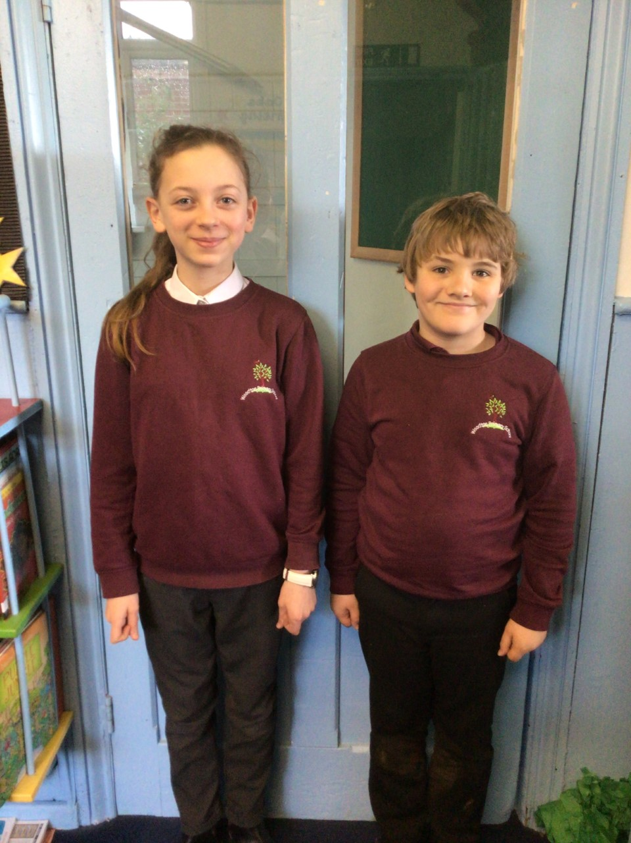

Willows

**Stars of the week:** All of Willows for settling in so well this week. 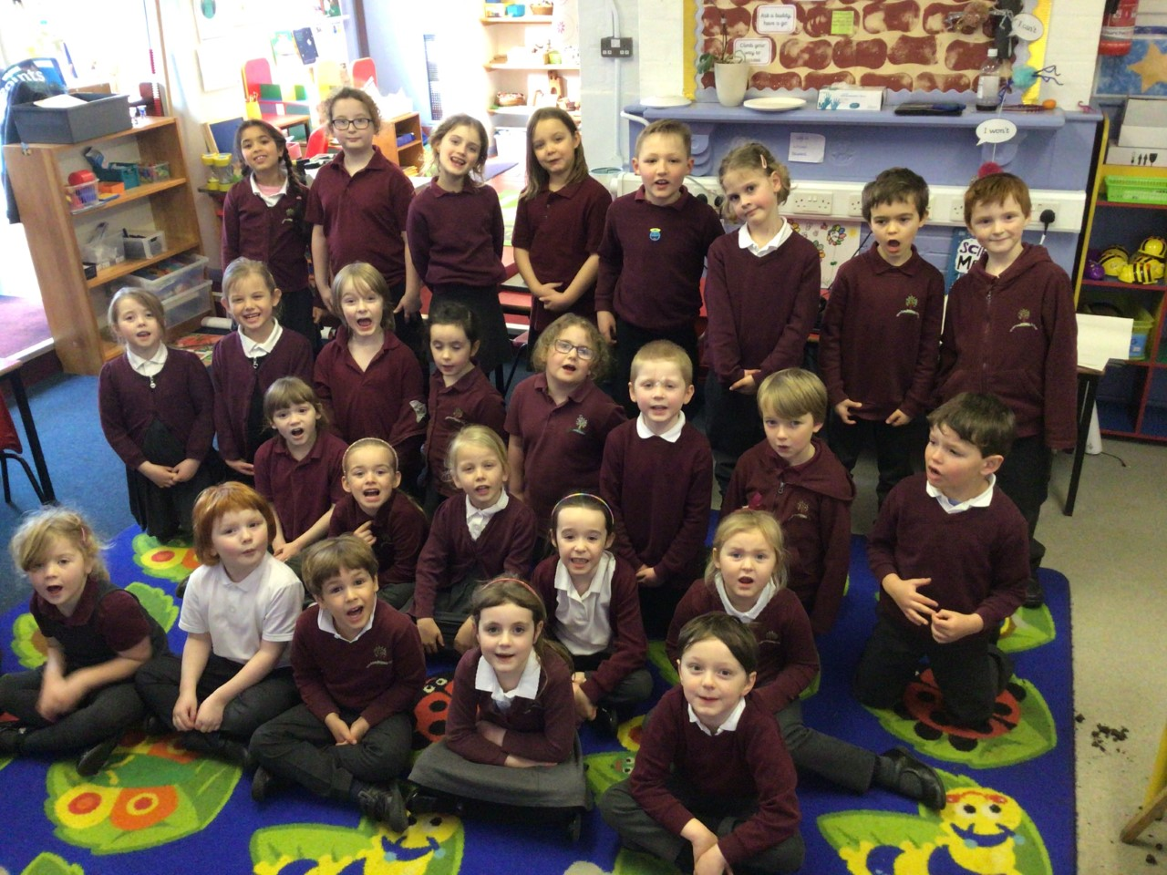

**Star of the Week**

Maths Whizz Wonders

**Amazing Usage** –

Willows – Lucy, Winter & Jesse.

Oaks – Betty, William & Riley.

**Brilliant progressions** -

Willows – Lucy, Winter & Jesse.

Oaks – Betty, Felicity Lily D.

Overall Winner for this week is **Oaks.**

CONGRATULATIONS.





Congratulations to all our celebration superstars this week. Well done for all your amazing effort 😊

# Celebration Newsletter