Oaks

Barley for always helping others and working her hardest.

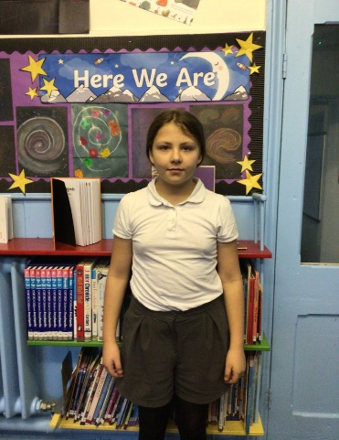

Willows

Kian for just being amazing.

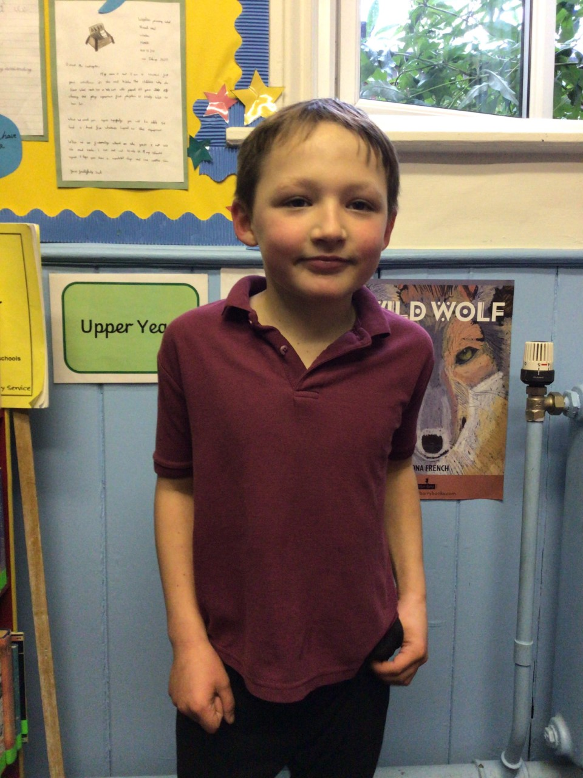

# Celebration Newsletter

Maths Whizz Wonders

Amazing Usage – Willows – Ada, Paige & Hector.

Oaks – Jessica, Betty & Lily.

Brilliant progressions - Willows – Ada, Florence & Jesse.

Oaks – Jessica, Barley & William.

Overall Winner for this week is **Willows** again, CONGRATULATIONS.

**Star of the Week**

Times Table Olympics

Congratulations to

Leila & Lucas – Silver award

Lily W – Gold award

Jessica – Level 10

Jack – Level 11



**House Points**

Reading Challenge

Congratulations to **Oaks** class for winning this week’s reading challenge.

Remember to keep reading at home and getting an adult to sign your reading diary to earn a gem for your class bottle.

Benjamin Britten

21

Kelly Holmes

15

Beatrix Potter

6

Stephen Hawking

18

# Celebration Newsletter

Congratulations to all our celebration superstars this week. Well done for all your amazing effort 😊