Oaks

**Star of the week:**

Phoebe for working diligently and producing work of a very high standard. Also for being caring and helping others when they are upset.

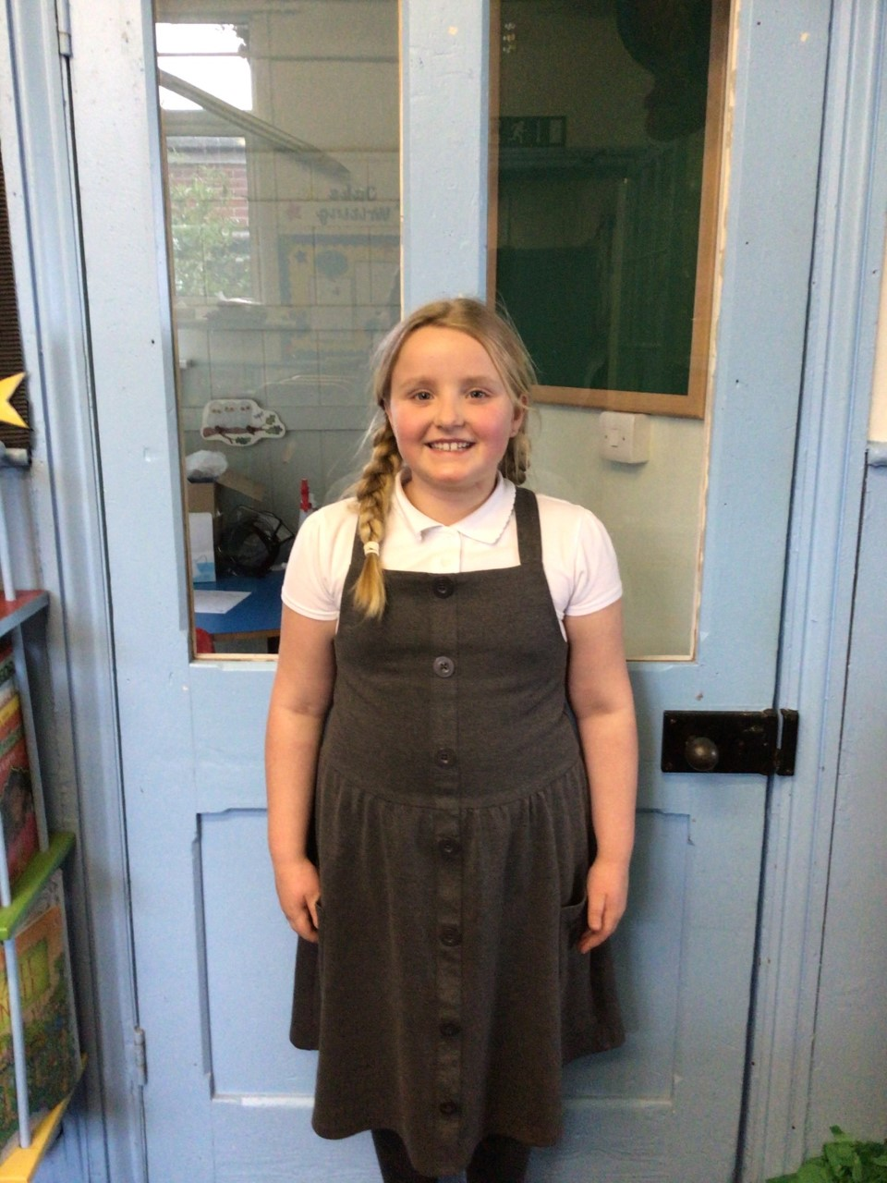

Willows

**Star of the week:** Charlie W has been working really well in class, persisting with his learning and showing a can do attitude to everything. Keep it up Charlie.

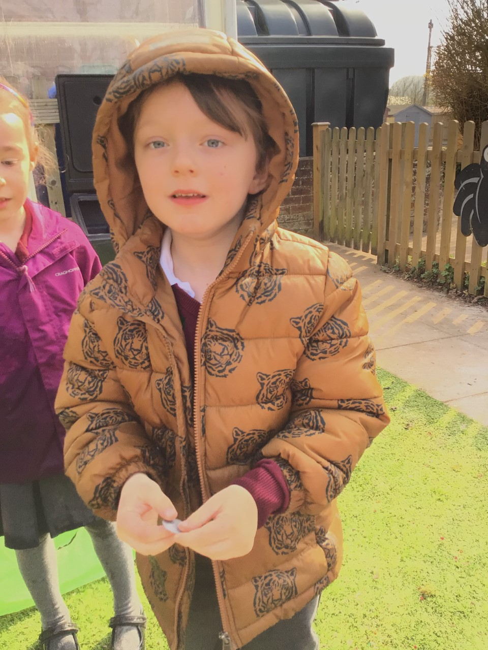

**Star of the Week**

Maths Whizz Wonders

**Amazing Usage** –

Willows – Charlie C, Charlie T & Simran.

Oaks – Jessica, Henry & George L.

**Brilliant progressions** -

Willows – Charlie C, Charlie T & Woody.

Oaks – Jessica, Henry & Lucas.

Overall Winner for this week is **Willows.**

CONGRATULATIONS.





Congratulations to all our celebration superstars this week. Well done for all your amazing effort 😊

# Celebration Newsletter