Oaks

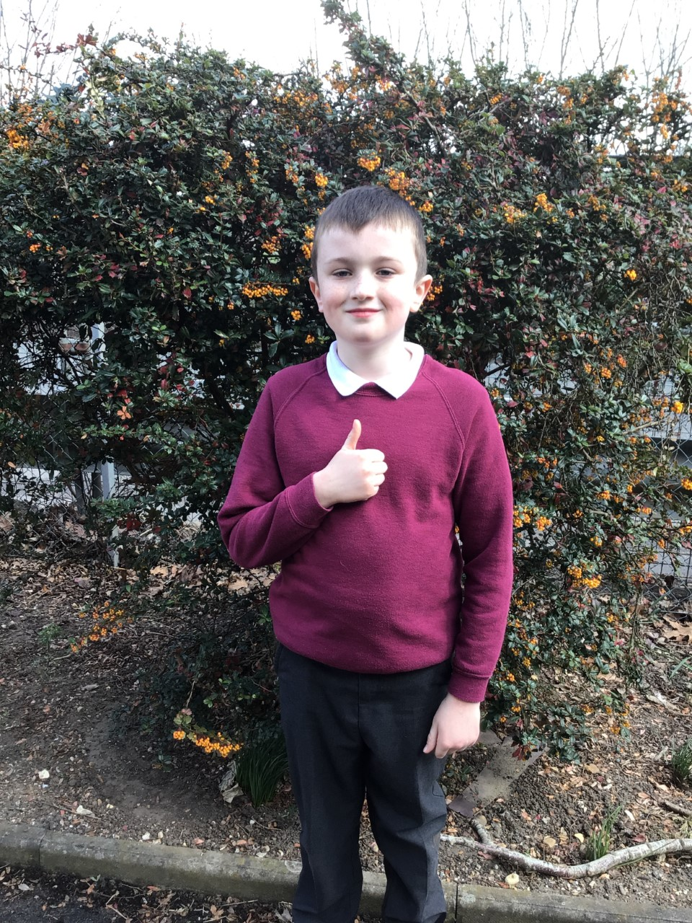

Henry for contributing in class, working very hard on his Union Jack picture and outstanding work in his maths this week.

Willows

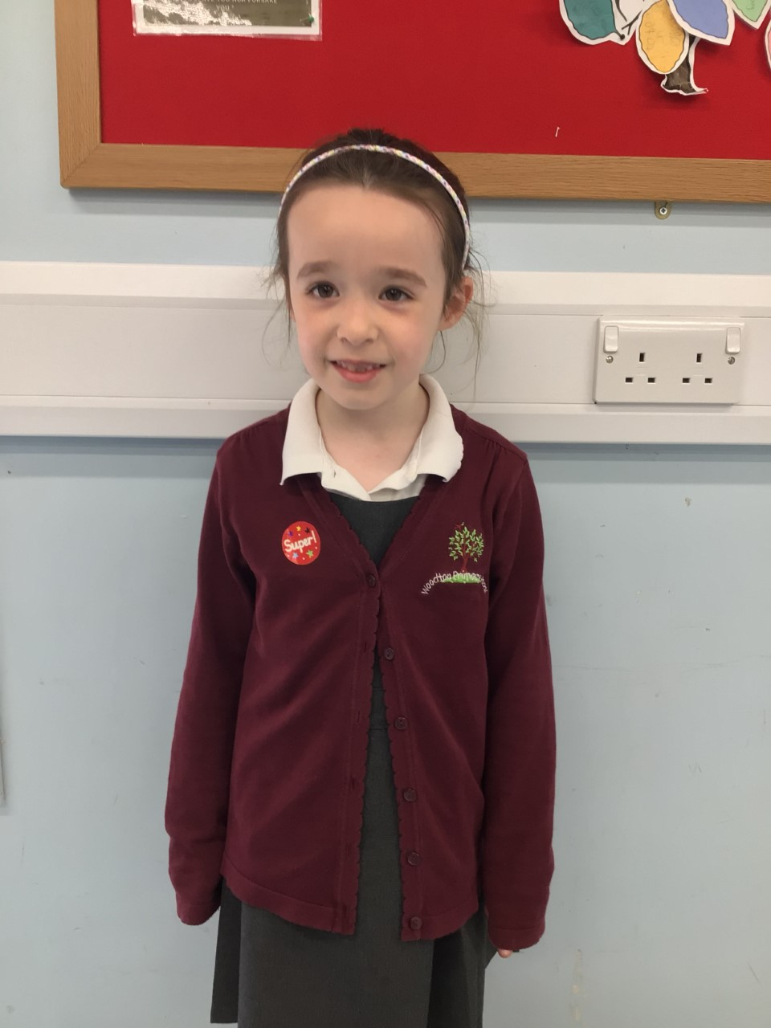

Willows star of the week is Evie. She persisted with her writing about the story of Lost of Found, using her phonics to support her, and has wowed us with her maths knowledge making teen numbers.

**Star of the Week**

Maths Whizz Wonders

**Amazing Usage** –

Willows – Anya, Charlie T & Hector

Oaks – Betty, Myles & Felik.

**Brilliant progressions** -

Willows – Charlie T, Anya & Woody.

Oaks – Betty, Lily W & Lacy W.

Overall Winner for this week is **Willows**,

CONGRATULATIONS.

Times Table Olympics

Coming Soon

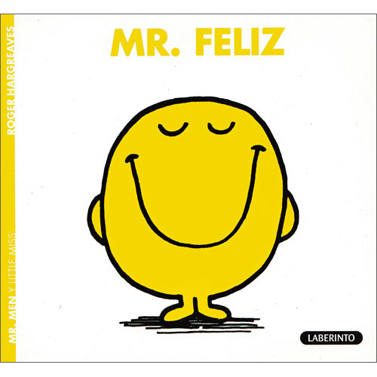



Congratulations to all our celebration superstars this week. Well done for all your amazing effort 😊

# Celebration Newsletter