Oaks

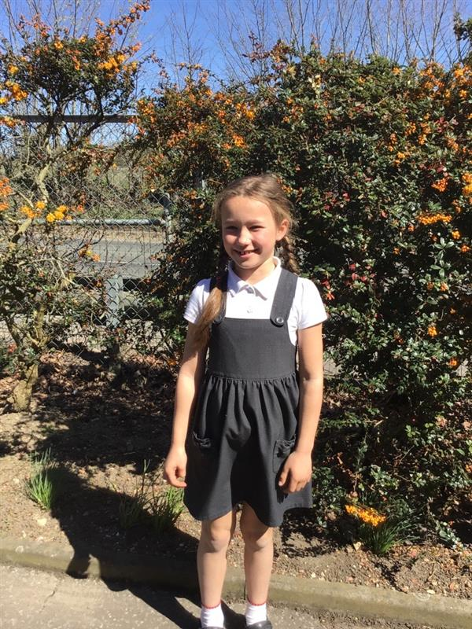

Felicity - For working hard on her bar modelling in maths and for a brilliant, independent start on her letter as an evacuee.

Willows

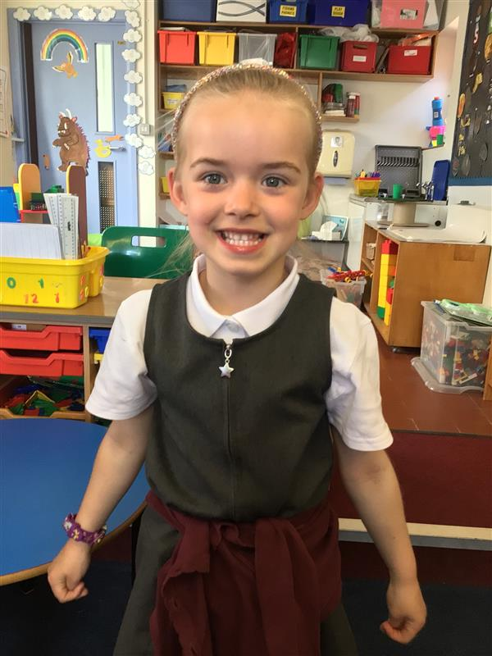

Willows star of the week is Kendall. She has been challenging herself in maths, persisting with doubles to 20. She has been using her phonics really well in her writing, reading, and amazing us daily.

**Star of the Week**

Maths Whizz Wonders

**Amazing Usage** –

Willows – Charlie L, Charlie T & Charlie C.

Oaks – Henry, Solomon & George L.

**Brilliant progressions** -

Willows – Charlie T, Lucy & Olivia.

Oaks – Nora, Henry & Solomon.

Overall Winner for this week is **Willows**,

CONGRATULATIONS.

Times Table Olympics

Coming Soon





Congratulations to all our celebration superstars this week. Well done for all your amazing effort 😊

# Celebration Newsletter