Oaks

Our star of the week this week is Riley.

For working very hard in his work and settling into the classroom amazingly.

Willows

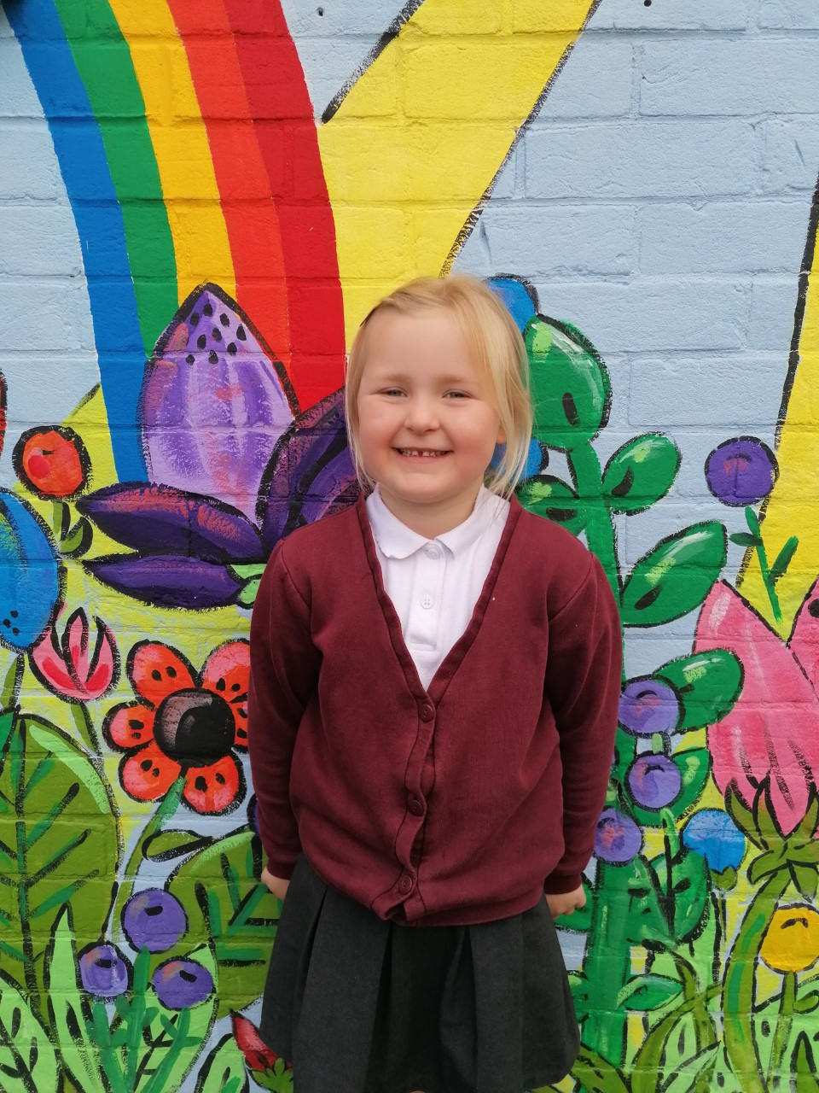

Our star of the week is Emmie. Emmie has independently been using her phonics, challenging herself to write some very tricky words. In science, she demonstrated a great understanding of scientific language to describe materials.

**Star of the Week**

Maths Whizz Wonders

**Amazing Usage** –

Willows – Jesse, Anya & Woody.

Oaks – Betty, Georgina & Jessica.

**Brilliant progressions** -

Willows – Charlie T, Jesse & Woody.

Oaks – Jack, Georgina & Lily W..

Overall Winner for this week is **Willows**,

CONGRATULATIONS.





Congratulations to all our celebration superstars this week. Well done for all your amazing effort 😊

# Celebration Newsletter