Oaks

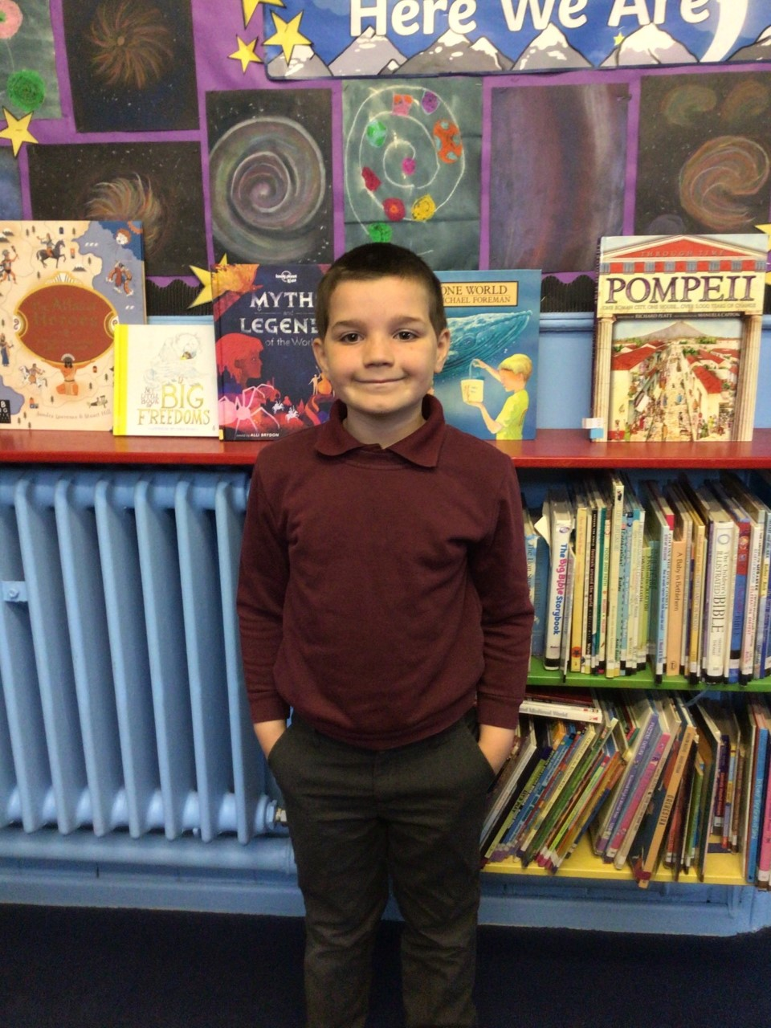

Riley R for his amazing maths work this week and continuously working his hardest in class.

Willows

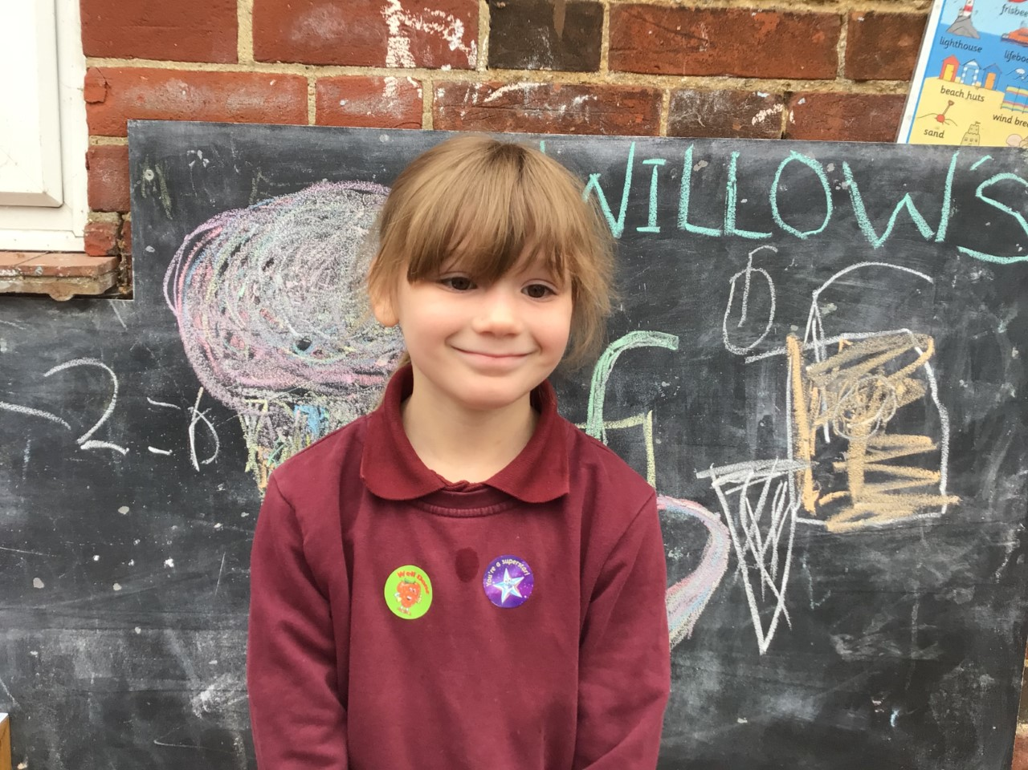

Star of the week is Holly.  Holly has amazed us with her maths this week, confidently adding and subtracting multiples if ten using a hundred square. She challenged herself to move her learning forward with her maths. Keep it up Holly!

**Star of the Week**

Times Table Olypmic Awards

Congrautlations to;

Jessica - Level 13

Illiana – European Award

Leila & Georgina – Gold Award



Maths Whizz Wonders

**Amazing Usage** –

Willows – Paige, Winter & Charlie L.

Oaks – Leila, Henry & Illiana.

**Brilliant progressions** -

Willows – Winter, Woody & Jesse .

Oaks – Nora, Leila & Lucas.

Overall Winner for this week is **Willows**,

CONGRATULATIONS.



Congratulations to all our celebration superstars this week. Well done for all your amazing effort 😊

# Celebration Newsletter