WELLNESS Home Life

Hello from your Wellbeing team,
How are you all doing? We have no doubt in our minds that you are all doing brilliantly each and every day. We hope you found our last Wellbeing Newsletter of some help and interest. Myself - Karen Taylor and Sally Brooks are here for you and if you would like to get in contact, we now have a direct email: wellbeing@woodton.sch.uk.
Mental Health Fact:
DID YOU KNOW?
Touch and movement are two healthy ways to quickly manage stress. Stroking a dog, cat, or other animals can lower blood pressure and help you quickly feel calmer and less stressed.

Headspace for You and the Children
I am sure you have all found that each day is different, some days it seems easy, other days it’s hard.
We need to try to keep ourselves grounded. There are many different things we can try which take seconds but can make such an impact on our wellbeing.
Every morning when you are waiting for the kettle to boil, try jumping on the spot for 1 minute. This has some really good health benefits;
- it revs up your metabolism
- helps towards keeping your bones healthy
- burns calories
- can improve your posture
- wakes the body up ready for the day
- gets the blood pumping round your body and to your brain
- improves co-ordination
- helps you to relax as it releases endorphins
- Also it’s just plain fun and makes you feel like a kid again.
(Try it with the kids, they’ll love it)
When you have your snack breaks with the kids try some breathing exercises. Try downloading the App – Headspace, it has some great breathing exercises that you and the children will feel the benefits from.

A thought;
Kindness begins with
the understanding
that we all struggle.
How to Lift Your Mood In Winter
- Move your body as frequently as you can. Exercise is one of the best anti-depressants you can get. You don’t have to run a marathon, you can: walk the dog, dance around the kitchen, do a home workout - Just move your body every day.
- Get some natural daylight. If you work from home sit near a window, take a lunch break and use it to go for a walk.
- Seek out good quality human connection. It’s one of the most powerful tools we have to stay healthy and happy. If you can’t see someone face to face use video calls, text, do whatever you need to but don’t go for days without speaking to someone.
- If you want to feel better, eat better. Pick one small change that you can sustain over time because what you put into your body will influence how you feel.

Child Mental Health and Wellbeing
Maintaining good mental health is just as important as having a healthy body. It affects the way children think, feel and act. As a parent, you play an important role in promoting your child’s mental health and recognising when there may be early signs of difficulties.

Here are 10 Top Tips for you to help promote good mental health;
- Connect with your child everyday – Try to make time every day for an activity where you can connect with your child without distractions that enables comfortable conversation. We all lead busy lives, but doing an activity like this together will offer your child the opportunity for them to feel secure and express how they are doing/feeling;
- Have quiet time together – This is a great way to connect with your child and takes no planning! Uninterrupted quiet time provides an ideal environment for your child to focus and build their attention span. When things are overwhelming, quiet time can help your child reset their thoughts and avoid behaviour escalation to meltdowns.
- Praise your child when they do well – Recognise efforts as well as achievements – praise the small steps. For example, say your child has difficulty sitting quietly and calmly at the dinner table. Although desired, it would be unrealistic to initially expect them to do so for half an hour. So small steps might be praising that they achieved 5-10 minutes. At the next meal this could be built on by reminding them of their previous achievement and setting a new goal of 15 minutes, this can also apply to schoolwork.
- Foster your child’s self-esteem - Self-esteem is how they feel about themselves, both inside and out. Children with good self-esteem generally have a positive outlook, accept themselves and feel confident. Fostering self-esteem includes showing love and acceptance, asking questions about their activities/interests and helping them set realistic goals.
- Actively listen to your child – That is really listening to what they are saying and how they are feeling. Often the way children feel may seem unrealistic disproportionate to adults but remember, children do not have the wisdom of experience and they may need help and direction to make sense of situations and feelings. Try to answer your child’s questions and reassure them in an age-appropriate manner. Whilst you may not be able to answer all their questions, talking things through can help them feel calmer.
- Wherever possible stick to commitments and routines – Following through on commitments and routines builds trust and continuity, important relationships factors. Try to keep to as many regular routines as possible to help your child feel safe and secure. This includes having regular times for going to bed, waking up, eating meals and doing activities/hobbies.
- Keep your promises – Should the need to break a commitment or routine occur make sure there is a valid reason and take the time to explain why to your child. Remember success comes from keeping your promises to your child.
- Find opportunities to play together – Play is a fantastic way for children to learn new things and develop problem-solving skills. It also offers great opportunities for them to learn how to express their feelings.
- Be a positive role model – Look after your own mental health and wellbeing. Children are intuitive and will readily pick up on feelings such as stress, anxiety, hopelessness and fear.
- Help your child to develop to a language of feelings – Teaching children about feelings can be hard as it’s an abstract concept but if they can understand and express their emotions, they will be less likely to ‘act out’. For example, you can discuss how characters in a book are feeling and the reasons why they may be feeling that way.

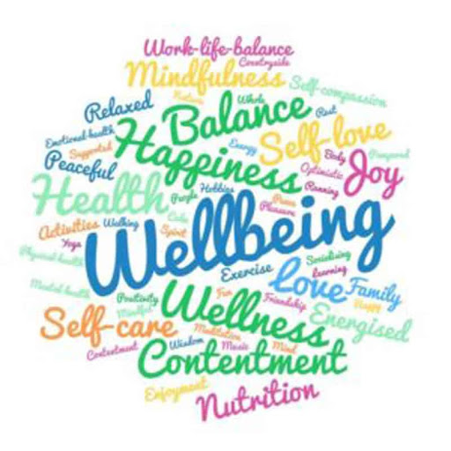
Wellness Tip
Cut Out Unnecessary Stressors
Whether we like it or not, some things simply can’t be changed. It’s best just to avoid stressing about them. Don’t make yourself crazy by trying to get a handle on something that isn’t going to be fixed. Take a step back, calm down, and stop trying to fight the impossible.

Just a thought;  The parent whipped off their cape, held their hands in the air and said ‘I’m struggling this time’. The other parents breathed a sigh of relief, ripped their capes off and said ‘Me too’, and they all knew they were not alone. | The simple things;  100% - Always make sure to take some YOU time!

