WELLNESS
Home Life

Hello from your Wellbeing team,

BACK TO SCHOOL
Panic Attacks - some support;
The majority of us at some point will experience a panic attack, at whatever age. A panic attack is a feeling of sudden and intense anxiety. Panic attacks can also be physical like shaking, feeling sick, heart racing, dry mouth, sweating etc. Children at any age can experience a panic attack, and will find it hard to understand the feelings from one. Here are some tips to help, if you or someone else experiences an attack.

- Concentrate on your breathing; Breathe in for 3 seconds, breathe out for 3 seconds. When you begin to calm down, you can increase how long you hold each breath to 5-7 seconds.
- Find a safe space; if a situation is making you feel panicked, try to find a space where you can take a moment to breathe and calm your thoughts. If you can’t physically go to a safe space, try visualising yourself somewhere you feel calm, like on a favourite holiday.
- Focus on your senses and surroundings; identify one thing you can see, hear, taste, touch and smell. When you are having a panic attack, you can feel out of touch with things around you. This technique can help you feel connected with your surroundings and in control.
- Talk to someone you trust; When you feel settled, talking about your panic attack with someone you trust can help you find out why it happened. Knowing why it happened can help you prevent it from happening again. Experiencing a panic attack can be stressful. You don’t have to go through it alone.
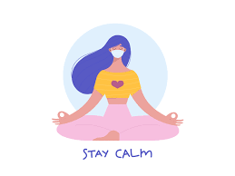

A thought;

To look after your family and friends, you have to look after yourself.
We are all going to experience different emotions over the next few weeks: some of us will be eager for the daily routine to start again; some of us will feel anxious about the change. We have put a few things together in this wellbeing newsletter, which will hopefully help ease any anxiety or worries that you may feel, we also have added some tips to help you support your children, as this could be quite an unsettling time for them too.
8 Ways to show your Mental Health some TLC
- Have a natter – Make time to chat to someone
- Get active – a few minutes a day can make a difference
- Find a routine – this helps you feel grounded
- Log off – put your phone away for a while
- Be crafty – make something nice
- Cut down the units – reducing can heighten your mood
- Give back – support someone else
- Prioritise sleep – a good sleep pattern is essential

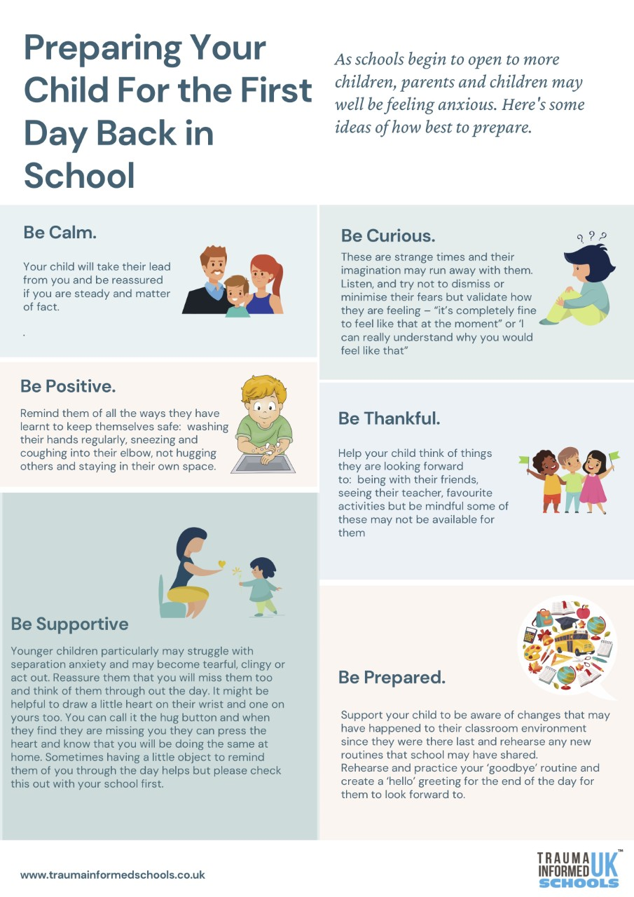
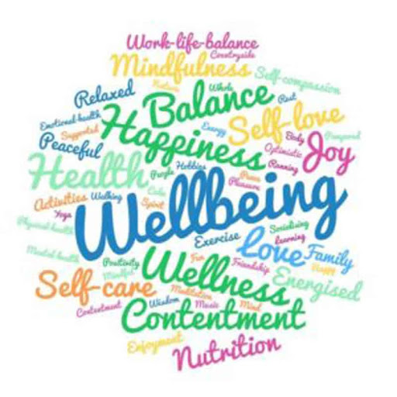
Wellness Tip
Try these things with your children at the end of each day so they end on a good note;

Self-Esteem Journal

Monday – Something I did well today….

Tuesday – I felt good about myself when…..

Wednesday – I had a positive experience with…..

Thursday – 3 Good things about me are……

Friday – Something I did for someone……

Just a thought;  Incase no one told you today….  You are needed,  you are stronger than you think,  You are doing great.  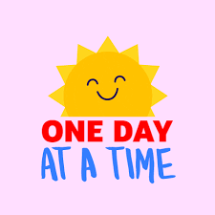 | The simple things;  The healing hug; Giving a hug to someone can have amazing results on their mental health. It has been proven to release a feel-good hormone called oxytocin. So, let’s give some extra hugs to help ease any anxiety that may occur over the next few weeks.

