Oaks

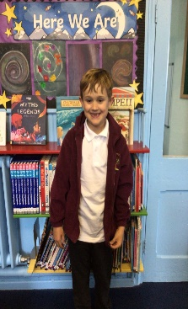

George for working very hard in everything he has done this week!

Willows

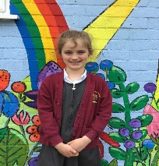

This week’s star in willows is Olivia.  Olivia has shown great persistence in all of her work, wowing us every day with her maths and writing. She is always kind and caring and is a fantastic fiend to everyone.

**Star of the Week**



Maths Whizz Wonders

**Amazing Usage** –

Willows – Anya, Charlie L & Hector.

Oaks – Betty, Felicity & Myles.

**Brilliant progressions** -

Willows – Anya, Woody & Charlie C .

Oaks – Georgina, Myles & Felicity.

Overall Winner for this week is **Willows**,

CONGRATULATIONS.



Congratulations to all our celebration superstars this week. Well done for all your amazing effort 😊

# Celebration Newsletter