Oaks

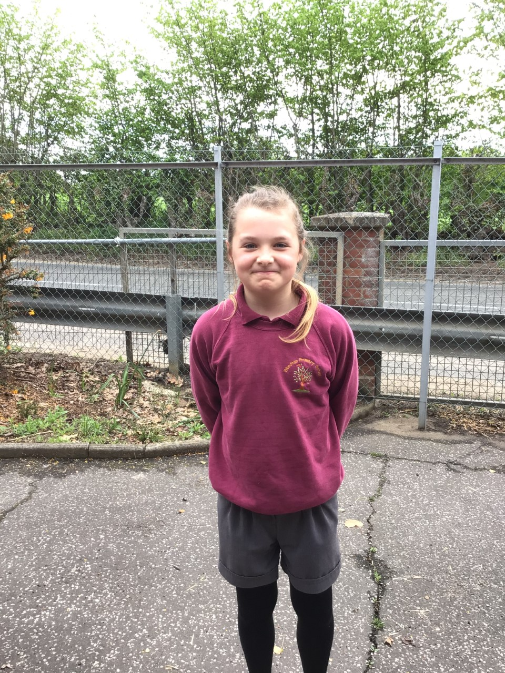

Oaks star of the week is Lacy.

Lacy has shown amazing persistence in finishing her work all week and constantly contributes in class discussions sharing her own ideas!

Willows

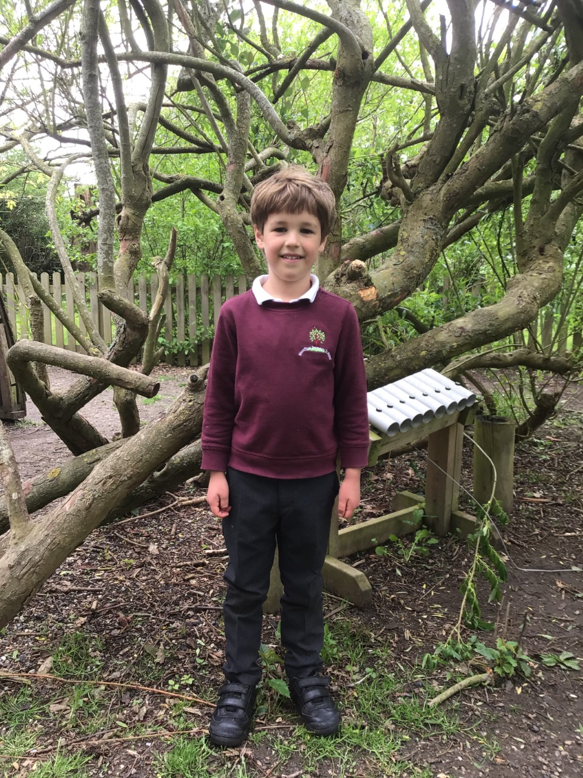

Hector is a superstar. He always tries his hardest and perseveres with all his learning. Hector is always smiling and shares his happiness with everyone.

**Star of the Week**



Time Table Olympics Awards

Solomon - Finalist

Betty - European

Georgina - European

Jack - level 13

Barley - level 8

Maths Whizz Wonders

**Amazing Usage** –

Willows – Charlie L, Simran & Hector.

Oaks – Betty, Felicity & Amelia.

**Brilliant progressions** -

Willows – Anya, Charlie C & Charlie L.

Oaks – Jessica, Barley & Lily D.

Overall Winner for this week is **Willows**,

CONGRATULATIONS.



Congratulations to all our celebration superstars this week. Well done for all your amazing effort 😊

# Celebration Newsletter