**Stars of the Week**

Willows

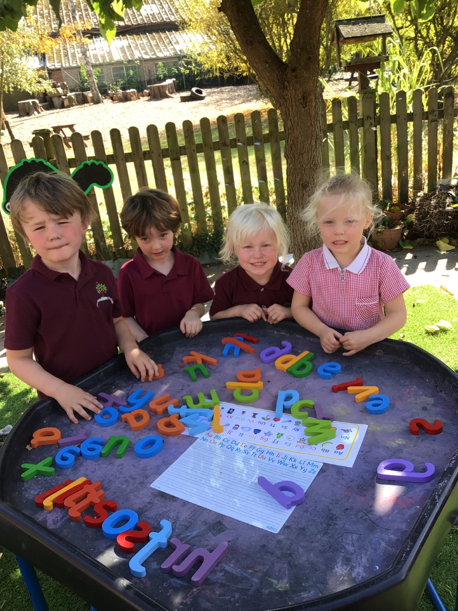

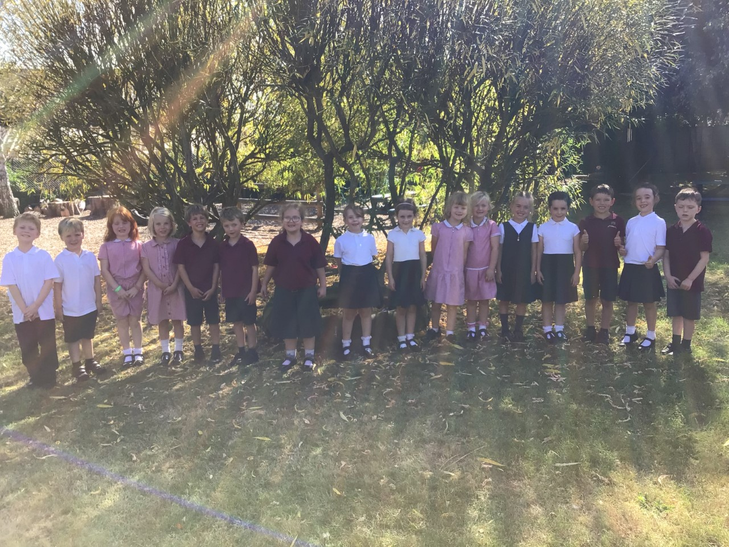

The Willows first star of the week are all our new Receptions. You have all settled in really well to Woodton Primary and have risen to the challenge of being in school. Our second star is all of Year 1 & Year 2. You have come back to school with positive mindsets, being caring and nurturing towards each other and wowing me with your brilliance.

Oaks

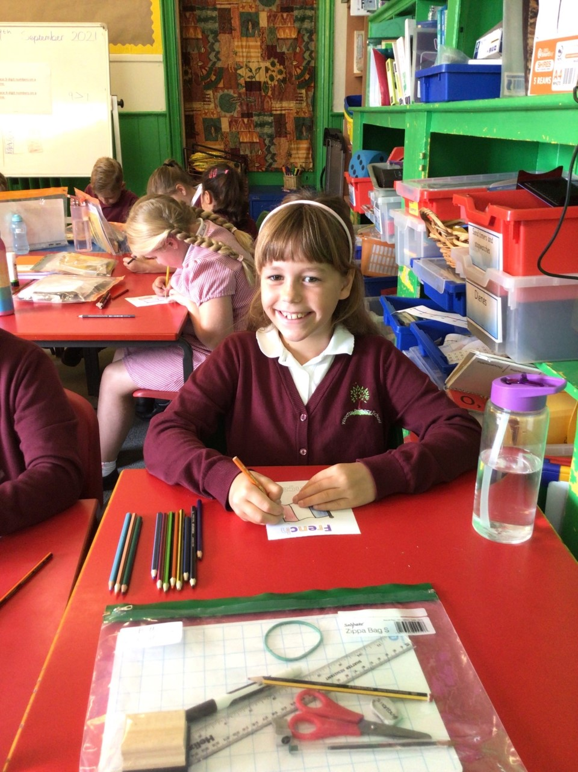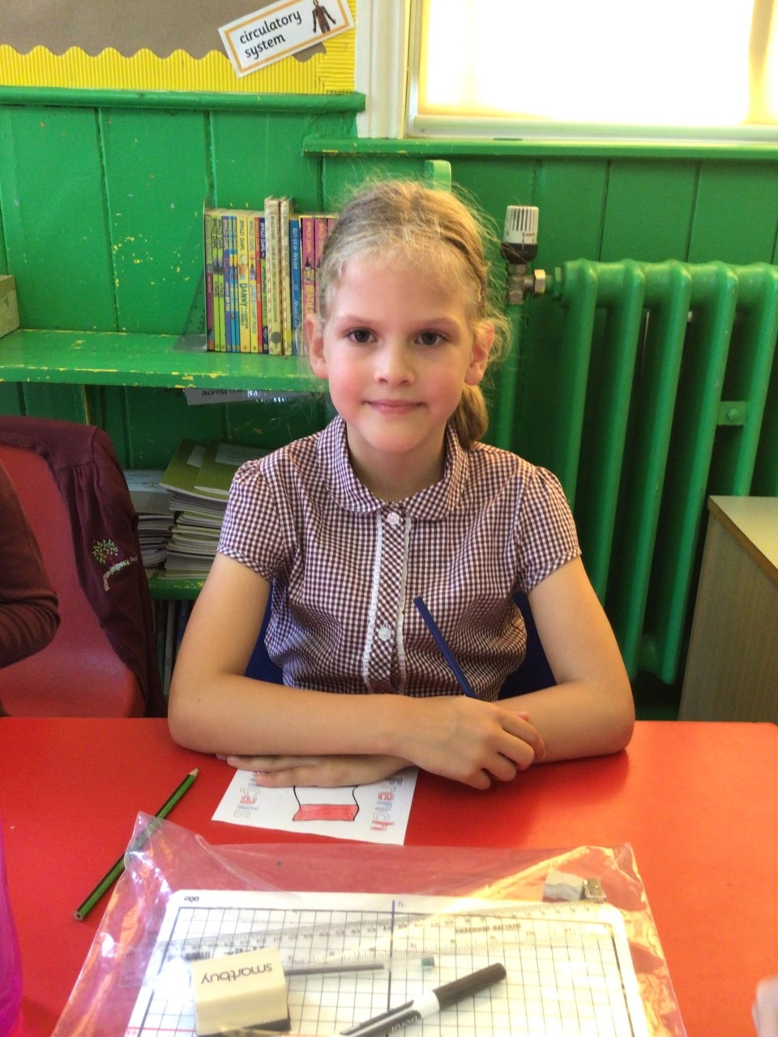

Betty is one of our stars of the week for working hard and settling into the new term amazingly. She has challenged herself with the work she has been set and inspired the other Oaks to do so too. Ava is also our star of the week because she has settled into KS2 so well. She has tried her best and worked her hardest this week. Well done girls!

Maths Whizz Wonders

**Amazing Usage** –

Willows – Charlie L, Paige & Hector.

Oaks – Betty, Illiana & William.

**Brilliant progressions** -

Willows – Hector, Florence & Ada.

Oaks – Charlie C, Lily W & Betty.

Overall Winner for this week is **Willows**

CONGRATULATIONS.



Time Table Olympics Awards

Coming Soon



House Point totals for this week

Stephen Hawkings – 21

Beatrix Potter – 34

Benjamin Britten – 24

Kelly Holmes – 25

Congratulations to all our celebration superstars this week. Well done for all your amazing effort

# Celebration Newsletter