Willows

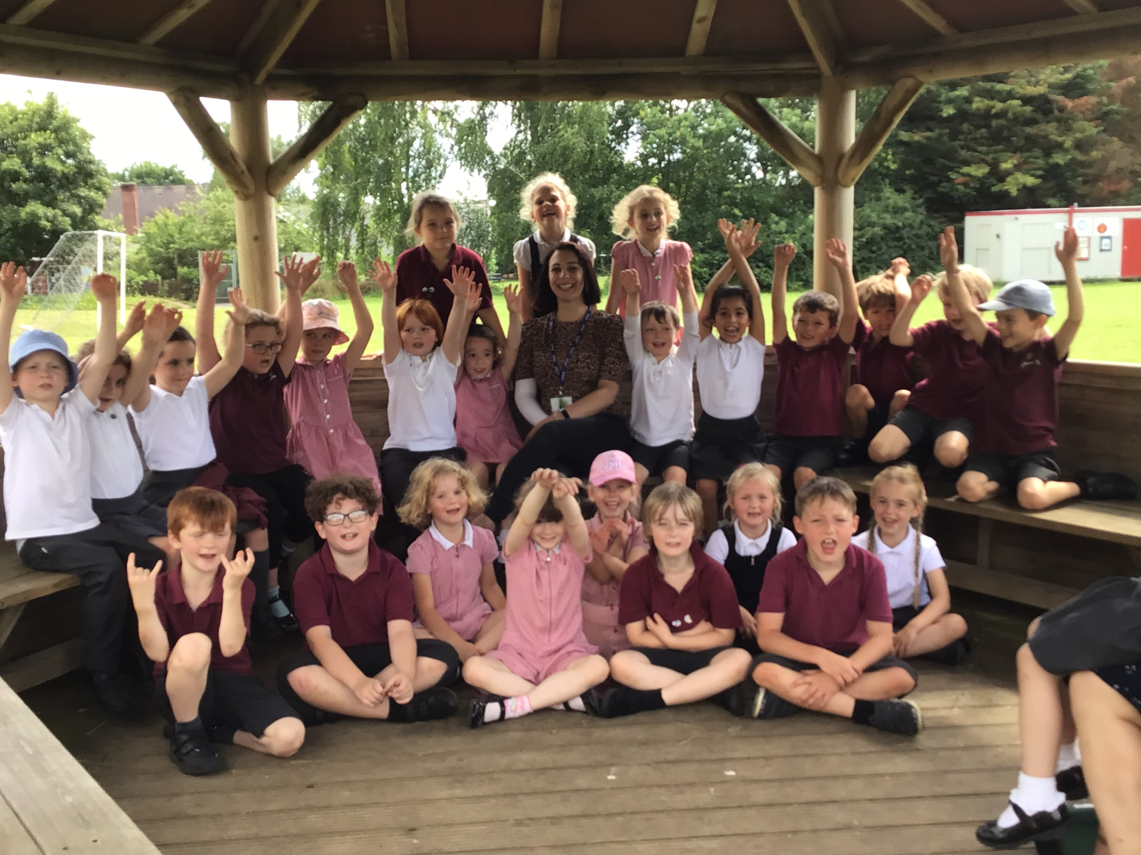

This week's star of the week is all of Willows.  Throughout this academic year you have demonstrated resilience in your home learning, you have been challenged in school and at home, you are nurturing and respectful to your friends and staff at the school on a daily basis.  You have been inspirational to me, and I can only hope to aspire to be as amazing as you all are!  Willows, you have all made me so proud this year.

Oaks

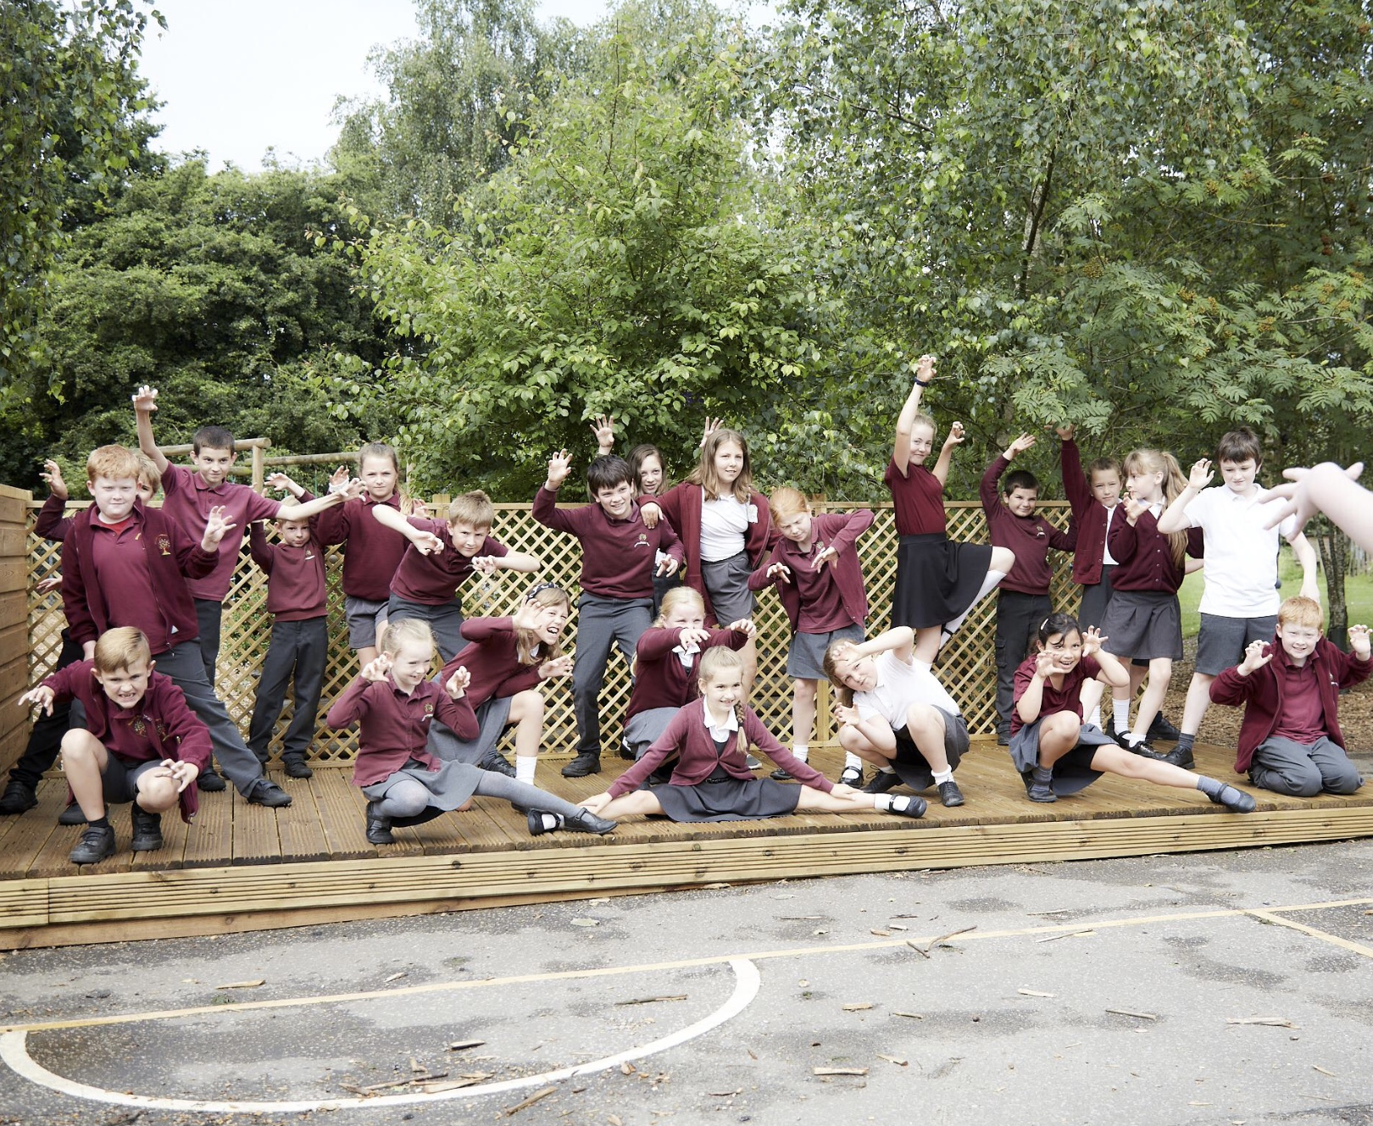

This week our stars of the week are the whole of oaks. You have all been incredible and worked SO hard with the production even more so when you had to re-film parts. Well done guys, we are so proud of you!

**Stars of the Week**

Maths Whizz Wonders

**Amazing Usage** –

Willows – Charlie C, Simran & Anya.

Oaks – Lacy, Leila & Myles.

**Brilliant progressions** -

Willows – Anya, Charlie T & Woody.

Oaks – Myles, Lacy & Henry.

Overall Winner for this week is **Oaks**,

CONGRATULATIONS.



Time Table Olympics Awards

Congratulations to….

European: Miley

Olympic: Georgina and Lily W

Bronze: Soloman

Finalist: George H



Congratulations to all our celebration superstars this week. Well done for all your amazing effort

# Celebration Newsletter