Willows

In Willows, our stars of the week are Lonnie for always giving 100% and trying his hardest, Rupert for his positive attitude towards learning and Charlie L and Florence for trying hard to code and helping others.

Well done all of you!

**Stars of the Week**

# Celebration Newsletter

Oaks

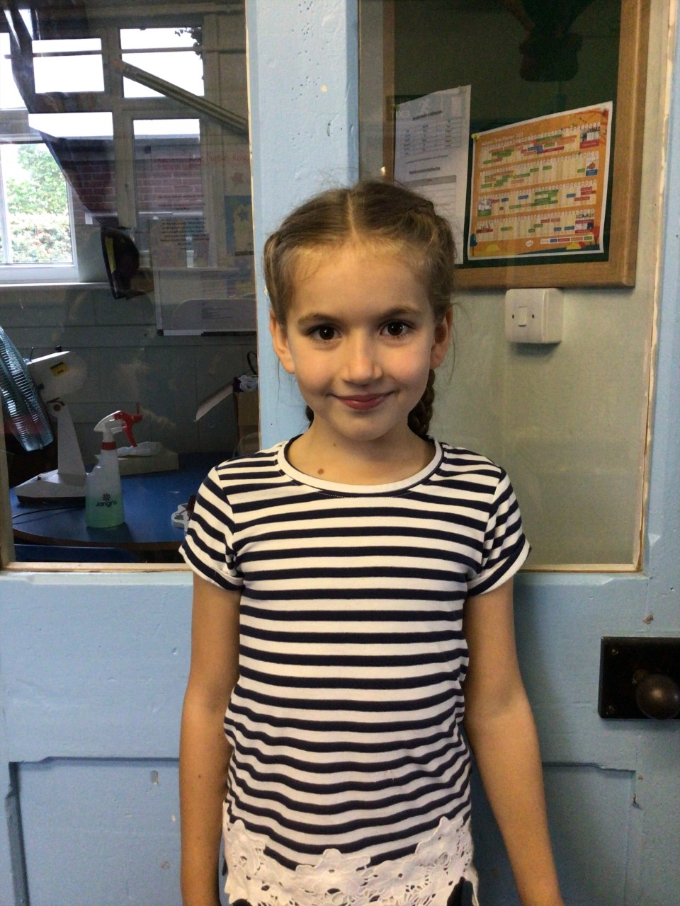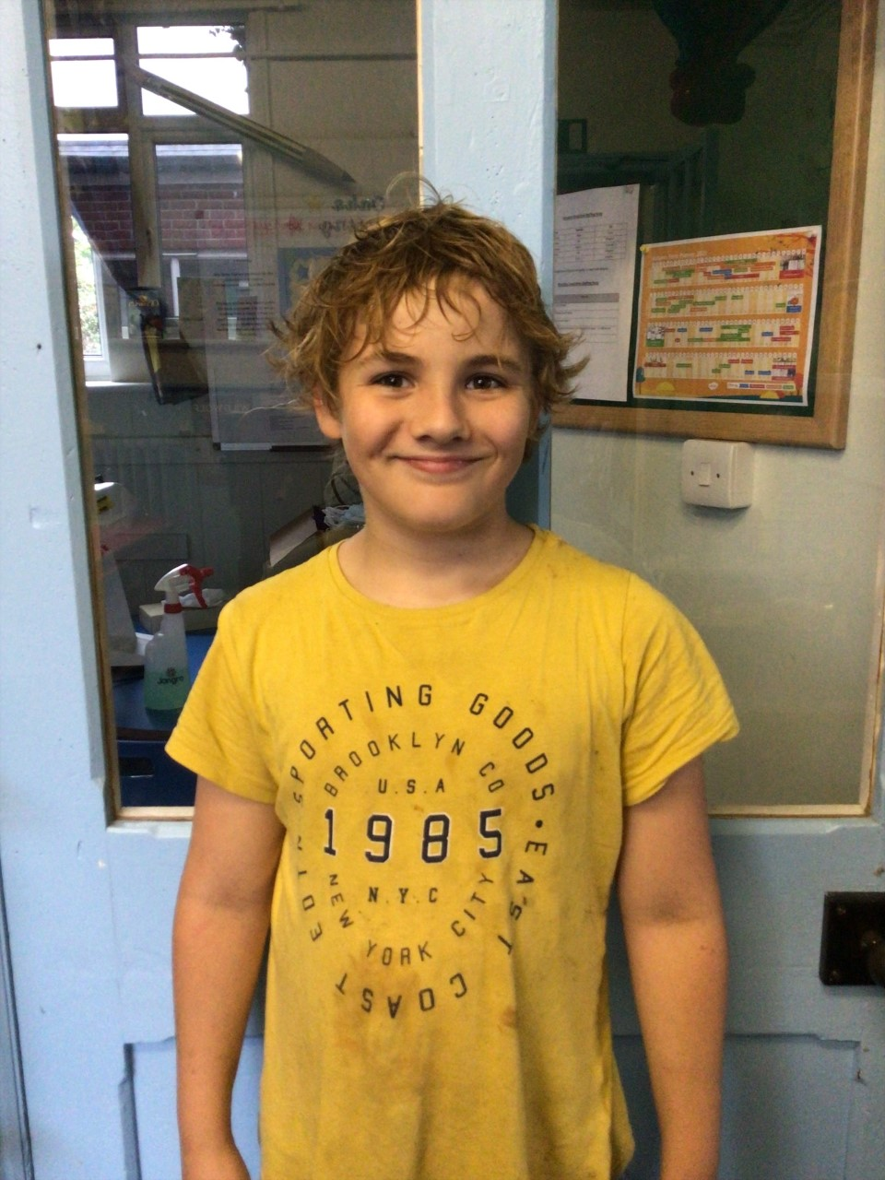

This week our first star of the week is Solomon. Solomon has wowed us this week by persevering in swimming and being moved up into the top swimming set.

Our second star is Illiana! Illiana always tries her hardest and works to the best of her ability with a positive mind-set.

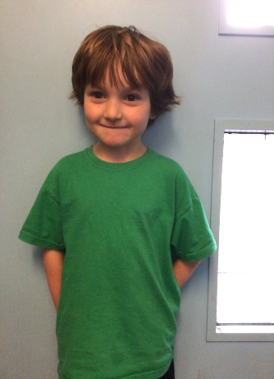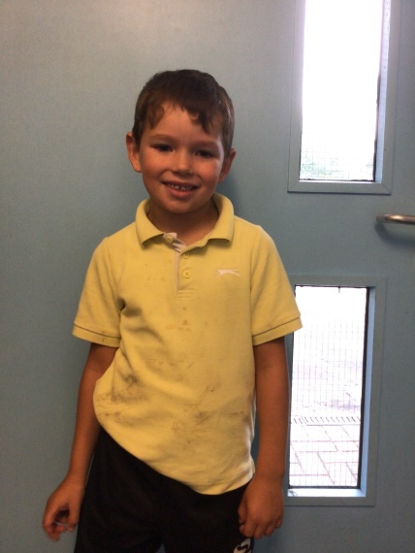

# 

House Point totals for this week

Stephen Hawkings – 176

Beatrix Potter – 188

Benjamin Britten – 193

Kelly Holmes – 194

**Class Attendance**

Willows – 94.44 %

Oaks - 97.89 %

**Well done to all of OAKS CLASS.**





Maths Whizz Wonders

**Brilliant progressions** -

Willows – Paige T & Maisy.

Oaks – Riley, Charlie C & Henry.

Overall Winner for this week is **Oaks**

CONGRATULATIONS.