Willows

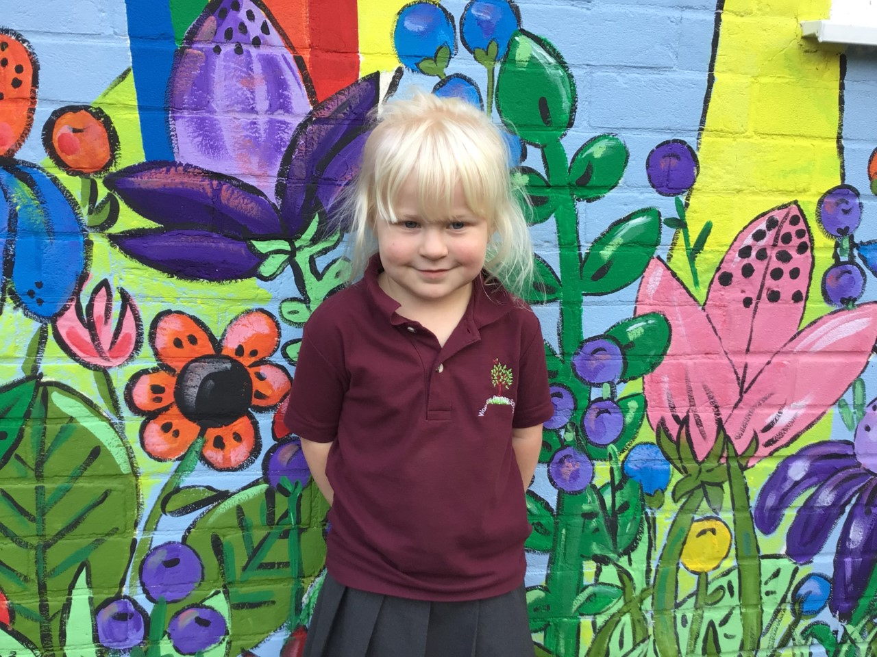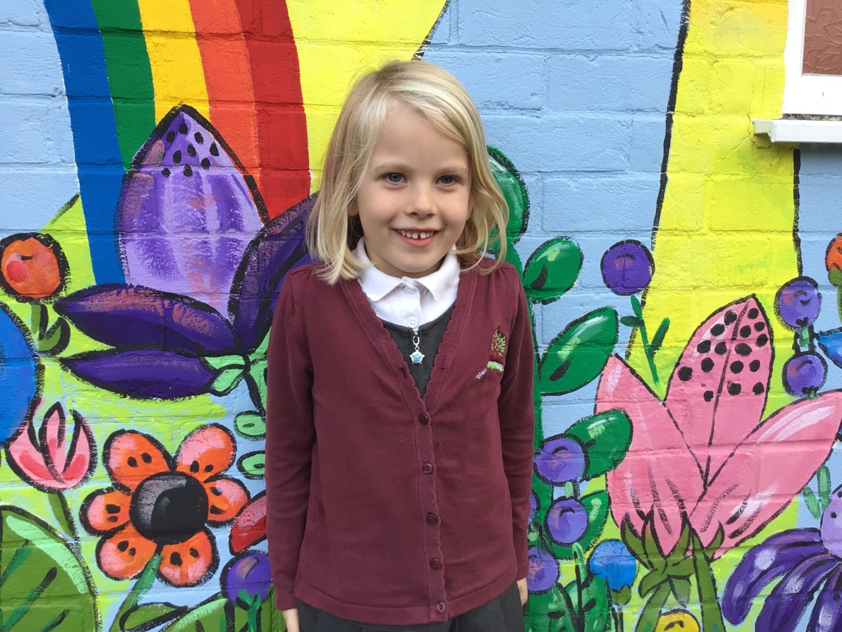

Millie is a star this week.  She has been amazing us with her marvellous maths.  Keep it up Millie.

Aria is wowing us with her amazing work and always trying her hardest.  Fantastic Aria.

Maisy is a superstar!  She always wants to challenge herself in her learning and astounds us with her wonderful attitude towards learning.

Oaks

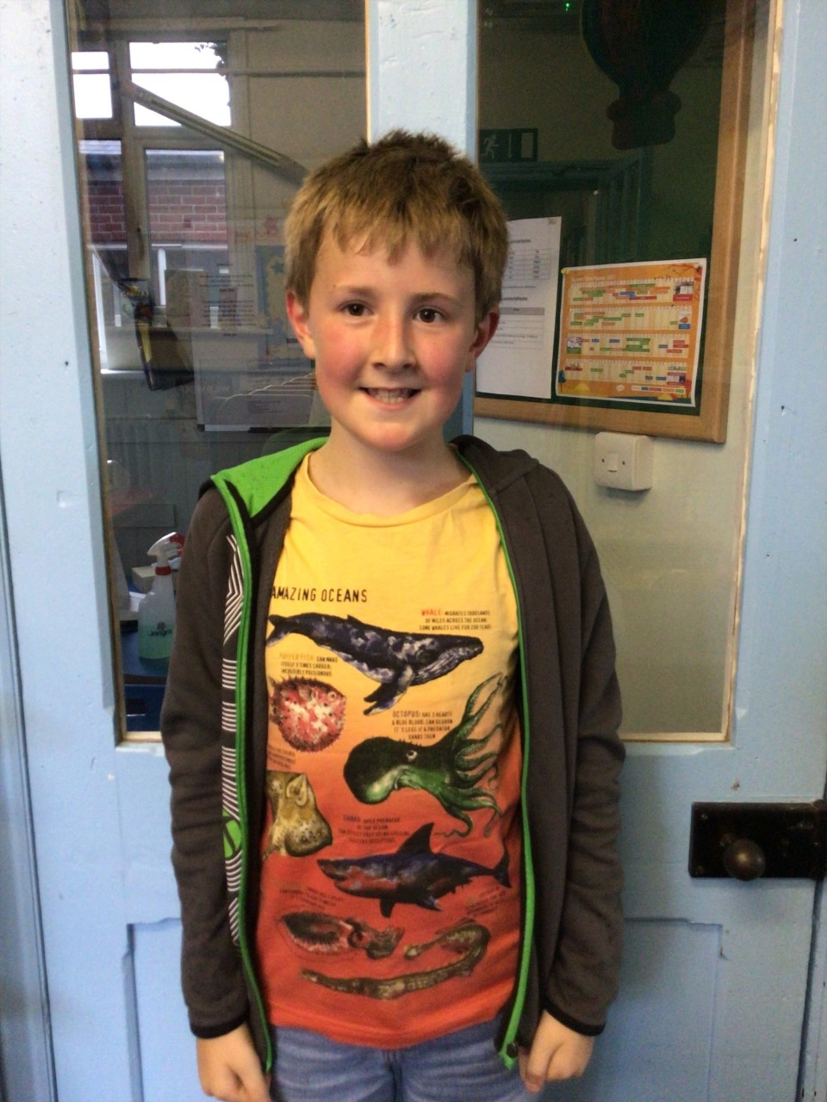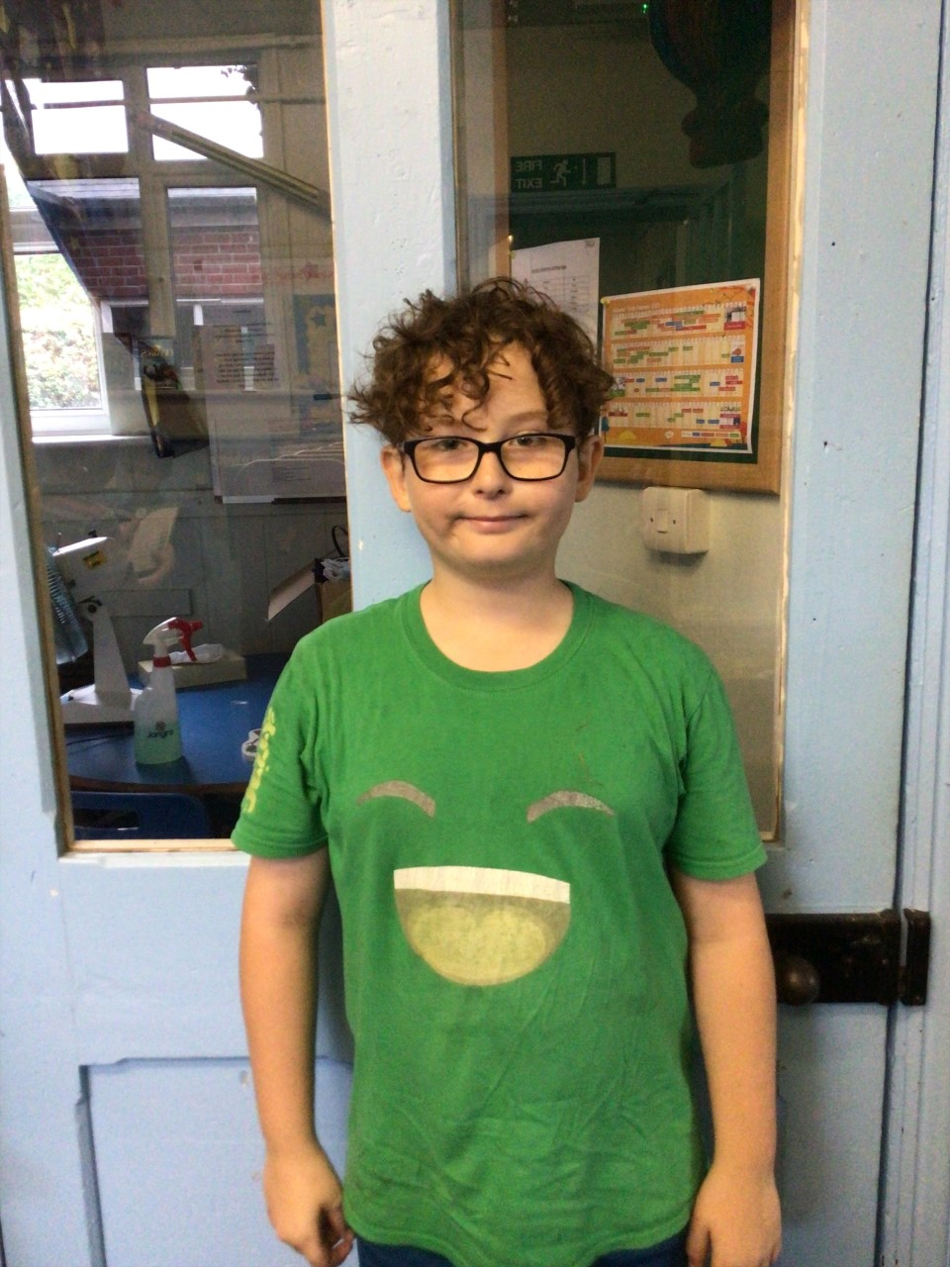

Oaks stars of the week

Jesse for great determination in his learning. He has been working independently and has really challenged himself all week! Well done Jesse.

Feliks has worked super hard this week particularly in RE. He shared some lovely ideas and inspired the others in Oaks to share their own ideas too!

**Stars of the Week**

# Celebration Newsletter



**Class Attendance**

Willows – 96.03 %

Oaks - 99.48 %

**Well done to all of OAKS CLASS.**

House Point totals for this week

Stephen Hawkings – 344

Beatrix Potter – 373

Benjamin Britten – 365

Kelly Holmes – 401

Maths Whizz Wonders

**Brilliant progressions** -

Willows – Maisy, Flo & Emmie.

Oaks – Charlie T, Lucas & Felicity G.

Overall Winner for this week is **Willows**

CONGRATULATIONS.

We would like to say a big THANK YOU to everyone that donated a shoebox for the Samartians Christmas Appeal.

