Willows

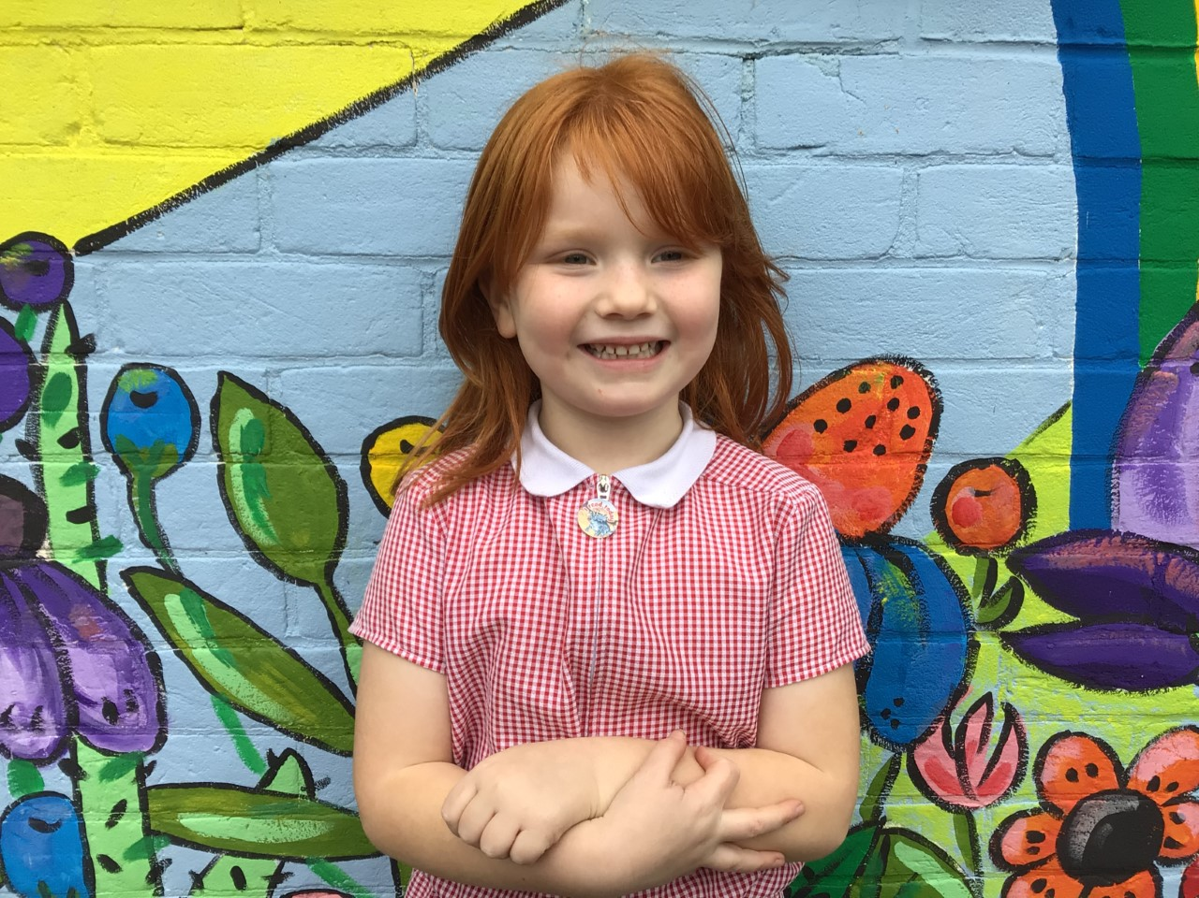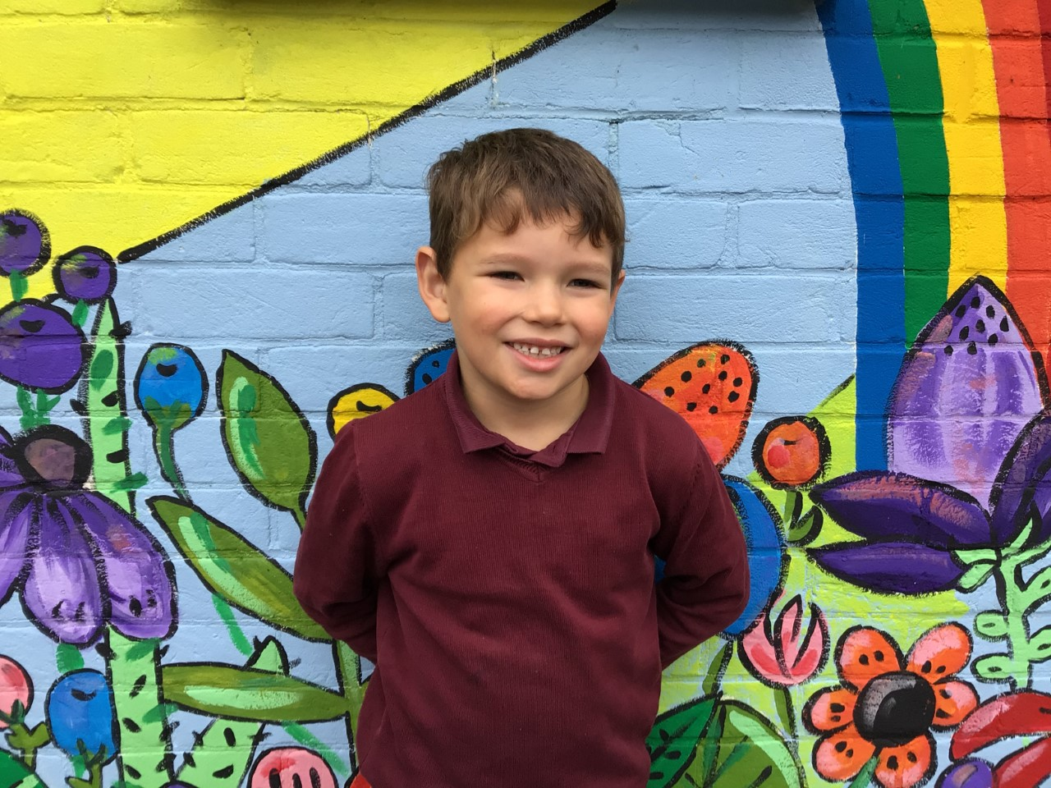

In Willows, our stars of the week are Crystal for challenging herself in her phonics writing and Rupert for always trying his hardest with his learning and challenging himself.

Well done both of you!

Oaks

This week Oaks stars of the week are Amelia for always having great positive attitude in class. Well done Amelia, your lovely outlook makes us all smile!

Nora for consistently putting fantastic effort into all of her learning. Keep it up! we’re really proud of you!

**Stars of the Week**

# Celebration Newsletter

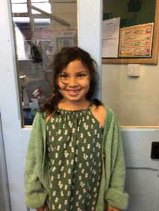

House Point totals for this week

Stephen Hawkings – 176

Beatrix Potter – 188

Benjamin Britten – 193

Kelly Holmes – 194

Maths Whizz Wonders

**Brilliant progressions** -

Willows – Flo, Emmie & Maisy.

Oaks – Leila, Phoebe & Lucas.

Overall Winner for this week is **Oaks**

CONGRATULATIONS.



**Class Attendance**

Willows – 95.16 %

Oaks - 91.64 %

**Well done to all of WILLOWS CLASS.**

Football Event

Well done to all the children that took part in the football event over the last few weeks, they were all amazing! Our school came 6th.

