Willows

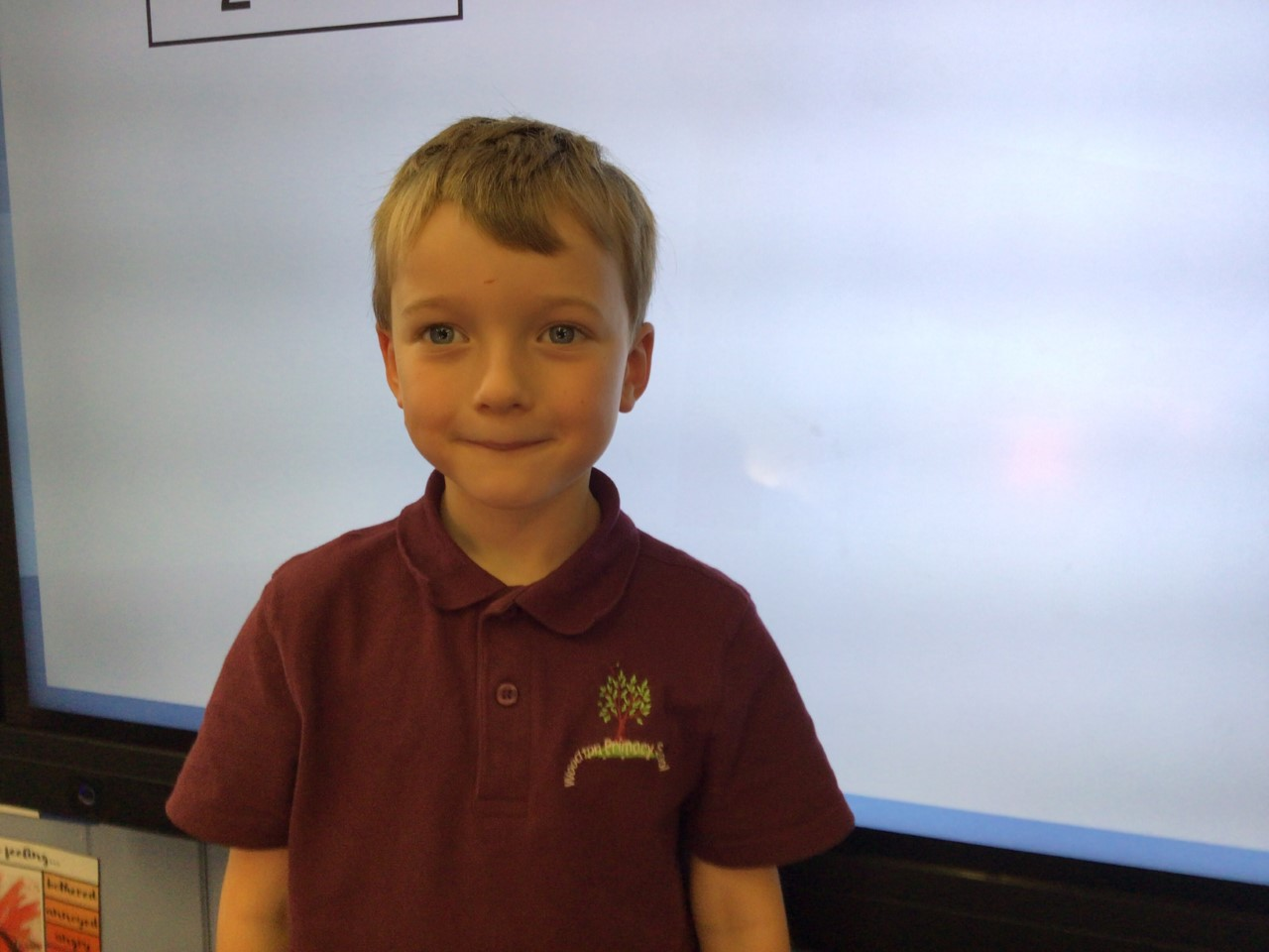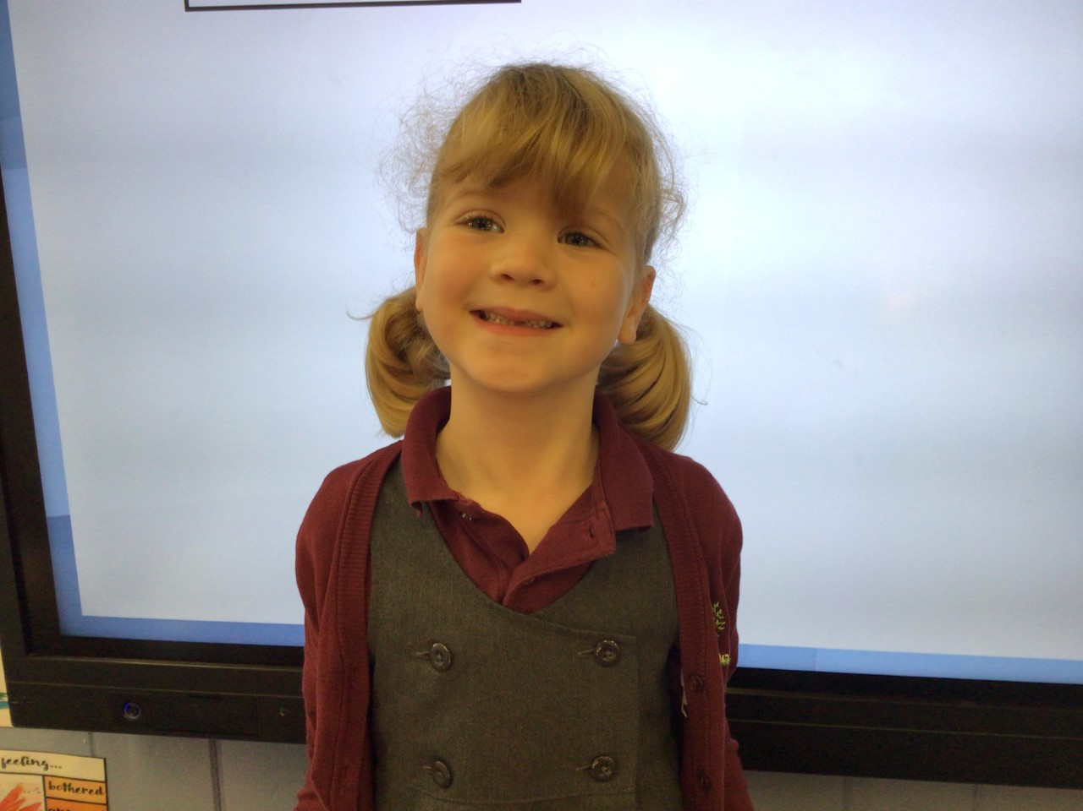

Willow is our star this week for wowing me with her maths work and challenging herself to keep her numbers in the boxes. Well done Willow.

Charlie is a superstar. He always follows the class rules and sets a great example to the others with his behaviour. He always helps and supports other children.

Oaks

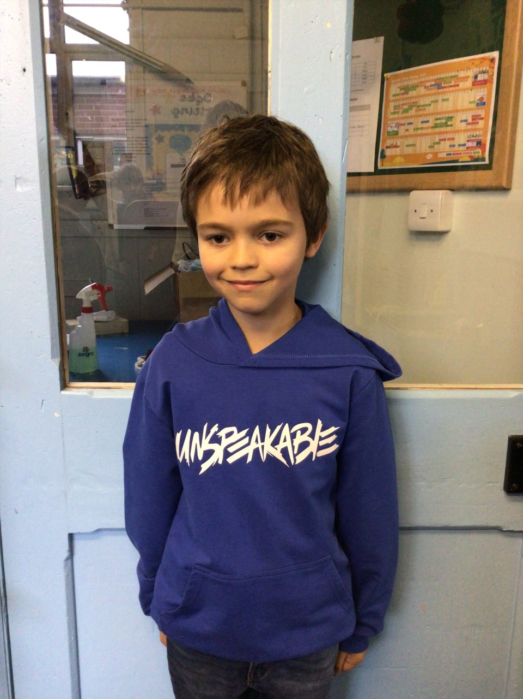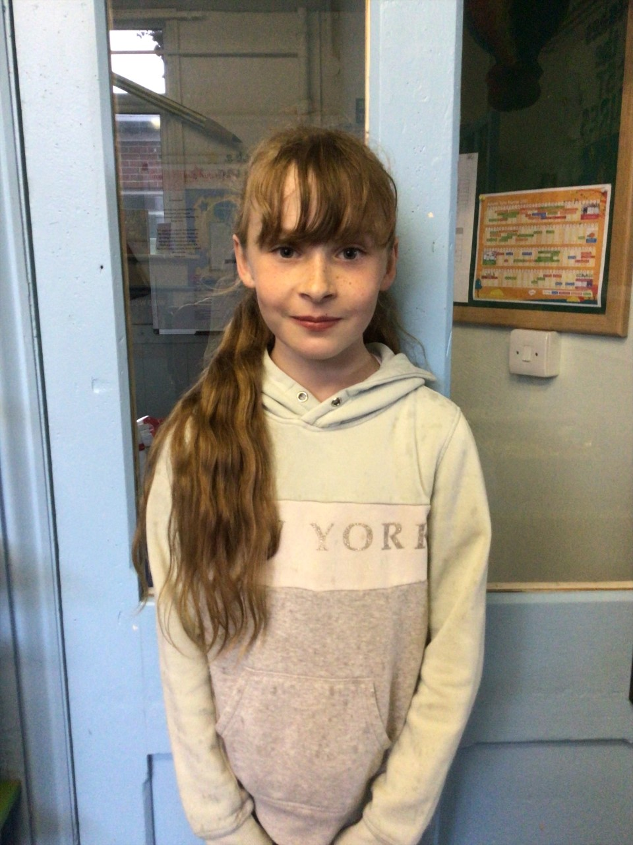

This week Oaks have chosen Charlie T! Charlie is amazing and always wows us with his work, challenging himself whenever he can!

Lily W always impresses us with her warm and kind nature towards the other children. She always goes out of her way to help others and is an amazing role model to the rest of the children in the school!

**Stars of the Week**

# Celebration Newsletter

House Point totals for this week

Stephen Hawkings – 268

Beatrix Potter – 288

Benjamin Britten – 278

Kelly Holmes – 300

Maths Whizz Wonders

**Brilliant progressions** -

Willows – Maisy, Emmie & Flo.

Oaks – Myles, Riley & Betty.

Overall Winner for this week is **Willows**

CONGRATULATIONS.



**Class Attendance**

Willows – 94.32 %

Oaks - 89.84 %

**Well done to all of WILLOWS CLASS.**

We would like to introduce our new school council.

