Oaks

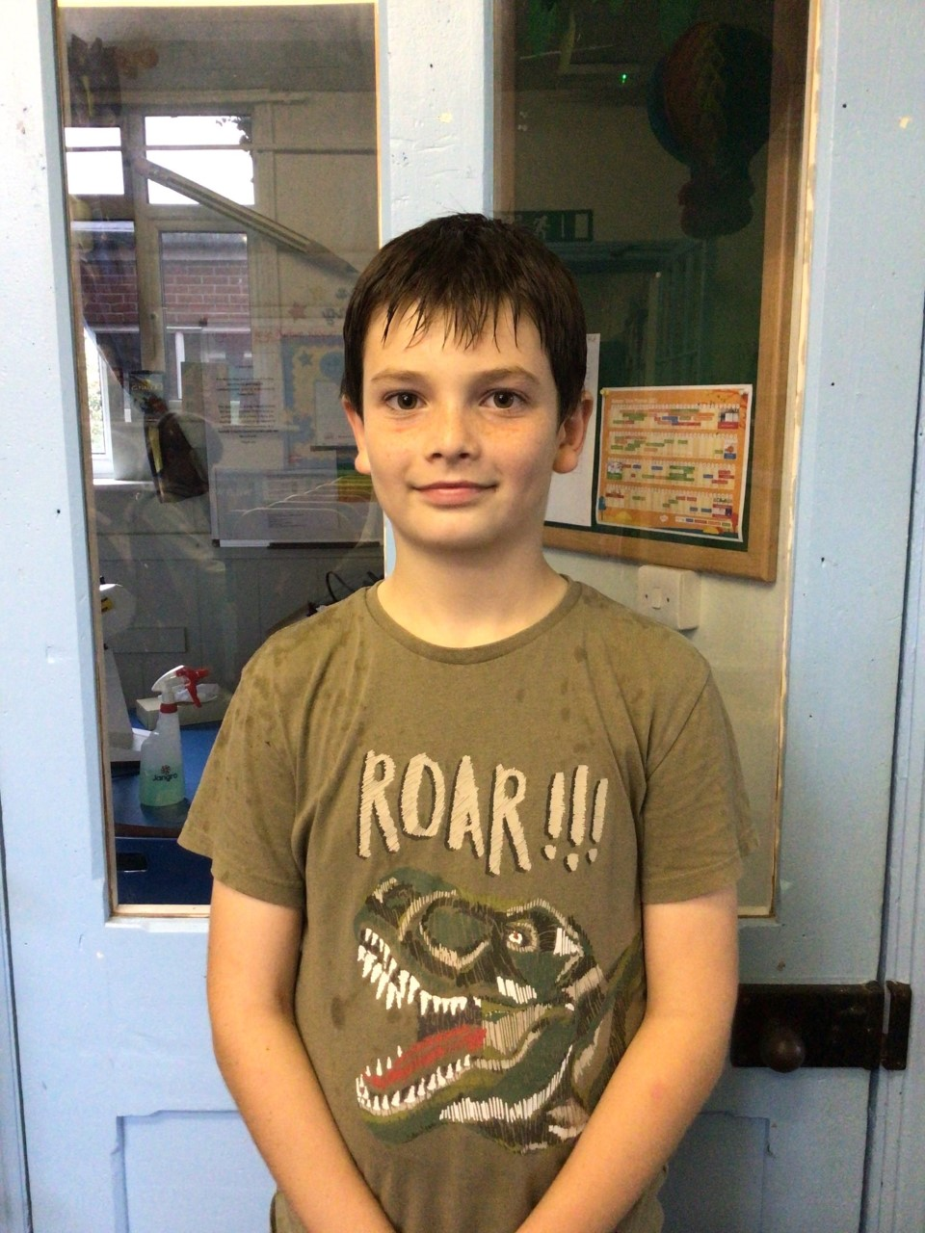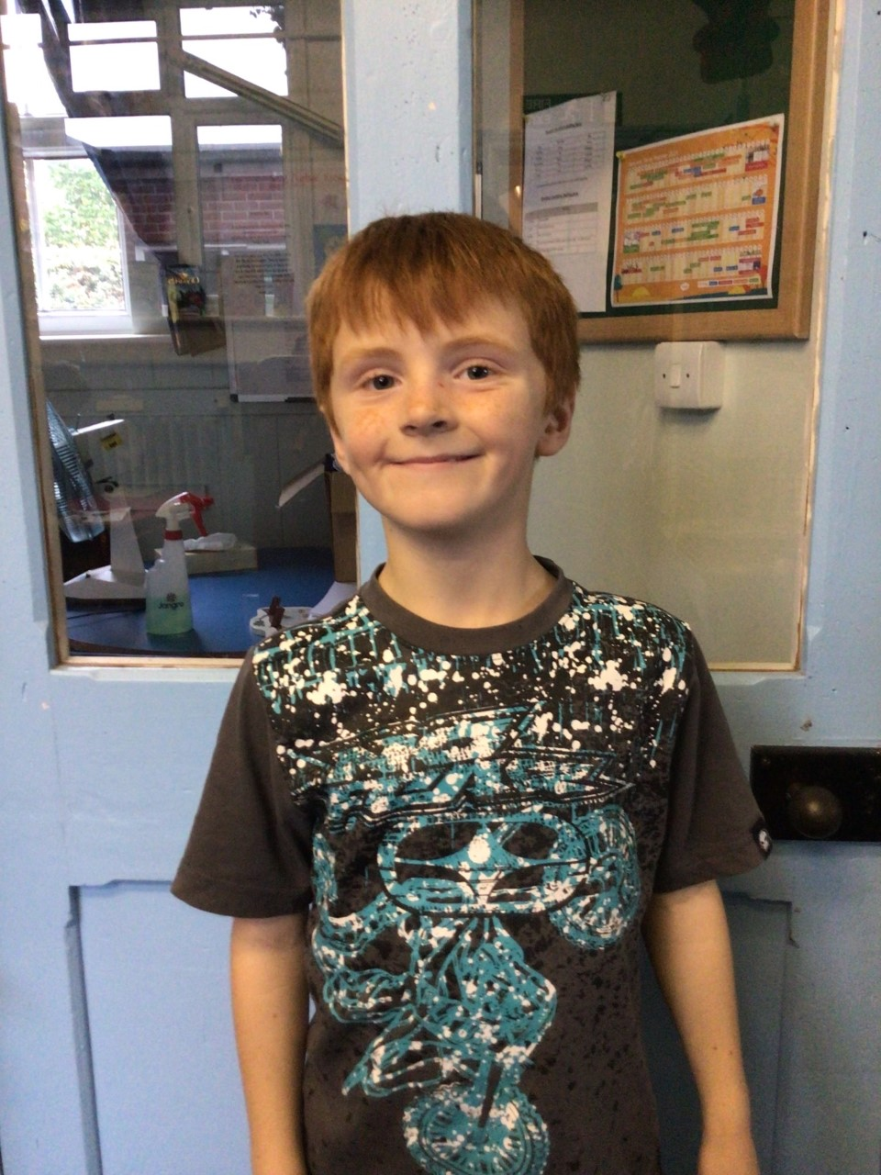

This week one of Oaks stars of the week is Charlie C. He has been showing us incredible determination in his work and has been working his hardest in everything in class! Our other star of the week is William! William wowed us with his factual knowledge when discussing Growth Mind-set. He gave some incredible facts that he has previously read and remembered as well as teaching the others in Oaks different things about their brain and memory.

**Stars of the Week**

Willows

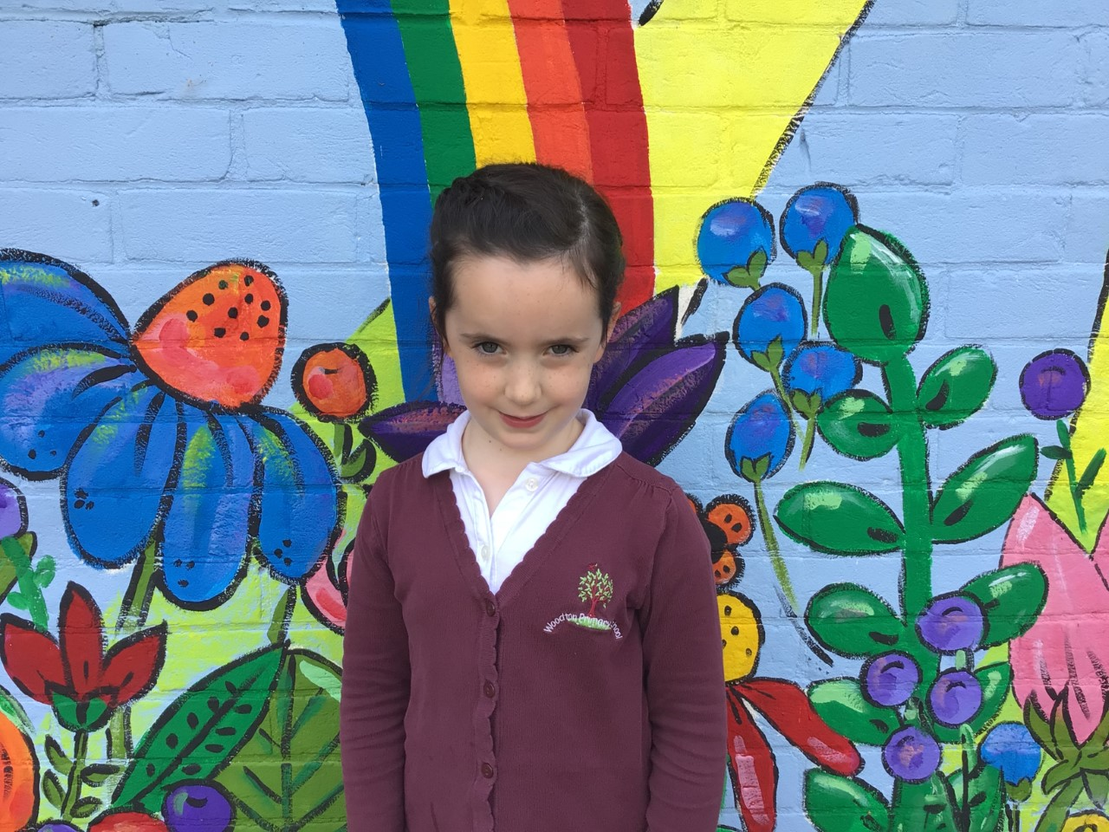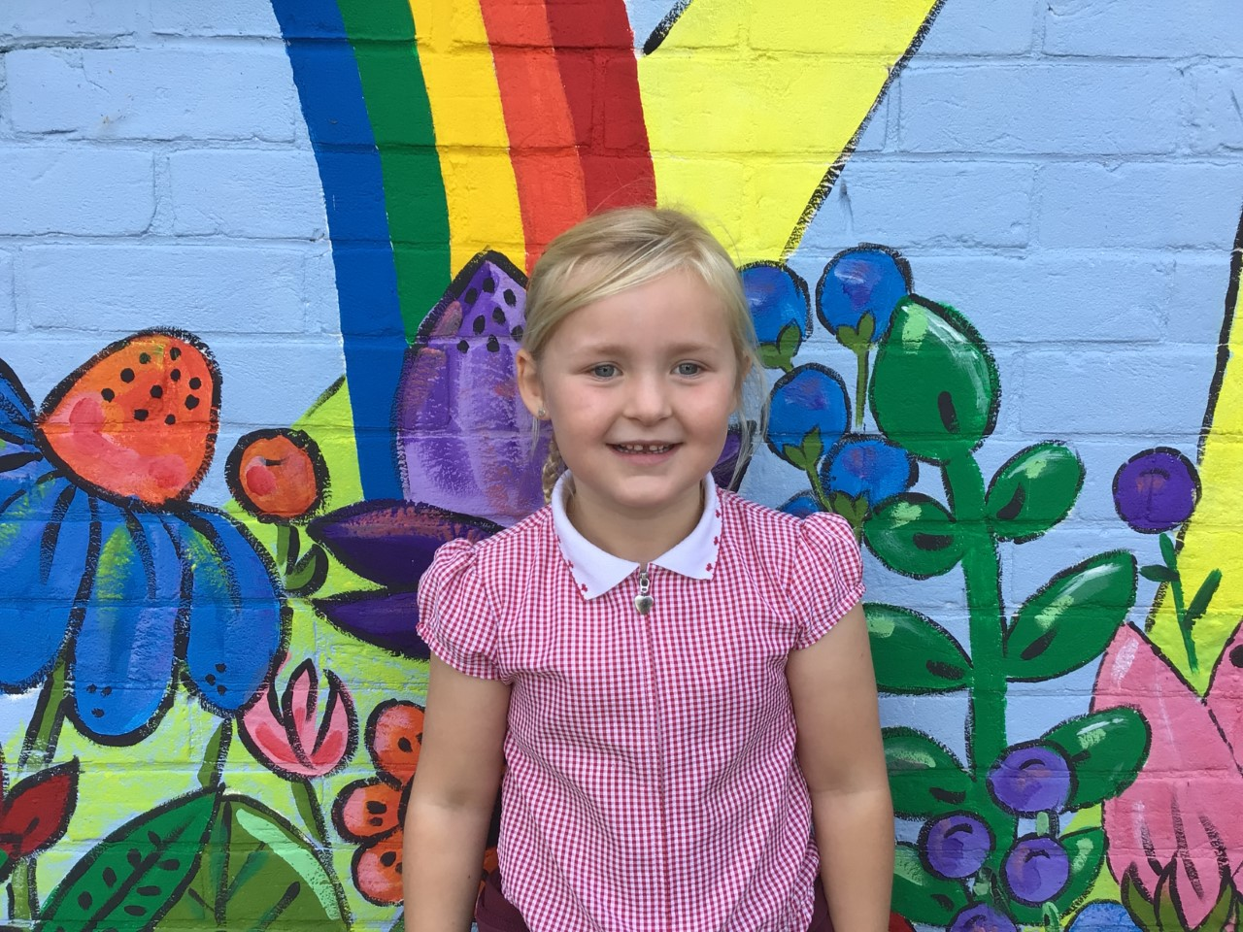

Paige has been challenging herself in all he learning this week and has demonstrated amazing understanding of using noun phrases.

Emmie has shown a positive mind-set to all her learning this week and challenging herself in her work.

# Celebration Newsletter

Maths Whizz Wonders

**Brilliant progressions** -

Willows – Charlie L.

Oaks – Felix, Myles & William.

Overall Winner for this week is **Oaks**

CONGRATULATIONS.

**Class Attendance**

Willows – 97.62 %

Oaks - 98.41 %

**Well done to all of OAKS CLASS.**



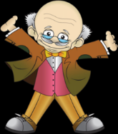

Reading Challenge:

This week Willows have won the reading challenge.

WELL DONE! 

House Point totals for this week

Stephen Hawkings – 125

Beatrix Potter – 131

Benjamin Britten – 138

Kelly Holmes – 126

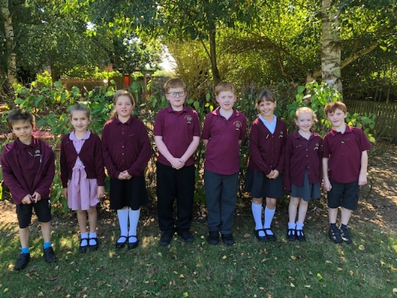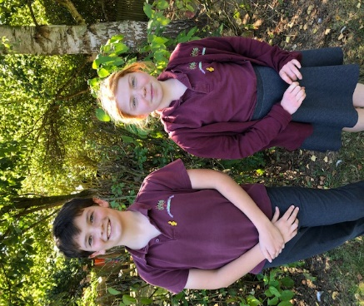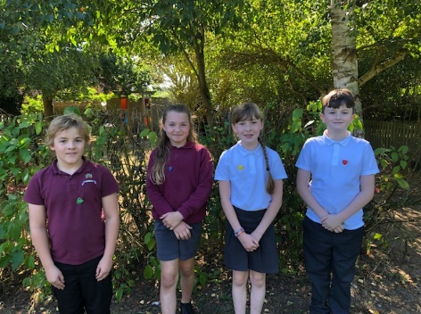

House Captains, Assembly monitors and Librarians

These are the House Captains (Lacy is now an

honorary member of Stephen Hawkins)

Our Assembly monitors

Our Librarians (James and George are

our lead Librarians)

# Celebration Newsletter