Willows

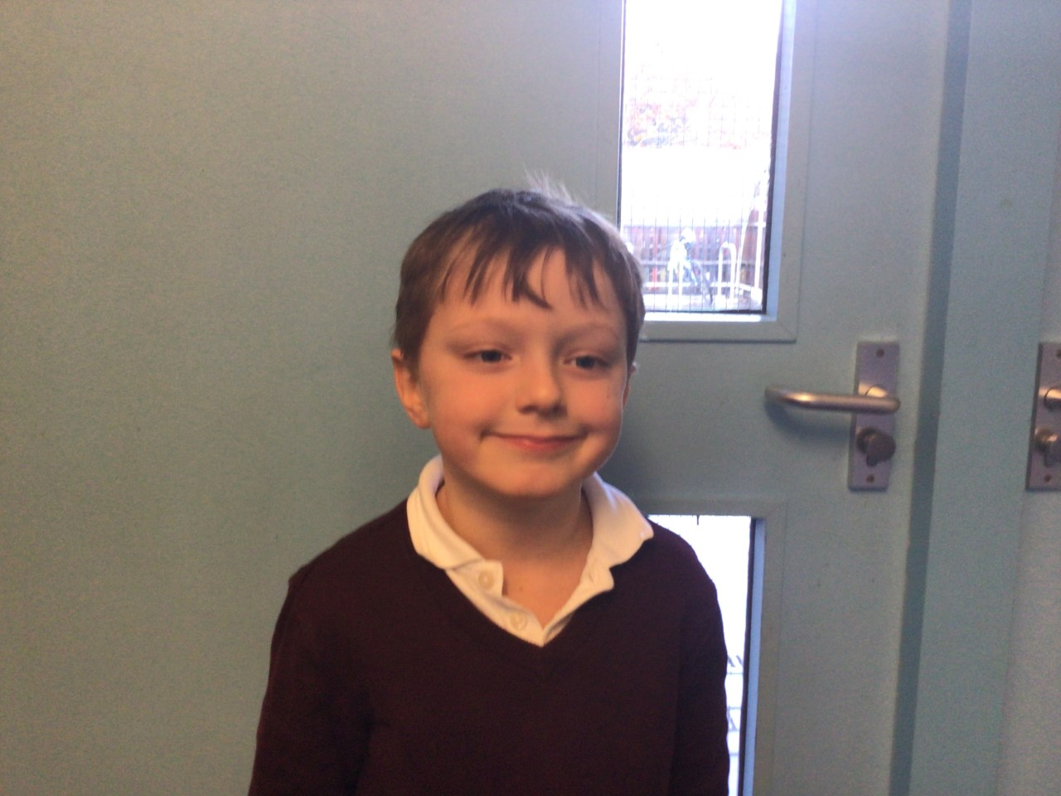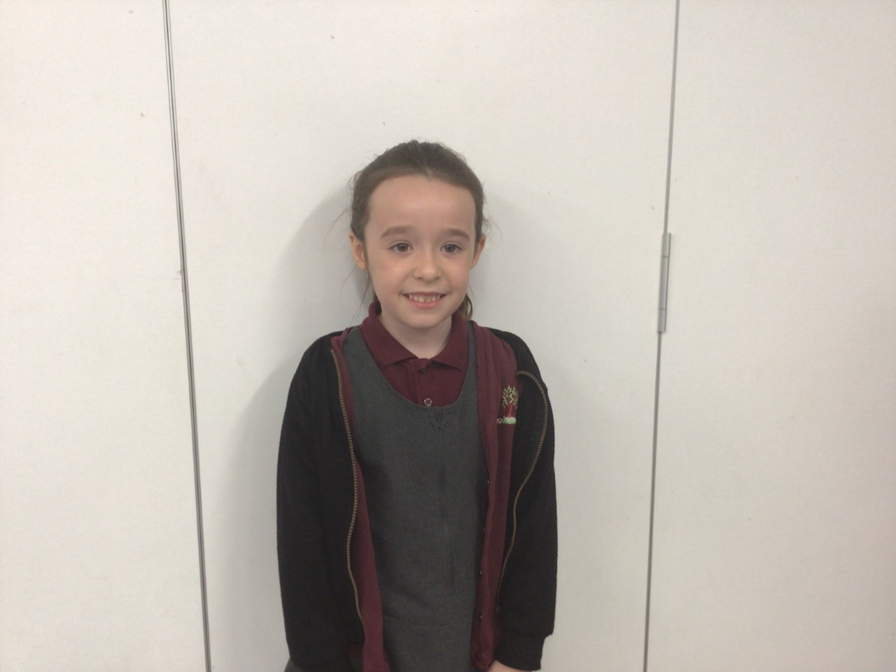

Stars of the week

Charlie has demonstrated resilience in his learning, even when he finds something tricky he perseveres and always tries his hardest.

Evie is showing great determination in her learning. She always challenges herself and aspires to be the best she can be.

Oaks

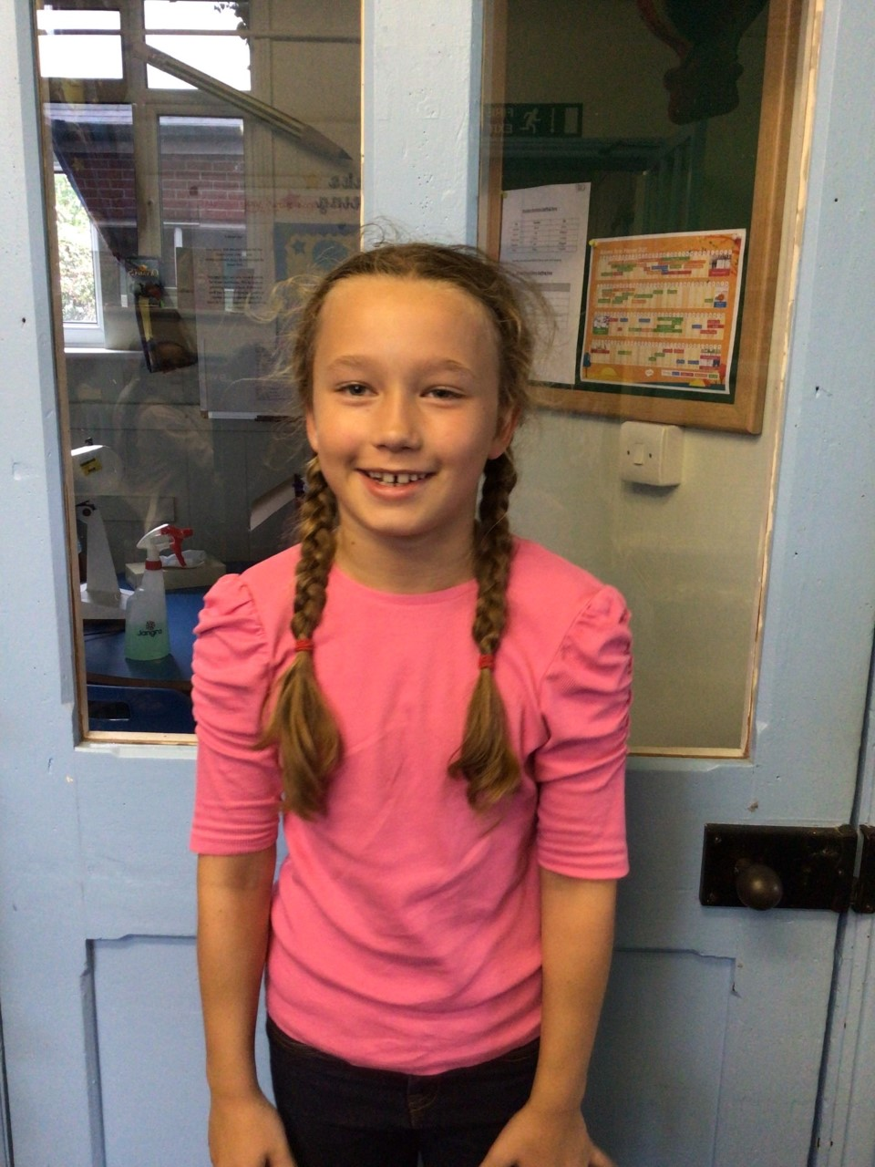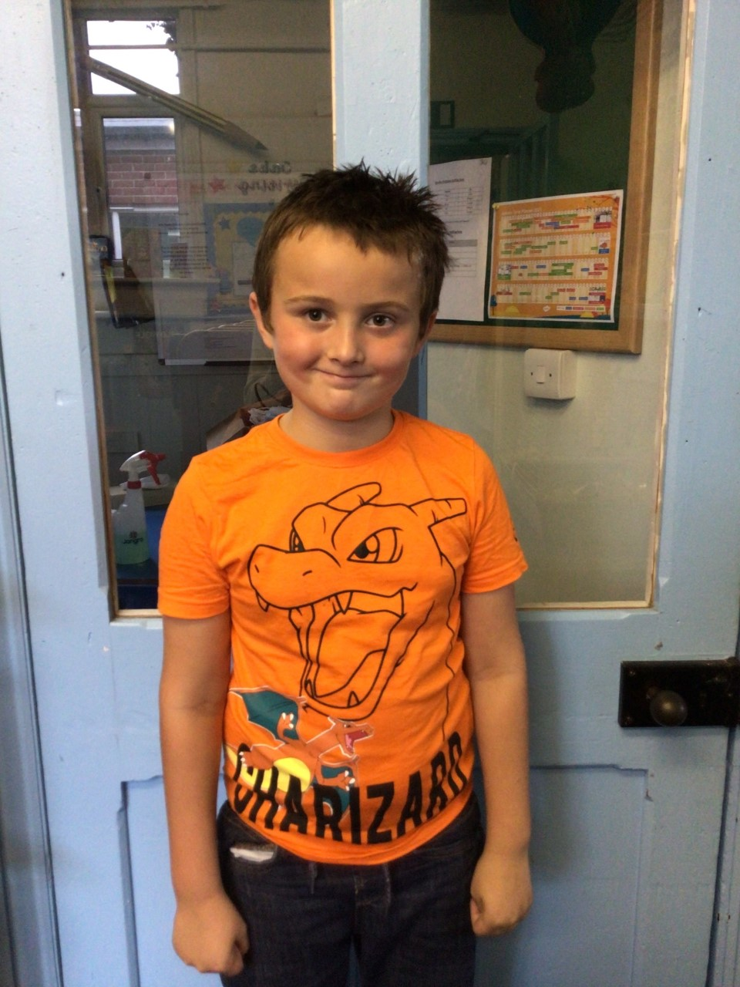

This week’s star of the week is Myles. We are so impressed with the hard work Myles always does. He is a great role model to the other children and always nurtures and supports others in class.

Our other star of the week is Felicity. Felicity always produces amazing work, she consistently shows a positive attitude towards her learning and is an all round superstar!

**Stars of the Week**

# Celebration Newsletter



**Class Attendance**

Willows – 92.26 %

Oaks - 99.11 %

**Well done to all of OAKS CLASS.**

House Point totals for this week

Stephen Hawkings – 292

Beatrix Potter – 319

Benjamin Britten – 309

Kelly Holmes – 332

Maths Whizz Wonders

**Brilliant progressions** -

Willows – Evie, Rupert & Flo.

Oaks – Lily W, Lacy W & Lucas.

Overall Winner for this week is **Willows**

CONGRATULATIONS.

Well done to all those who took part in the Cross Country event this week.

