WELLNESS
Home Life

Hello from your Wellbeing team, July 2021

A thought;

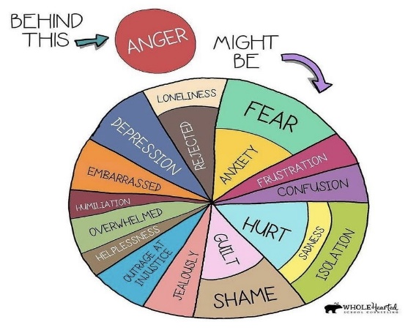
Why labelling feelings is so important

Helping children put their feelings into words can help them better navigate strong, negative emotional experiences. We tend to keep it simple when talking about feelings with young children and may often stick to the basics, such as angry, happy and sad. Once our children have mastered that, we can move on to a bigger variety of emotionally descriptive words. We can increase our child’s understanding of a bigger expanse of feelings by broadening the terms we use.

Brave Cheerful Worried Joyful Frightened Calm
Excited Confused Frustrated
Curious Friendly Shy Ignored Lonely Interested
Proud Embarrassed Jealous Angry Bored
Surprised Silly Uncomfortable
Stubborn Safe Relieved Peaceful
Overwhelmed Loving Cranky
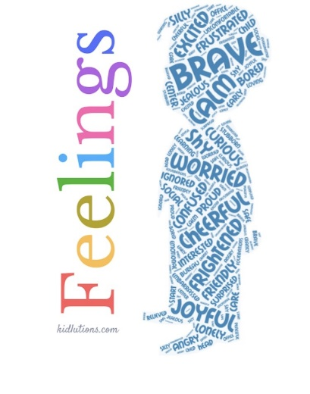
Wow, this has come round very quickly but here we are in the last full week of this academic year. This term has been very busy for the children and different in some ways with the restrictions. There will no doubt be mixed emotions about the Summer Holidays approaching, we are here if you need help or support in anyway. If you would like to contact us, please do not hesitate to email us on wellbeing@woodton.norfolk.sch.uk.

Top tip;
When your child is struggling, whether this is a meltdown, feeling sad, crying etc, sit and ask them to describe how they are feeling. Ask them to put their feelings into words. This is a known calming strategy and can help them cope with future emotions.

Support for families:
Parents reaching out (Children 11-16): parents@kooth.com
Point 1: Support for young people and their families – 0800 977 4077 or point1-support@ormistonfamilies.org.uk
Early Help hub: South Norfolk – 01508 533933
Norfolk Just One Number - www.justonenorfolk.nhs.uk or 03003000123

Anxiety

Anxiety is a normal reaction to danger. It can help you stay alert and react quickly to a threat. However, sometimes it can get in the way of the things we want to do, and that is when we need a bit of extra help.
Signs and Symptoms
Emotional Symptoms Physical Symptoms
- Feeling overly worried, nervous, restless or tense * Dizziness
- Feeling irritable/agitated * Shortness of breath/rapid breathing
- Feeling like your mind has gone blank (hyperventilation) Muscle tension
- Always watching for danger and anticipating the worst * Shaking
Irrational fears * Insomnia
- Trouble concentrating * Headaches
- Avoiding certain situations * Feeling weak or tired, panic attacks
* Avoiding social situations

There is many different ways that we can help others, or ourselves including children to ease the symptoms of anxiety.
Grounding Techniques
Grounding techniques can be useful for young people that are feeling overwhelmed by their worries.
- 5 things you can see
- 4 things you can touch
- 3 things you can hear
- 2 things you can smell
- 1 thing you can taste

The BBC and childline have put together some helpful advice support for anxiety and stress
https://www.bbc.co.uk/bitesize/articles/zfnhxbk
https://www.childline.org.uk/toolbox/calm-zone/

Signposting:
There are a range of services available to support children, young people and adults with anxiety across Norfolk & Waveney, and nationally.
Kooth – www.kooth.com
Kooth is an online counselling service for children and young people aged between 11 and 25. They can also further support via their website.
Childline – www.childline.org.uk
The childline website offers a variety of support including information, games, online counselling, Calm zone and a support took box. Children can also call for support or access online help from a counsellor.
Thinkninja – www.healios.org.uk/services/thinkninjal
This app is designed to support children and young people with their emotional wellbeing, including anxiety. Using CBT priniciples, the app also has a section on coping feelings during the coronavirus pandemic.
Young Minds – www.youngminds.org.uk
Young minds offers young people and their families information about different mental health concerns and a crisis messenger service for young people.

Wellness Tip
10 Steps to a Happy Child
- Listen when they talk
- Let them express their feelings & validate them
- Point out their strengths with compliments
- Encourage their friendships with other great kids
- Teach them to pay attention to others’ feelings
- Avoid excess screen time
- Let them have some relaxed playtime every day
- Eat dinner as a family
- Let your happiness show
- Tell them you love them – every day!
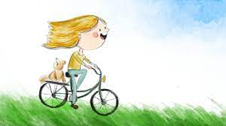

Just a thought;  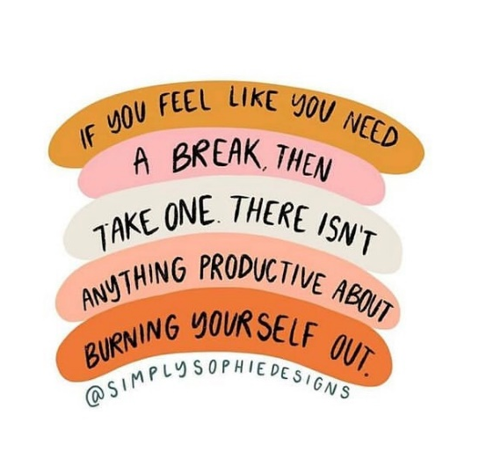 | The simple things;  Once a week for 20 minutes, sit in a hot bath that contains a handful of Epsom salts, 10 drops of lavender essential oil, and a half cup of baking soda. This combo draws out toxins, lowers stress-related hormones, and balances your pH levels.

Supporting your child with transitioning
Young people go through all kinds of changes as they grow up – including when they move into a new class, go to secondary school, move to a new house or area, or experience changes within their family.
These times of transition can be exciting. However, they can also be stressful, worrying or upsetting.
Change can be difficult when a young person does not want it to happen or does not feel ready for it, feels worried about something new or unknown, needs time to let go of something that has ended or feels that what is happening to them is out of their control. A child or young person may also find change difficult if they are already struggling with other things.

If your child is struggling to cope with change, have a look at these practical tips to help you support them.

Act On Warning Signs
You know your child better than anybody else. It’s important to act on the warning signs if you start to feel concerned.
- Look out for a change in things like sleeping or eating habits.
- Communicate with your child if you’ve seen these signs.
- Keep going, even if it feels like you’re not getting through to them.
- Contact your GP or school about the warning signs if things don’t improve.
Be part of the solution
As a parent, be part of the solution. There are a number of things you can do to support your child, whether that be helping them plan, problem-solve, or develop a sense of hope for the future.
- Get interested in what your child is doing.
- Open up conversations about what they’re involved in.
- Keep an eye on pressure points.

Be your child's anchor
If your child is experiencing problems or going through significant change, it’s important that you can be an anchor for them.
- Being an anchor will be reassuring if things are changing.
- Maintain hobbies and routines.
- Be a sense of hope by encouraging them.
Look after yourself
It’s important you look after yourself, so you can best look after your child.
- Recognise when you’re finding things hard.
- Talk to family and friends about how things are.
- Don’t blame yourself - it is not your fault.
- Recharge your batteries and relax.
Here is a good link from the BBC, this gives support and advice in many different areas of transitioning;
https://www.bbc.co.uk/bitesize/tags/zh4wy9q/starting-secondary-school/1

