Oaks

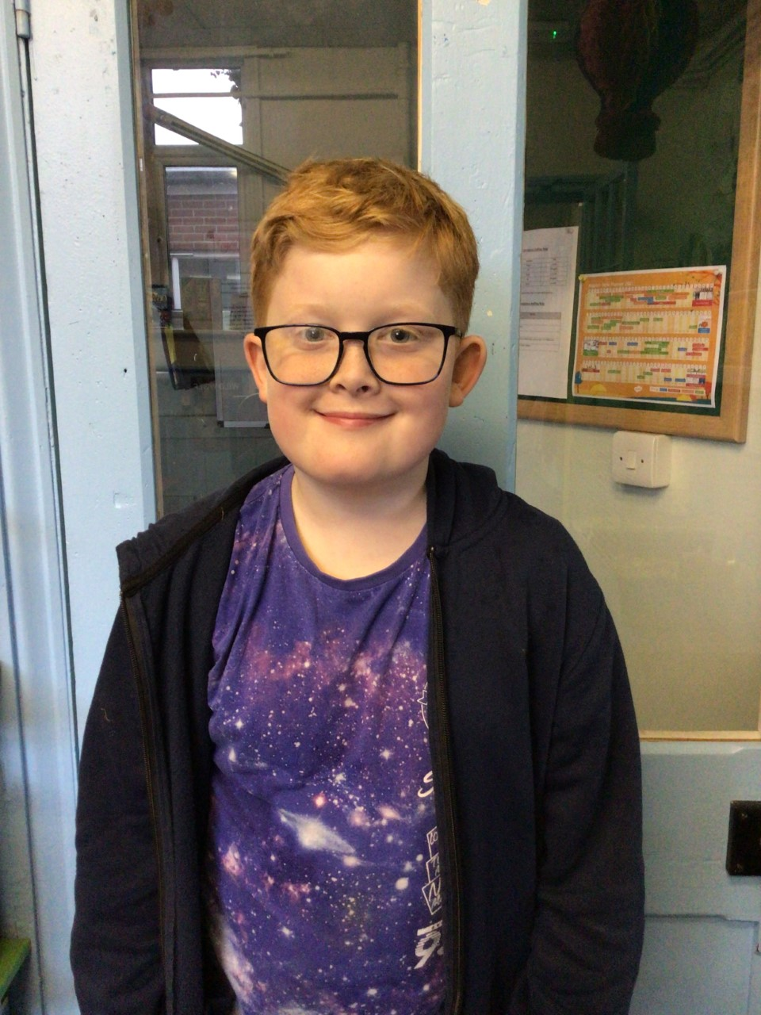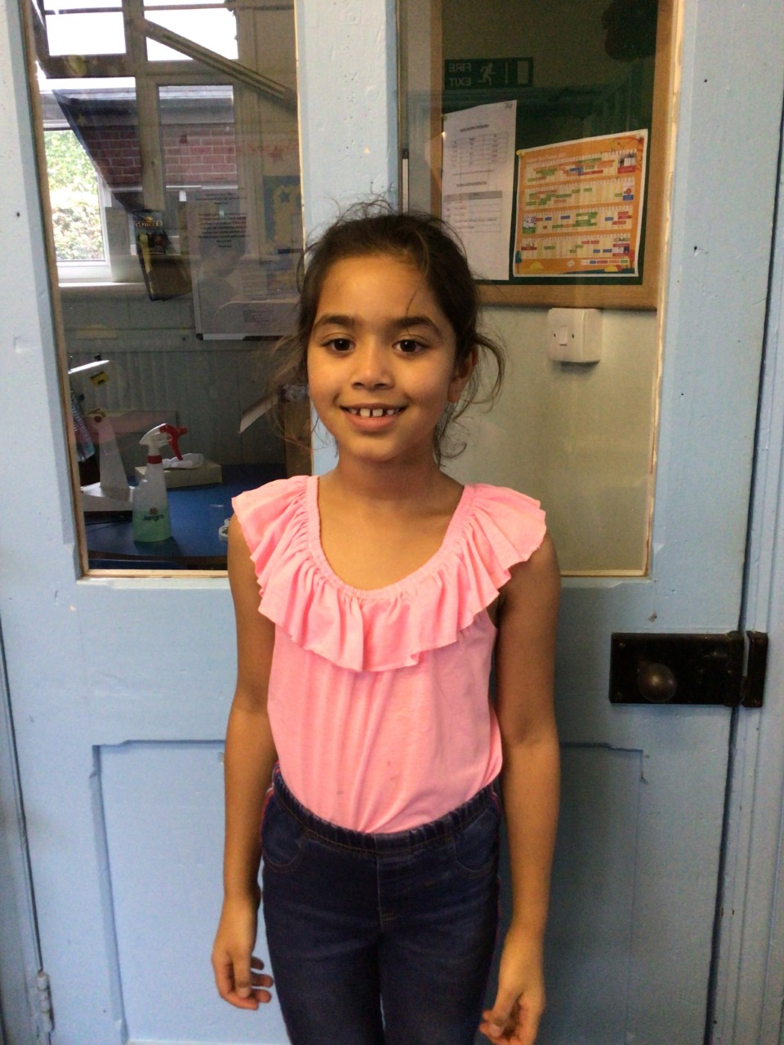

This week’s stars of the week are Simran for always trying her hardest and George for the great work in Geography.

Well done you two!

Willows

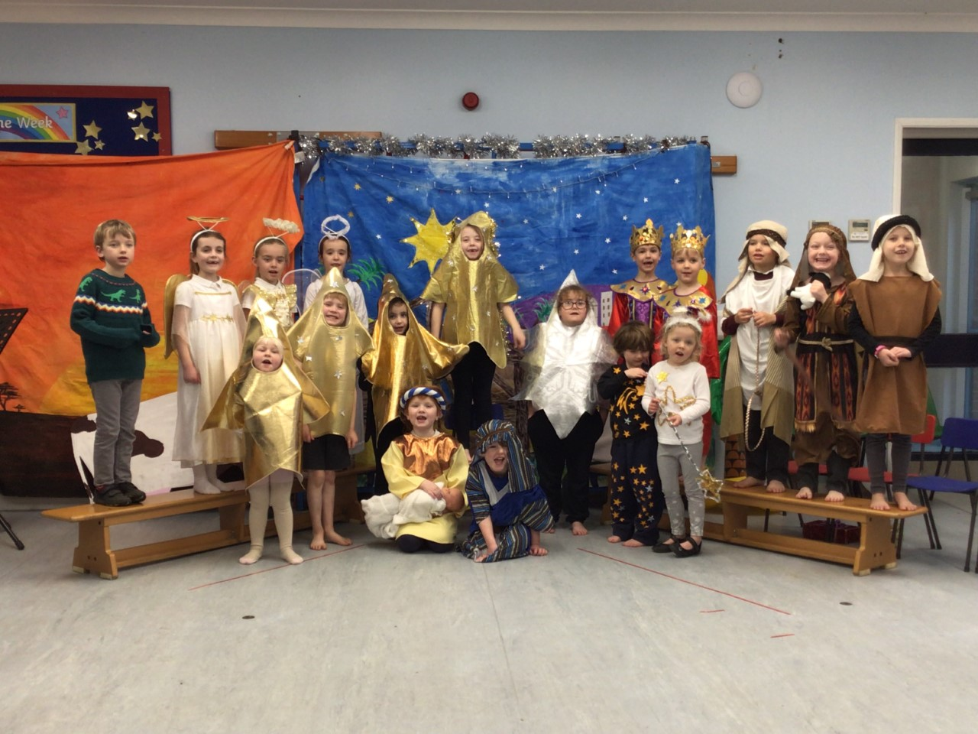

Willows are all stars this week, stars of the theatre!  They have amazed us with their amazing acting skills and beautiful singing.

Willows, you are all stars 🌟

**Stars of the Week**

# Celebration Newsletter



**Class Attendance**

Willows – 85.17 %

Oaks - 93.98 %

**Well done to all of OAKS CLASS.**

House Point totals for this week

Stephen Hawkings – 11

Beatrix Potter – 21

Benjamin Britten – 28

Kelly Holmes – 23

Maths Whizz Wonders

**Brilliant progressions** -

Willows – Maisy and Charlie W.

Oaks – Lucas, Woody & Ava.

Overall Winner for this week is **Oaks**

CONGRATULATIONS.

Reading Challenge:

Willows have WON the reading challenge.

Congratulations!

