Oaks

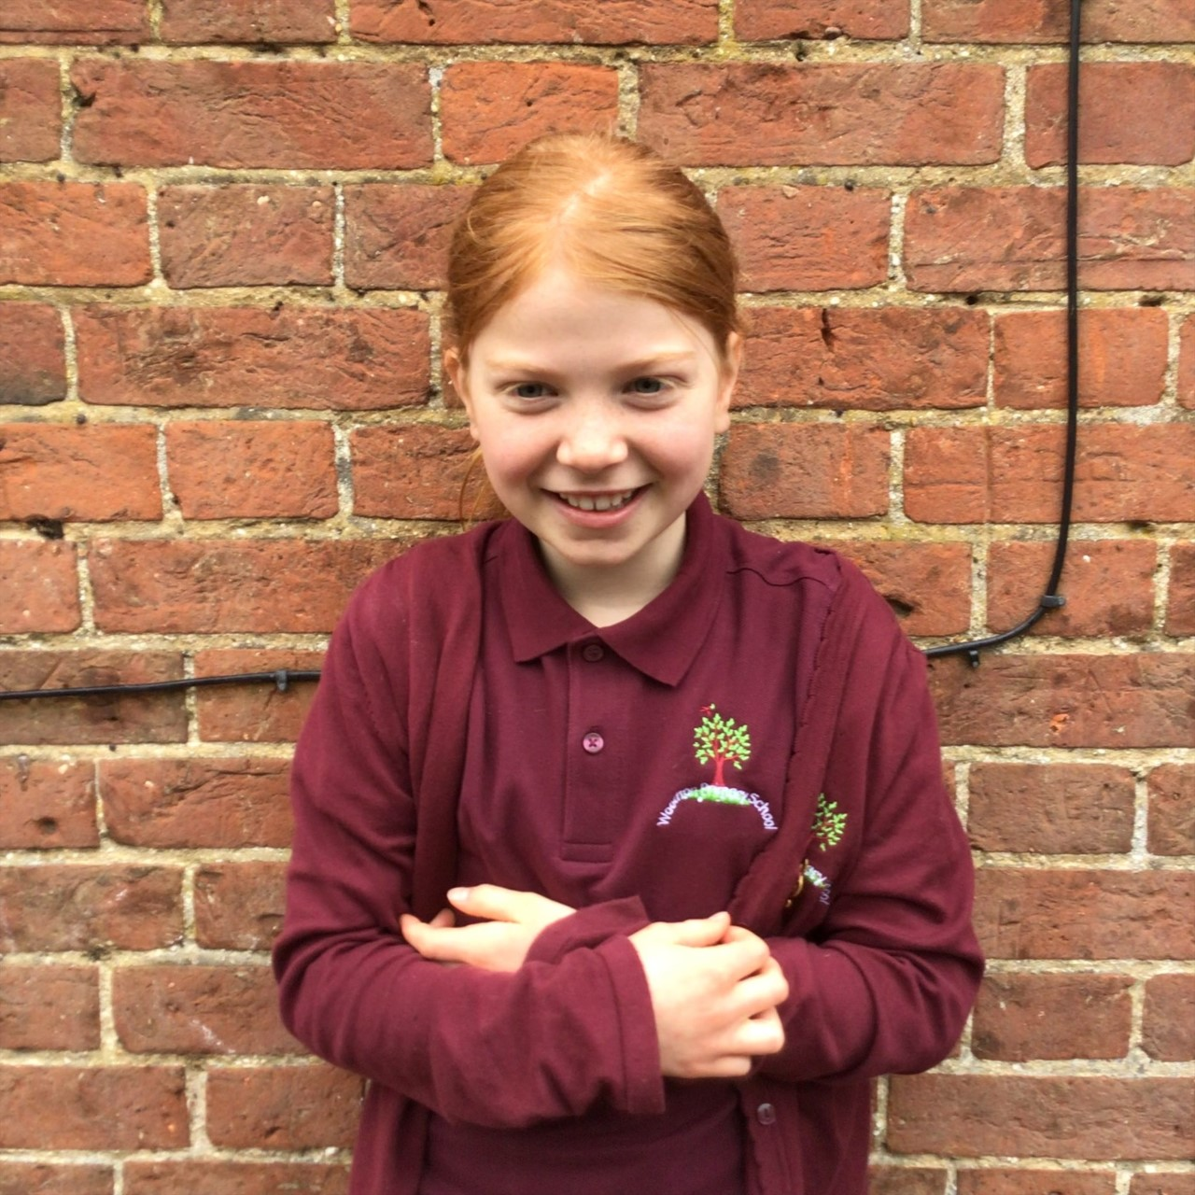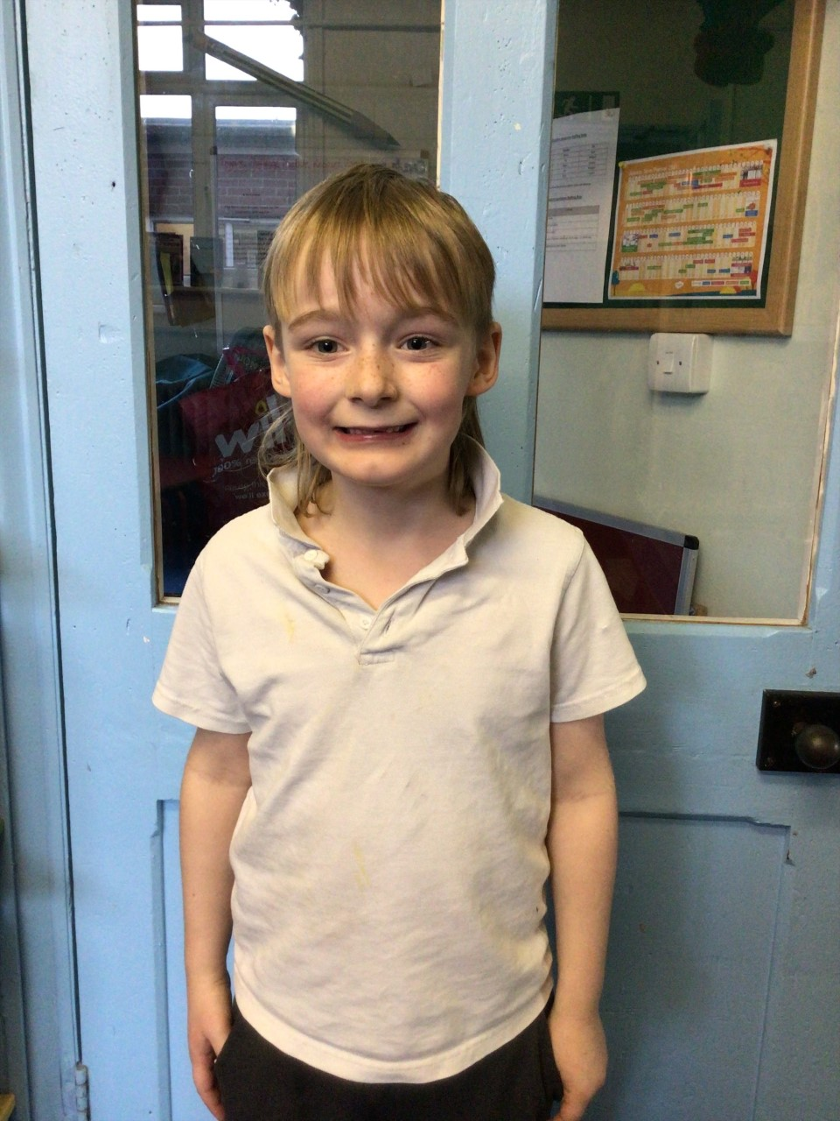

Woody is our star of the week because he always works very hard in class. He showed lots of determination when writing his newspaper report about the discovery of Tutankhamun and really impressed us with his knowledge. Lily D always always works incredibly hard in class. She consistently reads at home, learns her spellings every week and is all round amazing. She is an inspiration and role model to the rest of Oaks. Well done Lily!

Willows

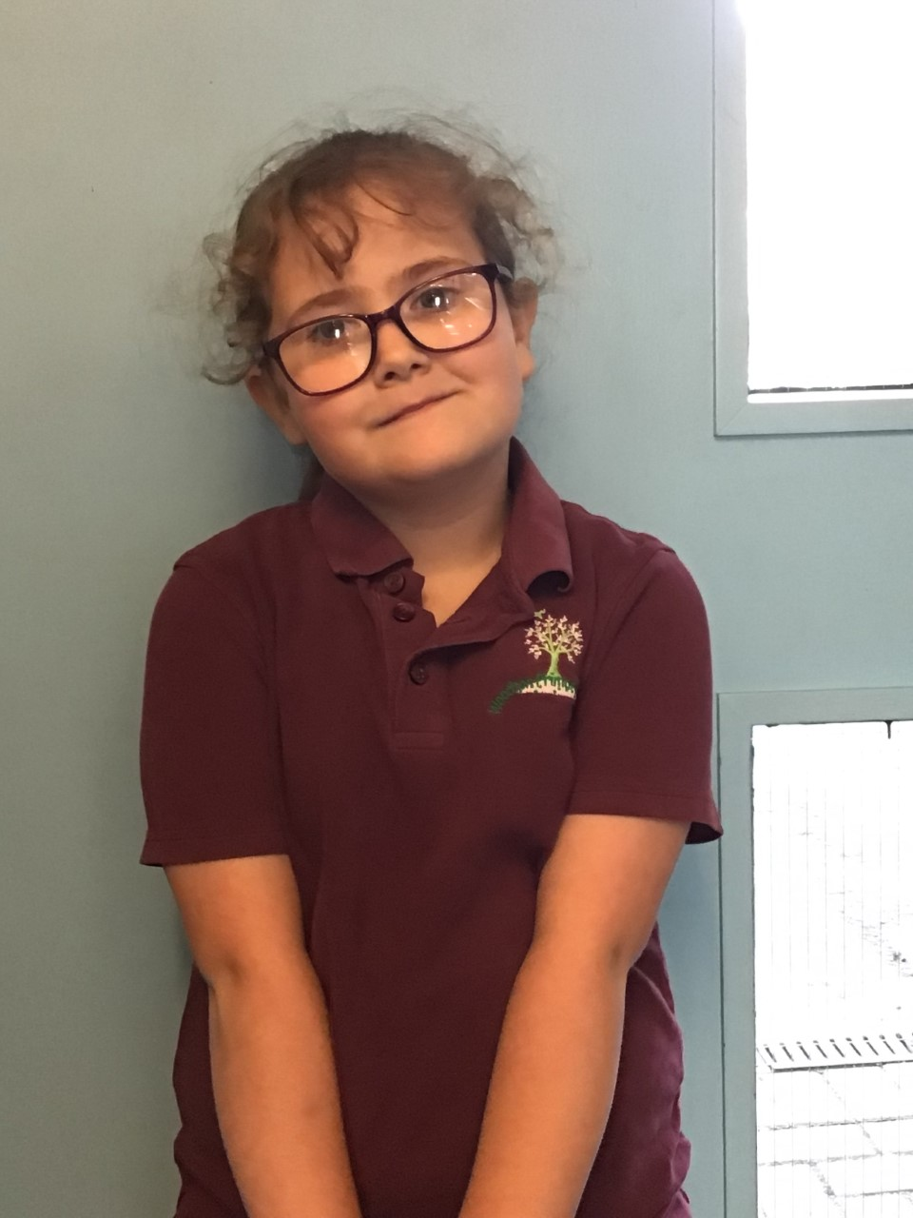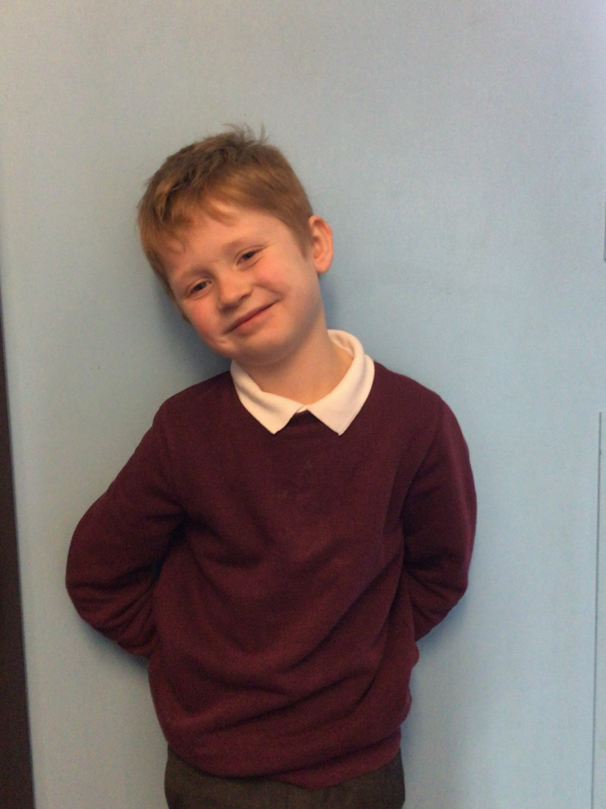

Willows stars of the week are Winter for never giving up and trying her hardest in Maths, and Theo for being independent and working so amazingly in Phonics and Maths.

**Stars of the Week**

# Celebration Newsletter



**Class Attendance**

Willows – 91.67 %

Oaks - 90.36 %

**Well done to all of WILLOWS CLASS.**

House Point totals for this week

Stephen Hawkings – 385

Beatrix Potter – 413

Benjamin Britten – 389

Kelly Holmes – 428

Maths Whizz Wonders

**Brilliant progressions** -

Willows – Finlay, Maisy & Charlie L.

Oaks – Charlie T, Simran & Leila.

Overall Winner for this week is **Willows**

CONGRATULATIONS.

A big WELL DONE to William, Solomon, Lily D, Lily W and Lacy for completing their Level 2 On Road Cycling Course this week.



