Oaks

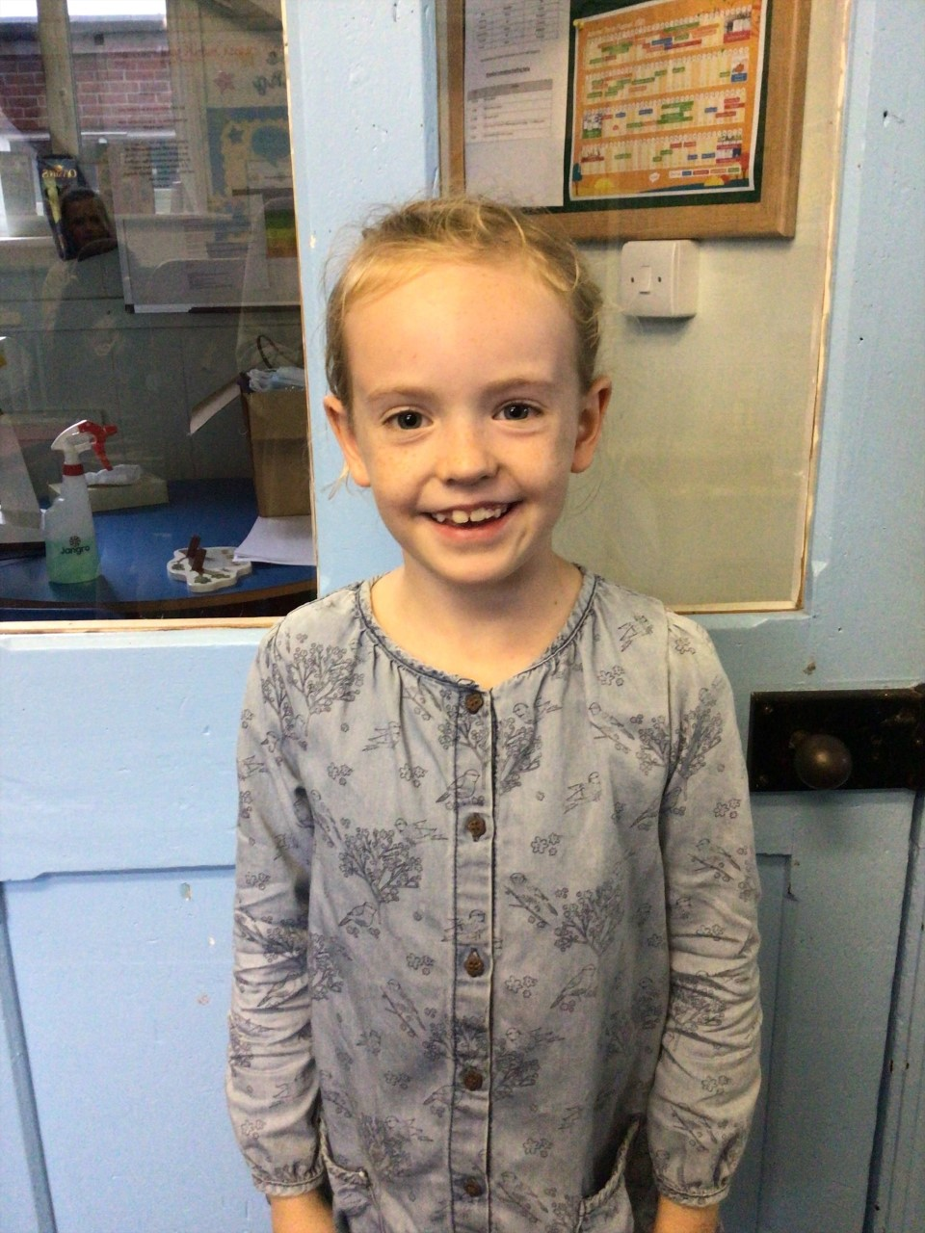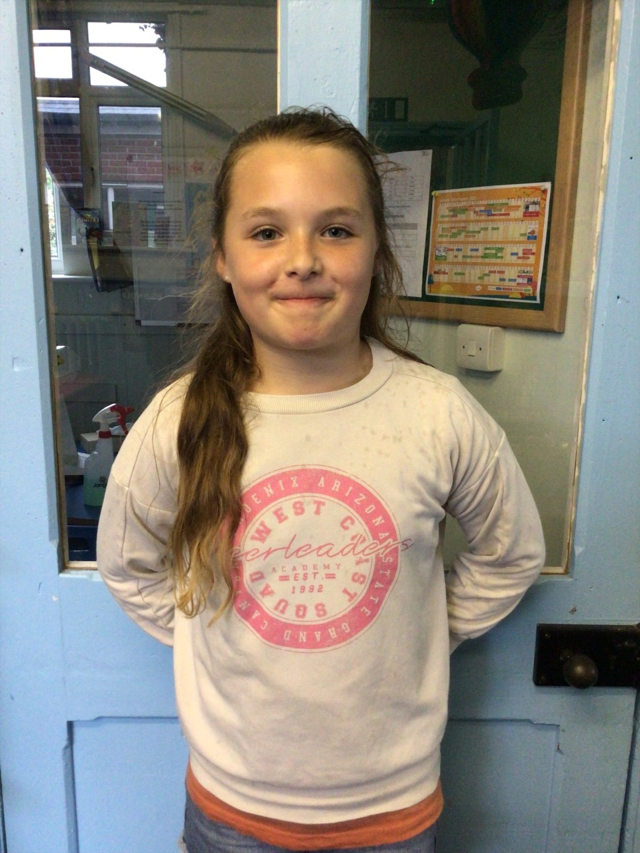

Our stars of the week are, Lacy as she has amazed us with her nurturing and supportive attitude towards the other children on her table during Tuesday’s lesson. Also, Leila for always getting on and works so hard in every lesson, Fantastic work girls!

Willows

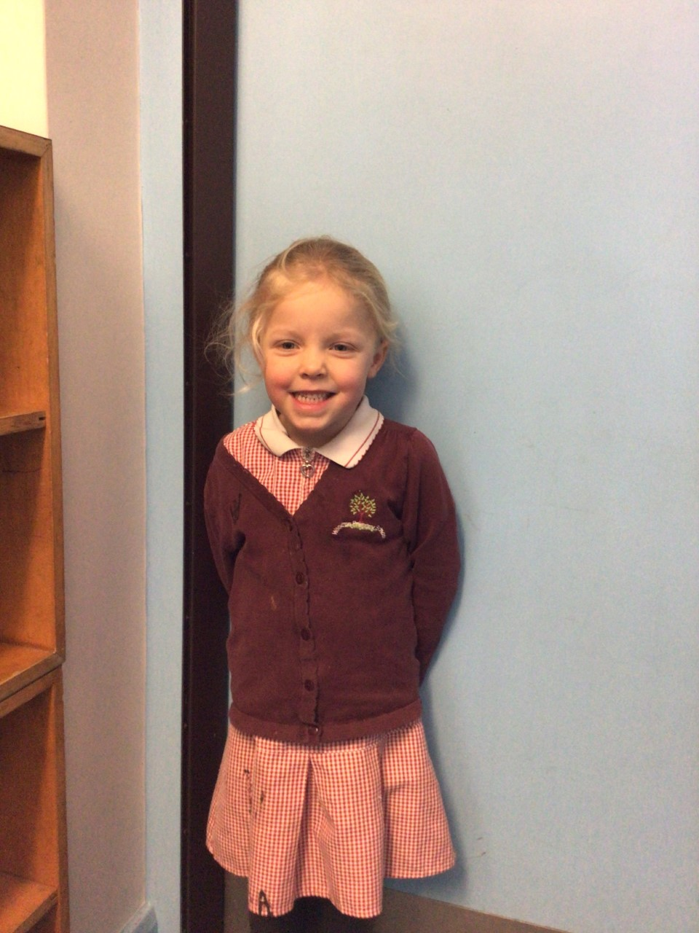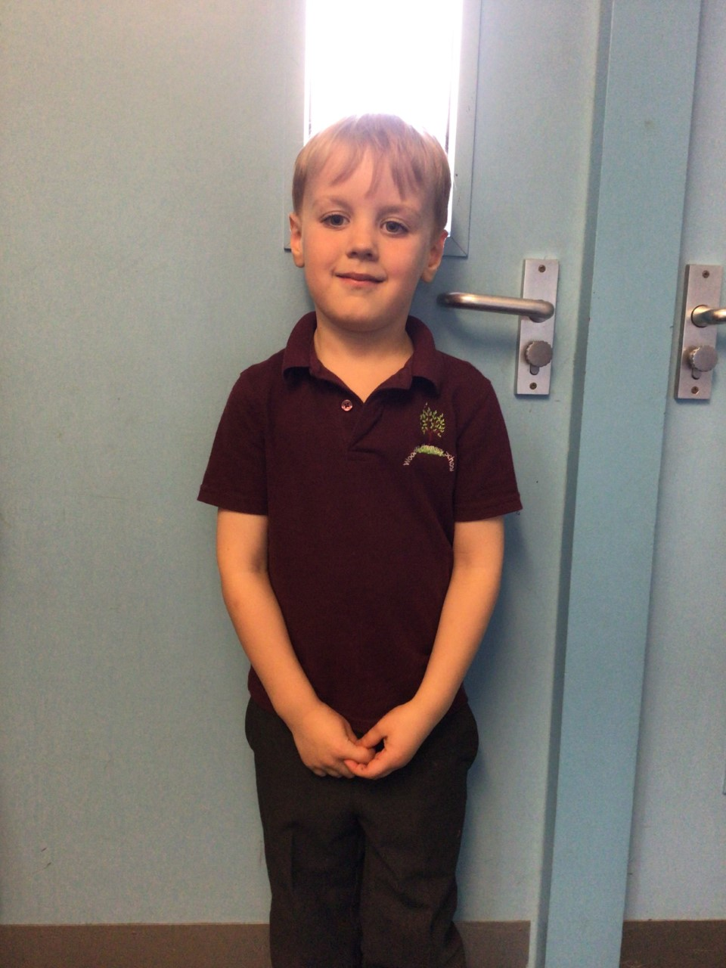

Willows stars of the week are Felicity for always trying her hardest in all her work and Finlay for always participating in class discussions.

Well done you two!

**Stars of the Week**

# Celebration Newsletter



**Class Attendance**

Willows – 94.05 %

Oaks - 90.1 %

**Well done to all of WILLOWS CLASS.**

House Point totals for this week

Stephen Hawkings – 450

Beatrix Potter – 483

Benjamin Britten – 444

Kelly Holmes – 506

Maths Whizz Wonders

**Brilliant progressions** -

Willows – Charlie W, Emmie & Finlay.

Oaks – Charlie T, Georgina & Betty.

Overall Winner for this week is **Willows**

CONGRATULATIONS.

Reading Challenge:

Keep up the reading to fill those jars in class!



