Oaks

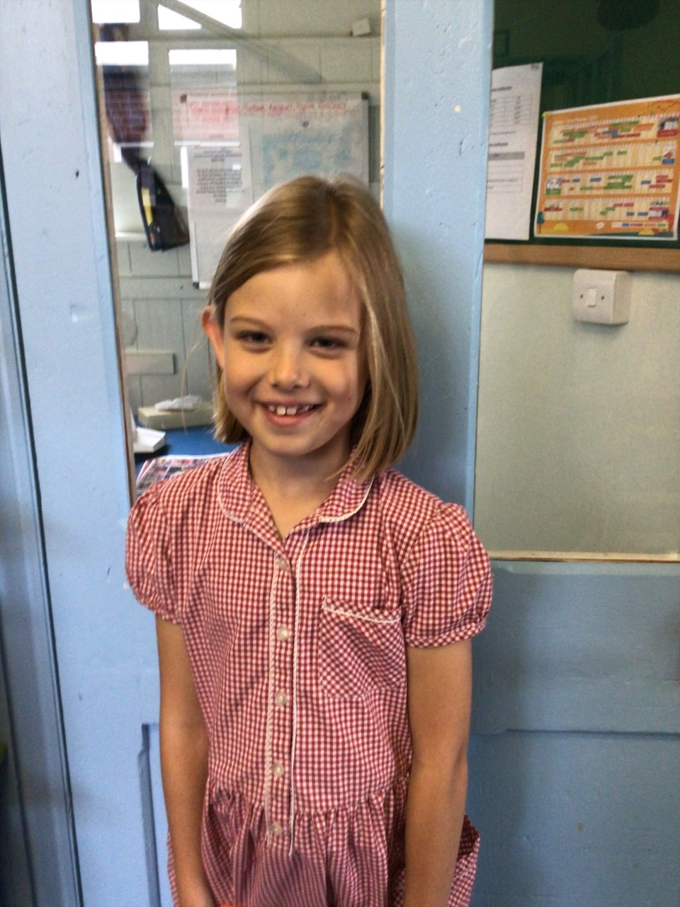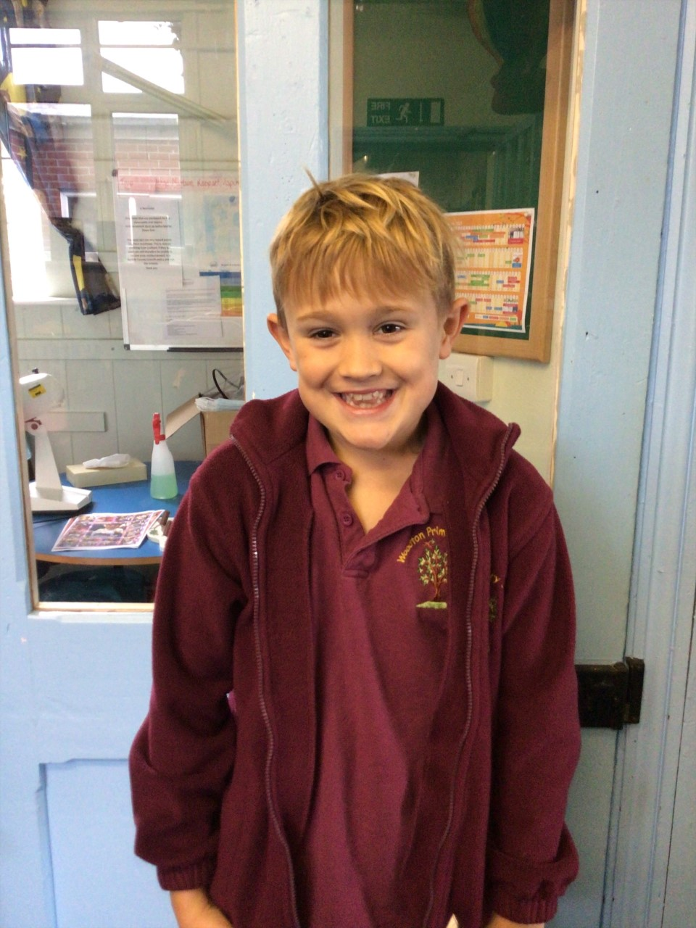

Our stars of the week are George Lloyd for being brilliant this week. He has been sharing some fantastic ideas and really wowed us with his contributions in class. Well done George.

Anya is always amazing and lovely. She gets on with her work and always works her hardest!

Willows

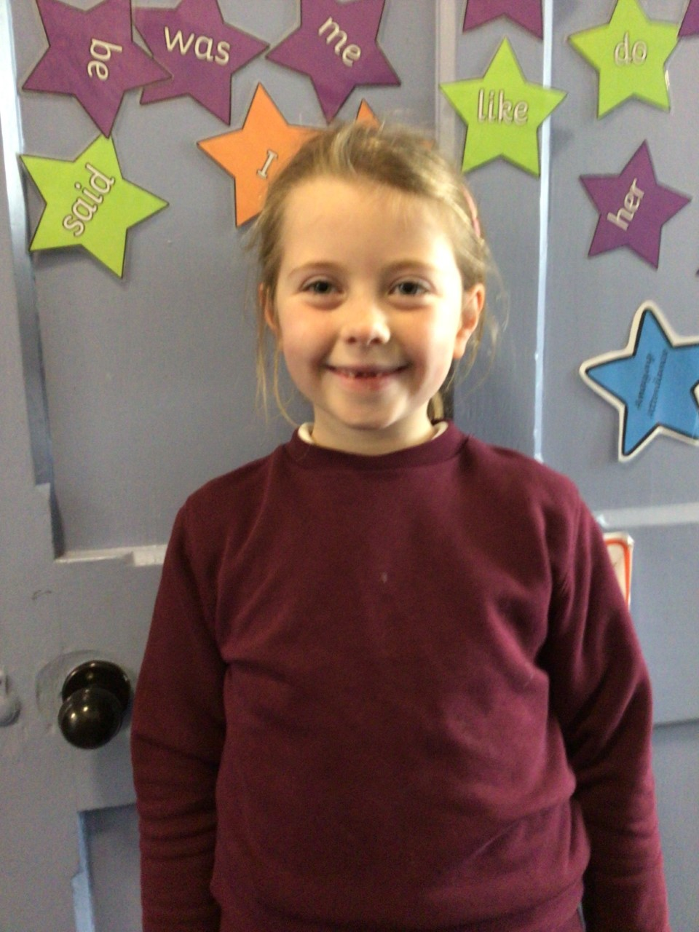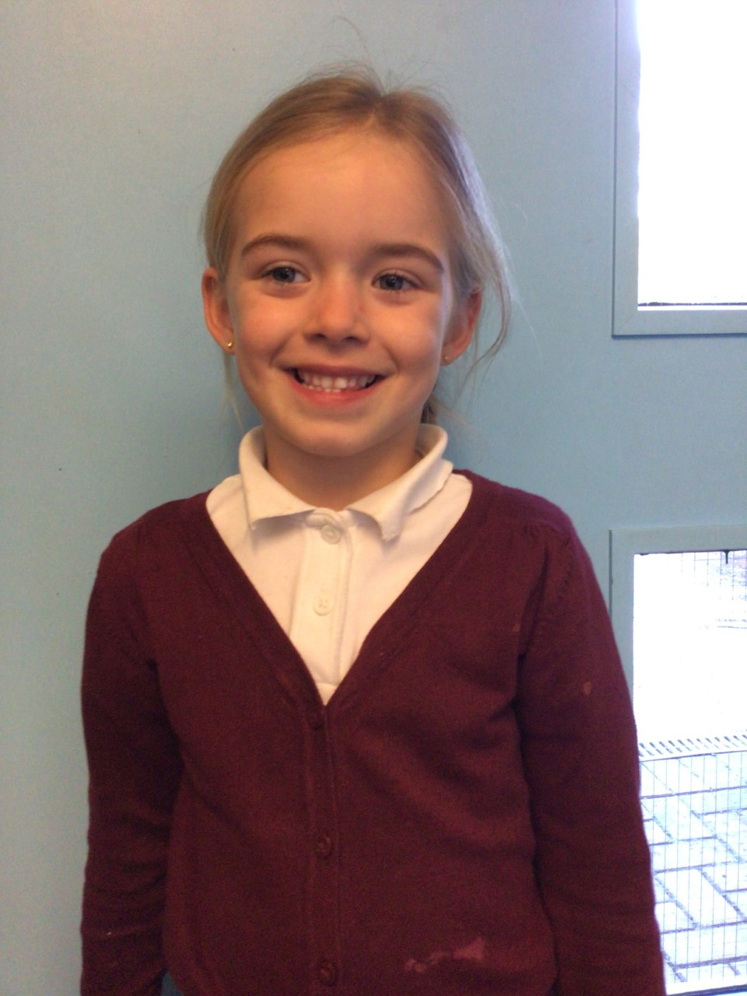

Willows stars of the week are Kendall for always trying her hardest and challenging herself in her learning and Ada for rising to the challenge of being Willows ‘Big Star’

WELL DONE GIRLS!

**Stars of the Week**

# Celebration Newsletter



**Class Attendance**

Willows – 98.41 %

Oaks - 94.49 %

**Well done to all of WILLOWS CLASS.**

House Point totals for this week

Stephen Hawkings – 512

Beatrix Potter – 548

Benjamin Britten – 513

Kelly Holmes – 571

Maths Whizz Wonders

**Brilliant progressions** -

Willows – Maisy, Emmie & Flo.

Oaks – Leila, Georgina & William.

Overall Winner for this week is **Oaks**

CONGRATULATIONS.

Reading Challenge:

Keep up the reading to fill those jars in class!



