Willows

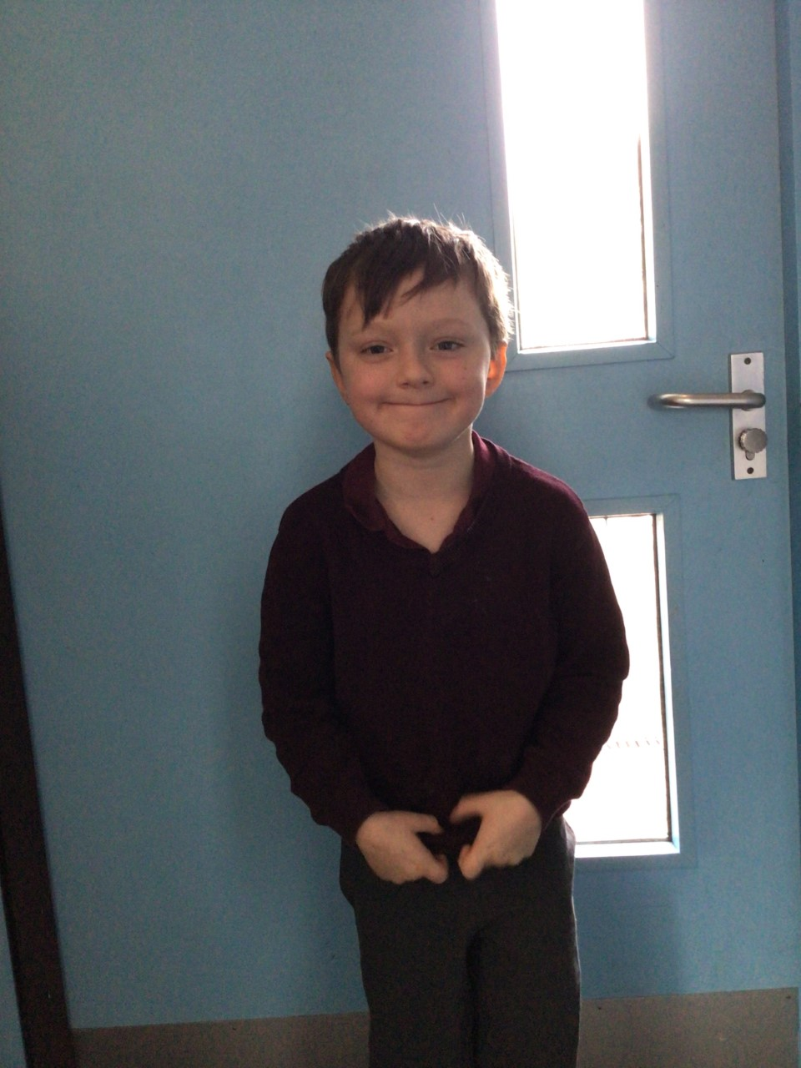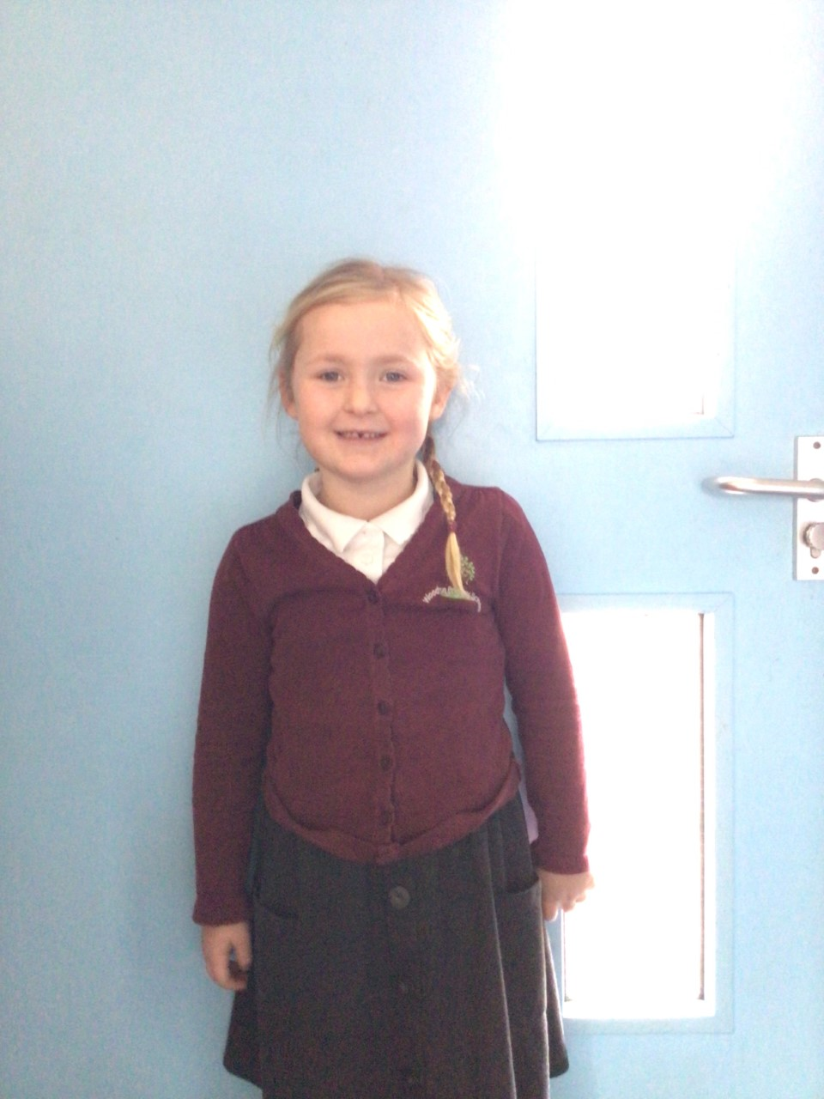

Our stars of the week this week are Emmie for always trying her hardest in Willows in all her learning and inspiring us to do our best and Charlie W for having an incredible positive attitude in school and always being enthusiastic in his learning.

Oaks

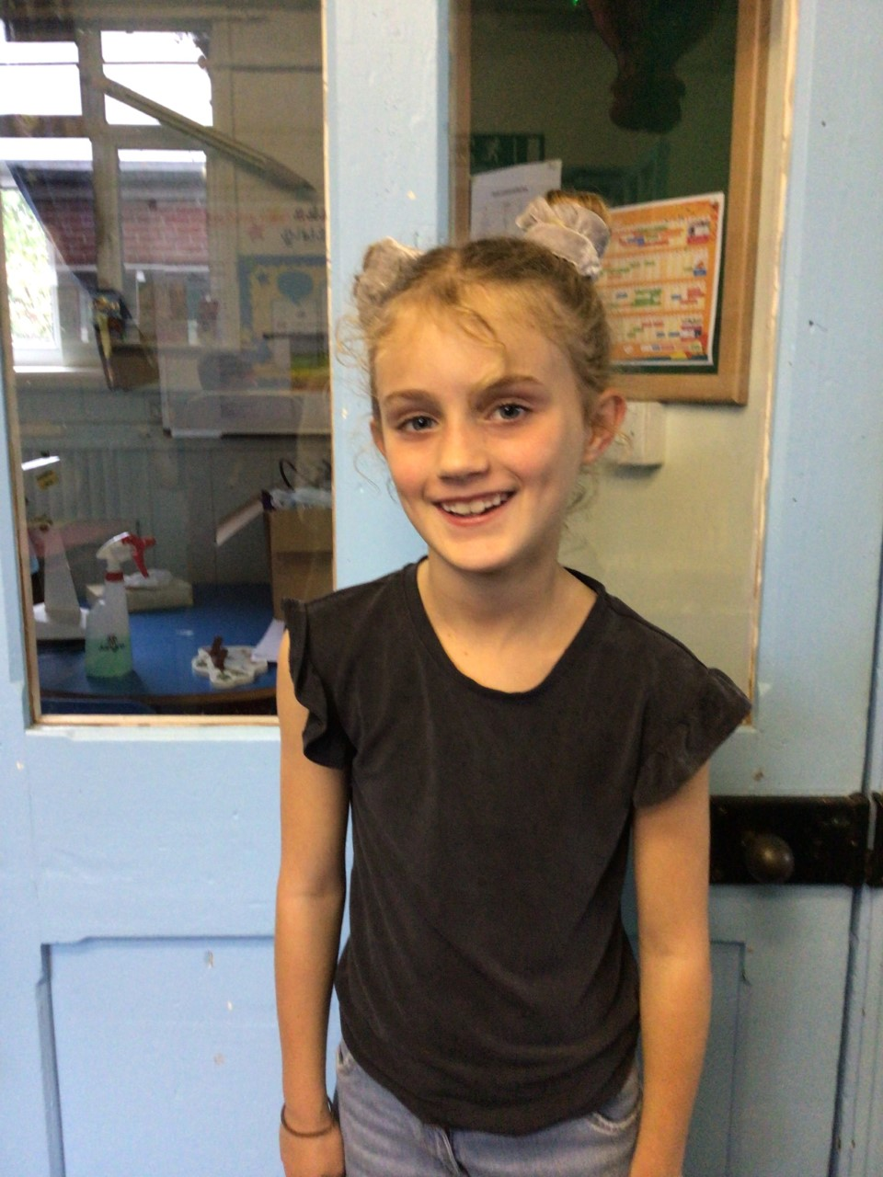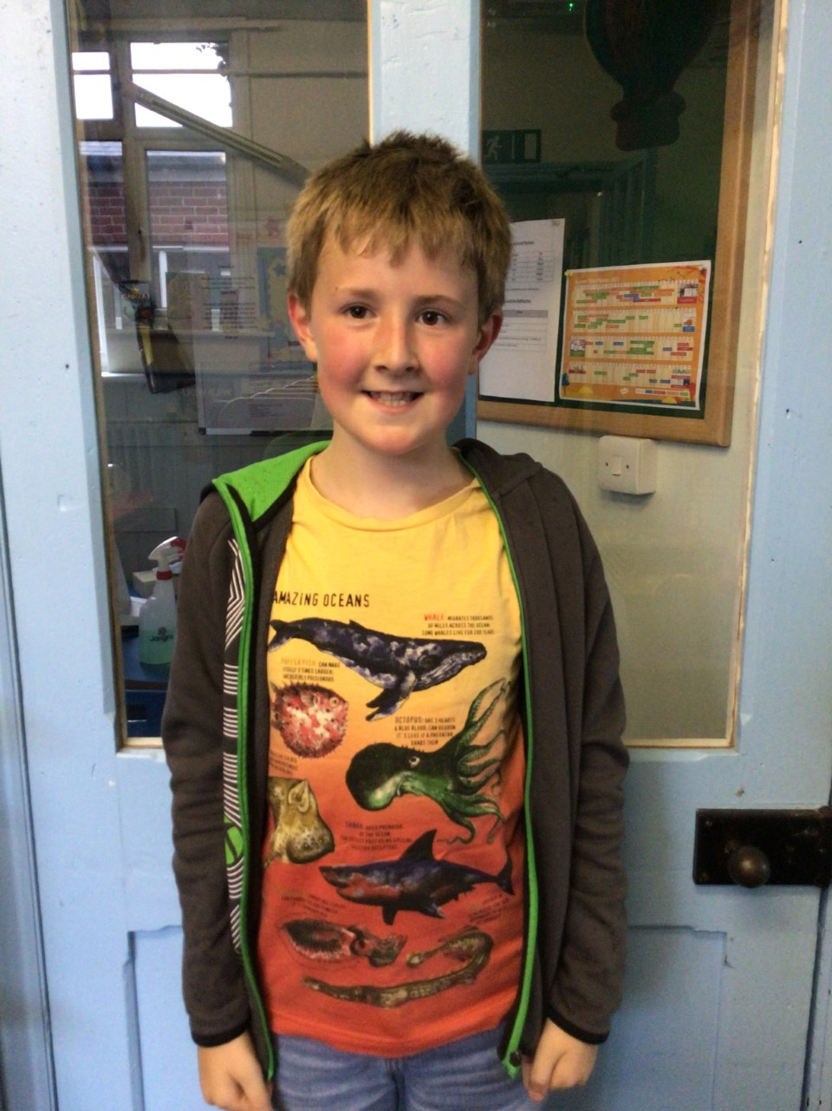

Our stars of the week this week are Olivia Lloyd and Feliks Wiseman.

Olivia has shown great determination and improvement with her maths work and Feliks for contributing his brilliant ideas during our PSHE lessons.

# Celebration Newsletter

**Stars of the Week**

House Point totals for this week

Stephen Hawkings – 54

Beatrix Potter – 113

Benjamin Britten – 75

Kelly Holmes – 84

**Class Attendance**

Willows – 95.95 %

Oaks - 94.18 %

**Well done to all of Willows CLASS.**

Maths Whizz Wonders

**Brilliant progressions** -

Willows – Maisy & Kendall.

Oaks - Charlie T & Simran.

Overall Winner for this week is

**Willows**

CONGRATULATIONS.

Reading Challenge:

WELL DONE **OAKS**

You won the reading challenge.

