Oaks

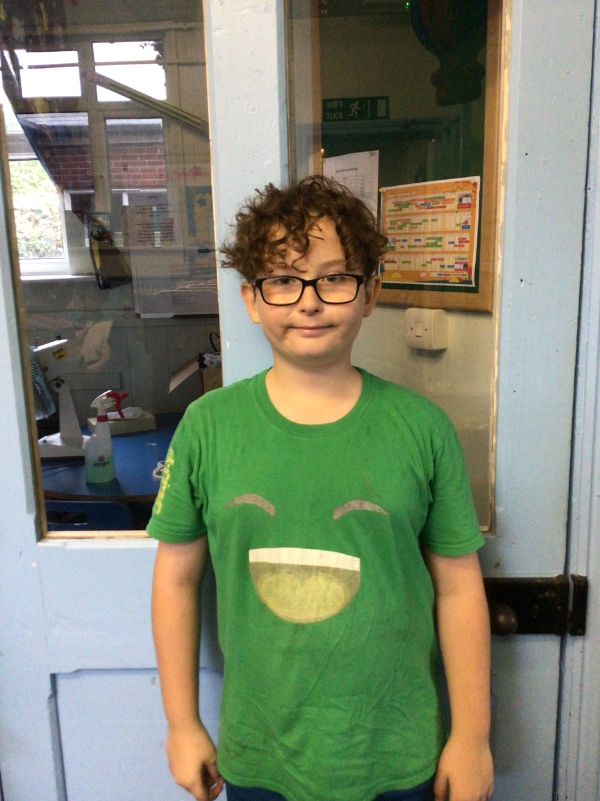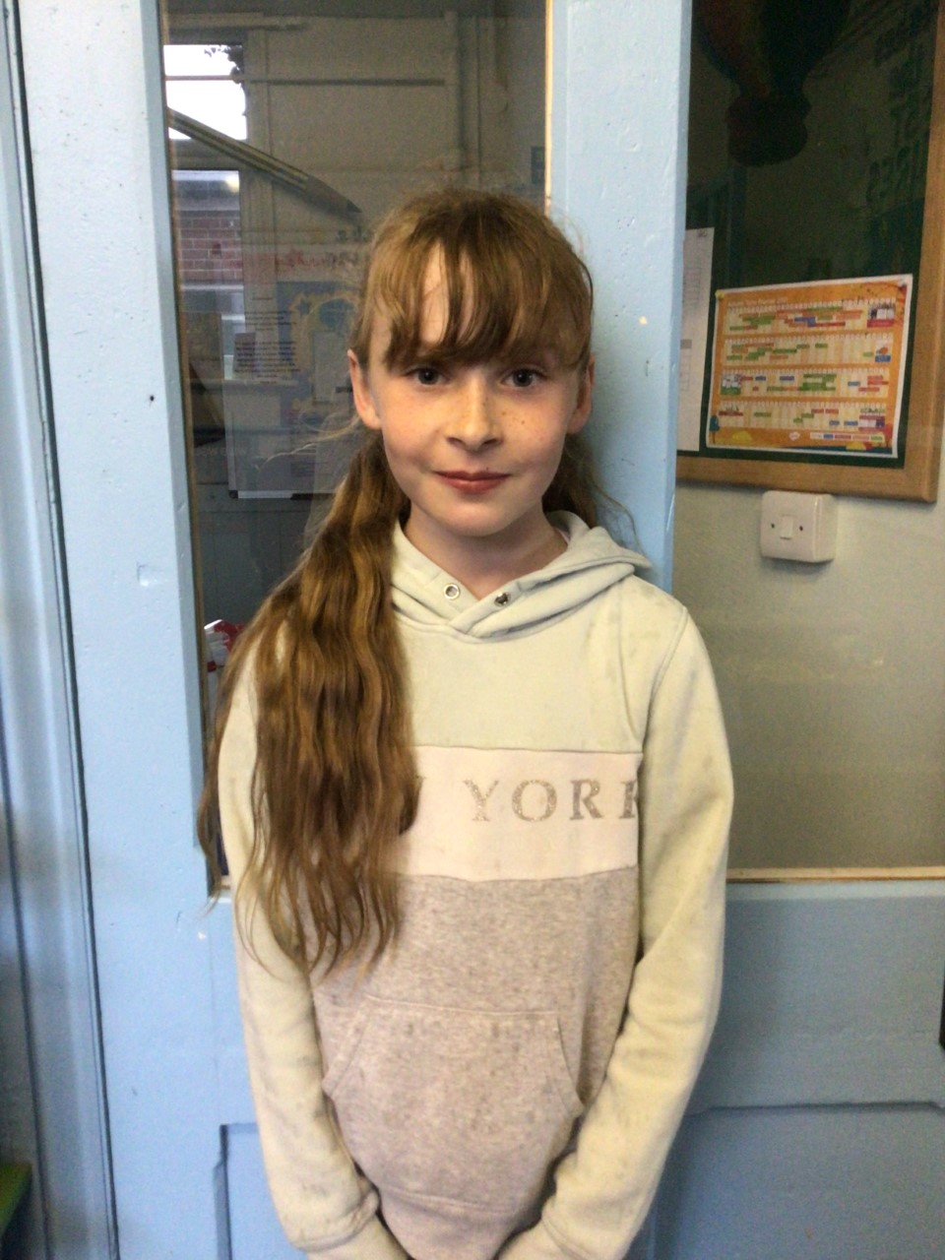

Our stars of the week this week are Jesse and Lily

Jesse, for the effort he has put into learning short multiplication and Lily for demonstrating a great attitude with her class work and a great determination to do well.

Willows

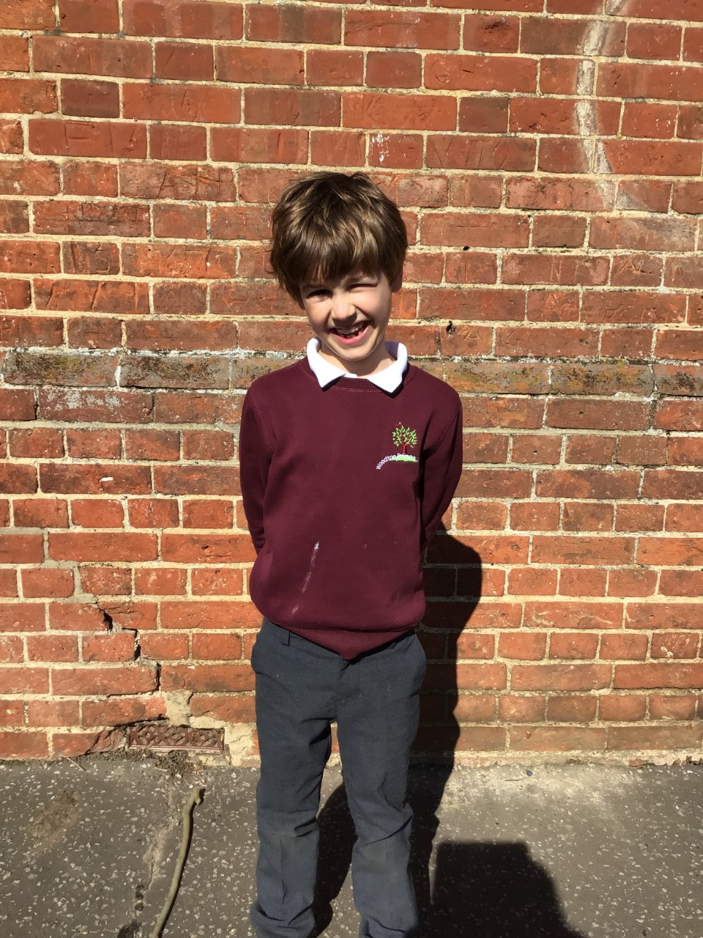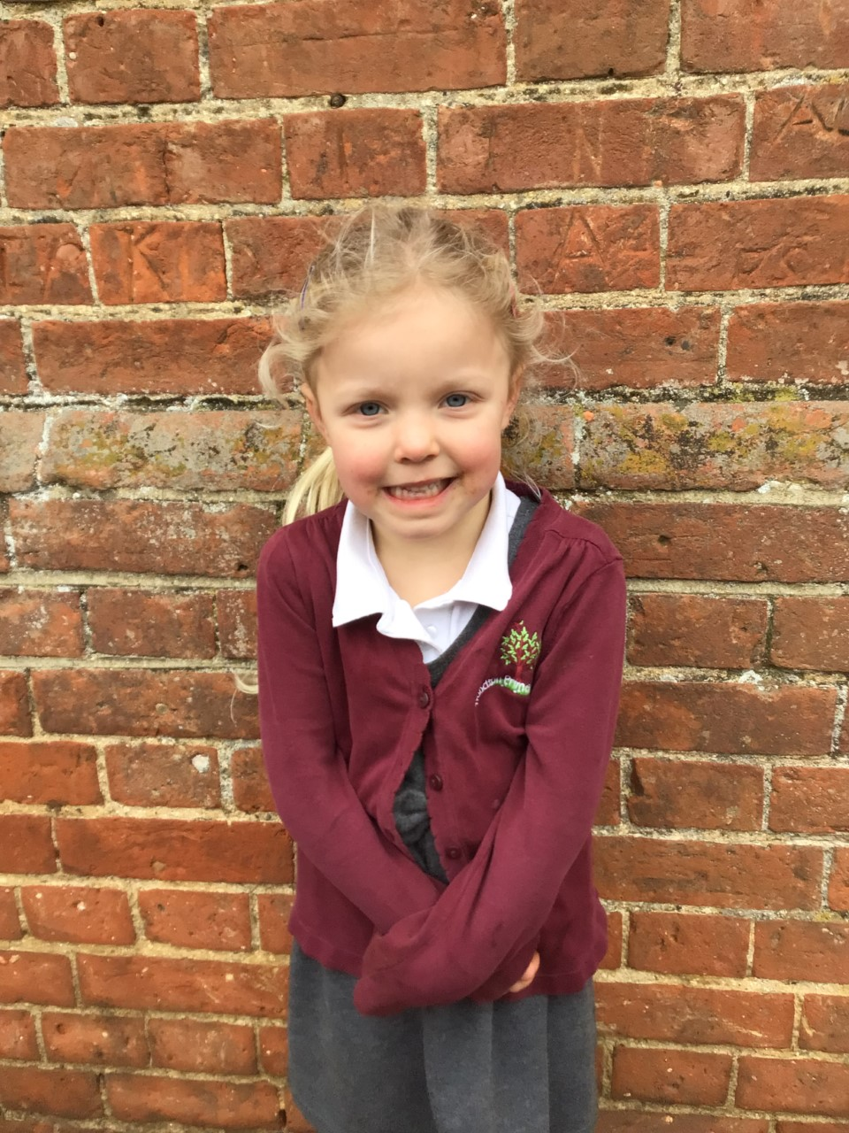

Willows stars of the week this week are Hector for his marvellous maths and showing great resilience when he hurt himself and Felicity for always coming to school with a smile on her face and working really hard in class.

# Celebration Newsletter

**Stars of the Week**

House Point totals for this week

Stephen Hawkings – 85

Beatrix Potter – 69

Benjamin Britten – 131

Kelly Holmes – 57

**Class Attendance**

Willows – 97.35 %

Oaks - 97.98 %

**Well done to all of Oaks CLASS.**

Maths Whizz Wonders

**Brilliant progressions** -

Willows – Finlay, Charlie L & Emmie.

Oaks – Georgina, Lacy & Illiana.

Overall Winner for this week is

**Willows**

CONGRATULATIONS.

Reading Challenge:

Keep up the reading to fill those jars in class!



