Oaks

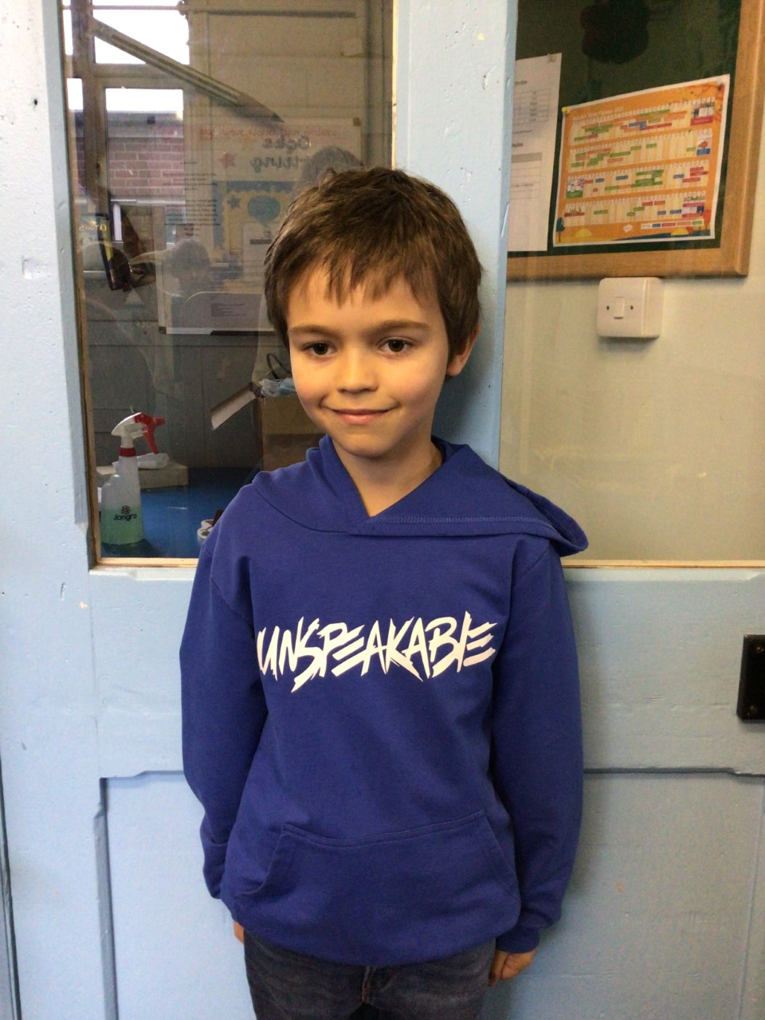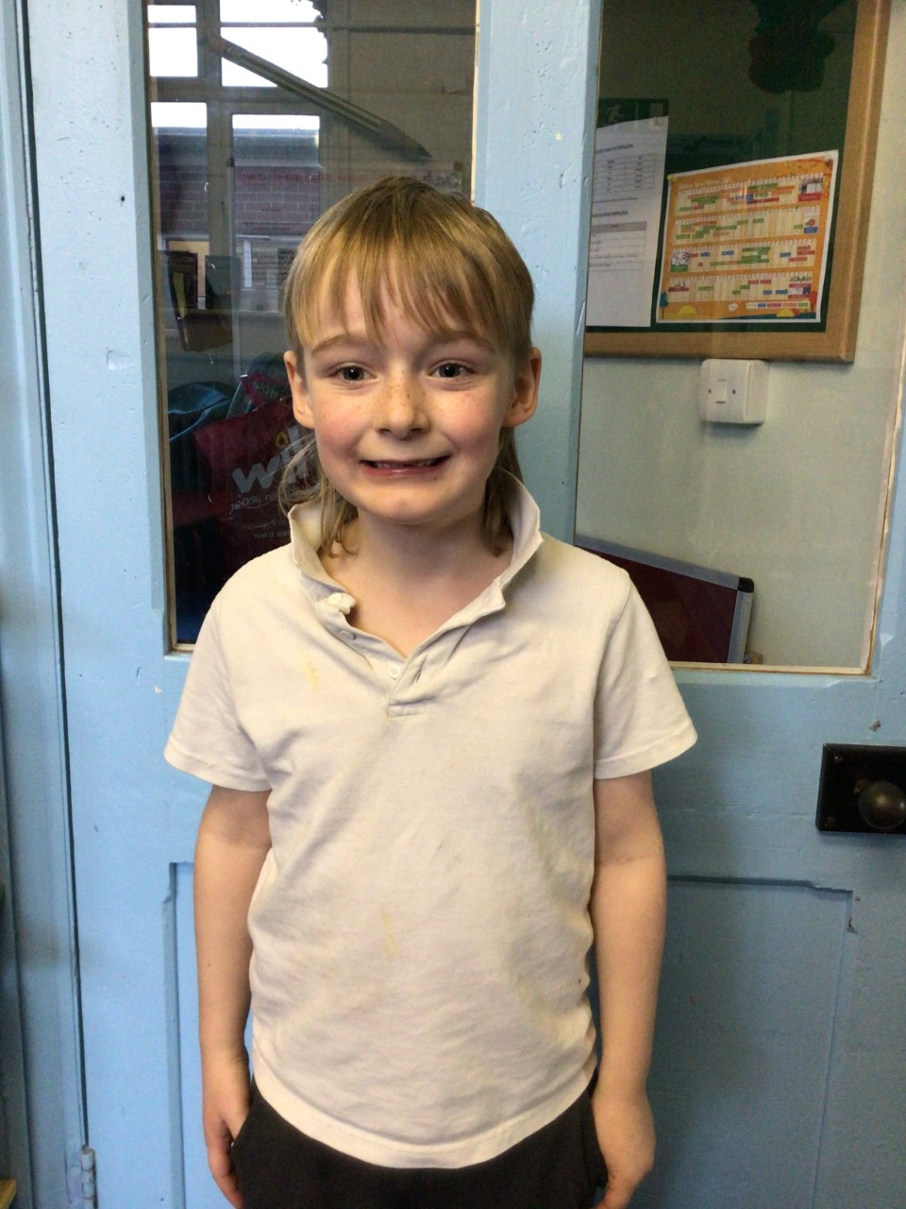

In Oaks this week, our stars of the week are Charlie T for writing an amazing descriptive narrative in English and always showing willingness to learn. Our second star of the week is Woody for resilience in solving maths problems and challenging himself.

Willows

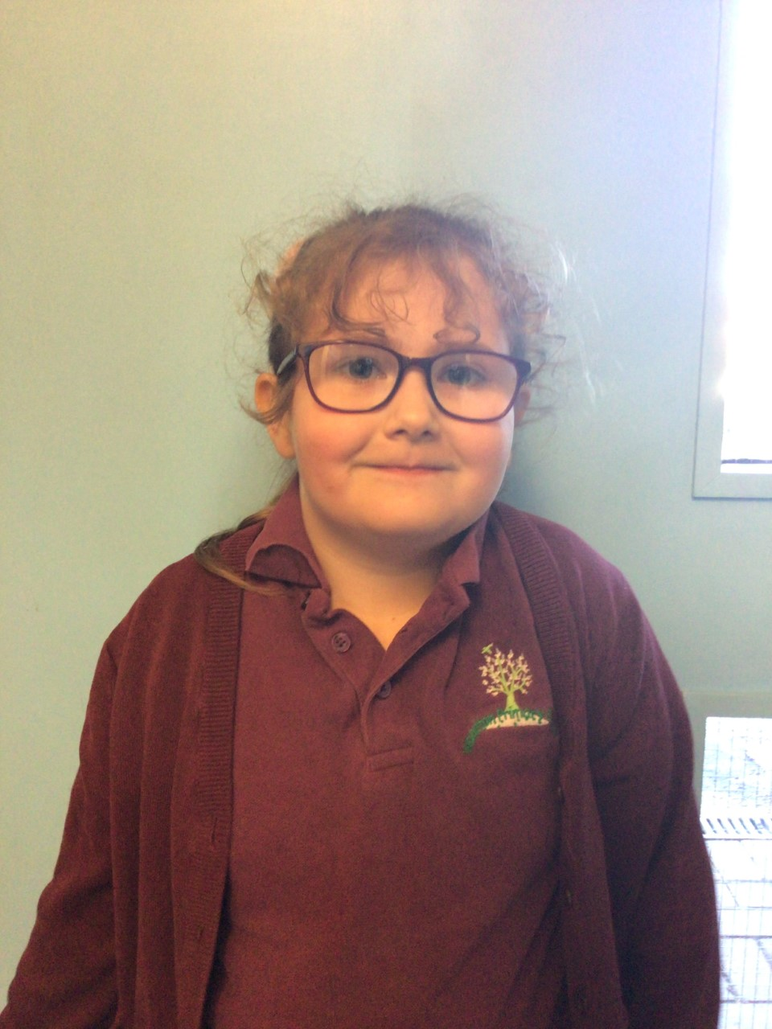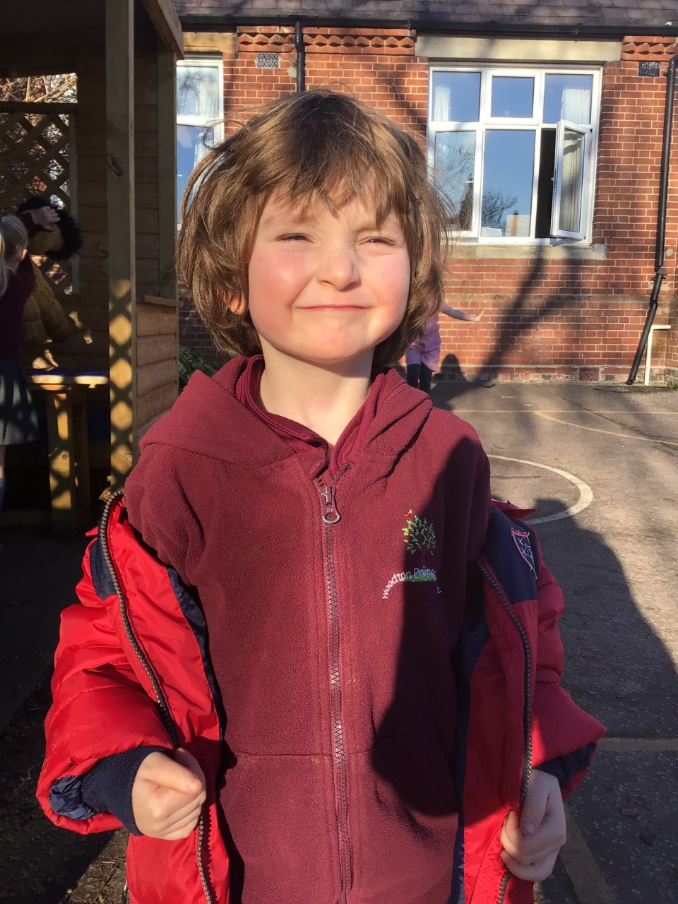

In Willows this week, our first star of the week is Lonnie who wows us in Phonics and always tries his hardest with his writing. He has amazed us all with his money work this week. Keep it up Lonnie!

Our second star is Winter, she has amazed us with her money work this week, making amounts and recognising all the coins. Great work Winter.

**Stars of the Week**

# Celebration Newsletter



**Class Attendance**

Willows – 94.37 %

Oaks - 95.31 %

**Well done to all of OAKS CLASS.**

House Point totals for this week

Stephen Hawkings – 28

Beatrix Potter – 61

Benjamin Britten – 48

Kelly Holmes – 44

Maths Whizz Wonders

**Brilliant progressions** -

Willows – Maisy, Flo & Charlie L.

Oaks – Charlie T, Charlie C & Woody.

Overall Winner for this week is **Oaks**

CONGRATULATIONS.

Happy New Year



