Oaks

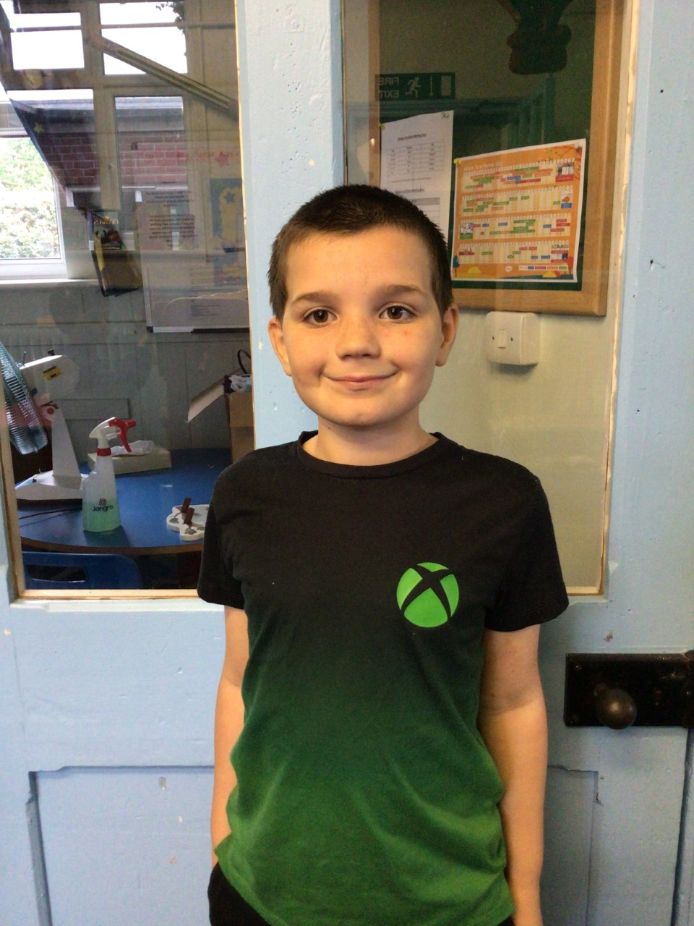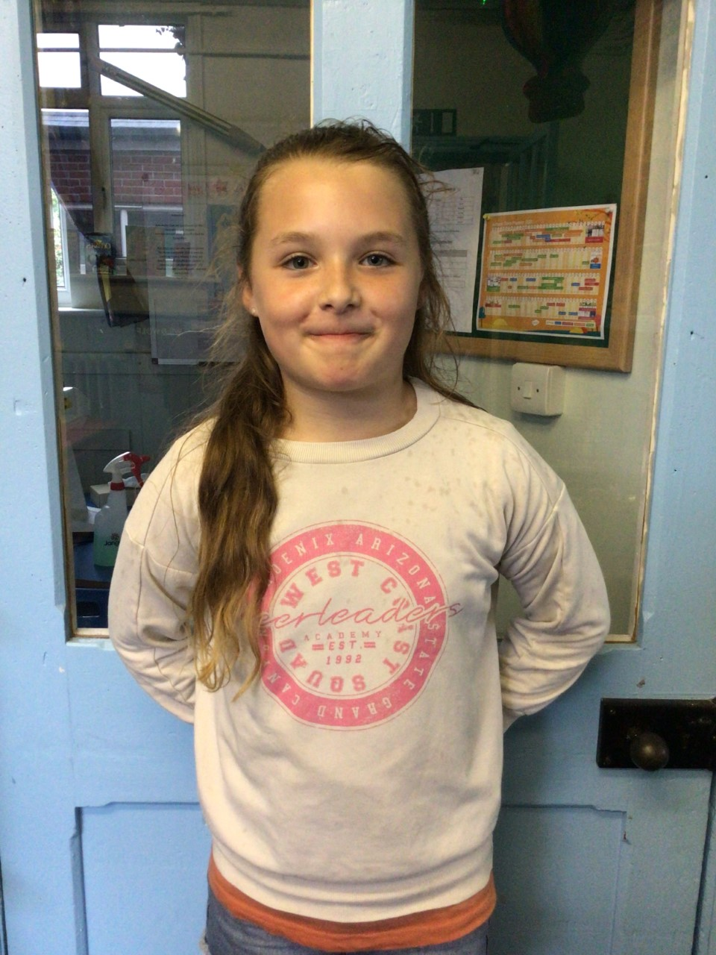

Oaks stars of the week are Riley for working really hard in class all week and Lacy for always helping others during RE lessons.

Well done Riley and Lacy!

Willows

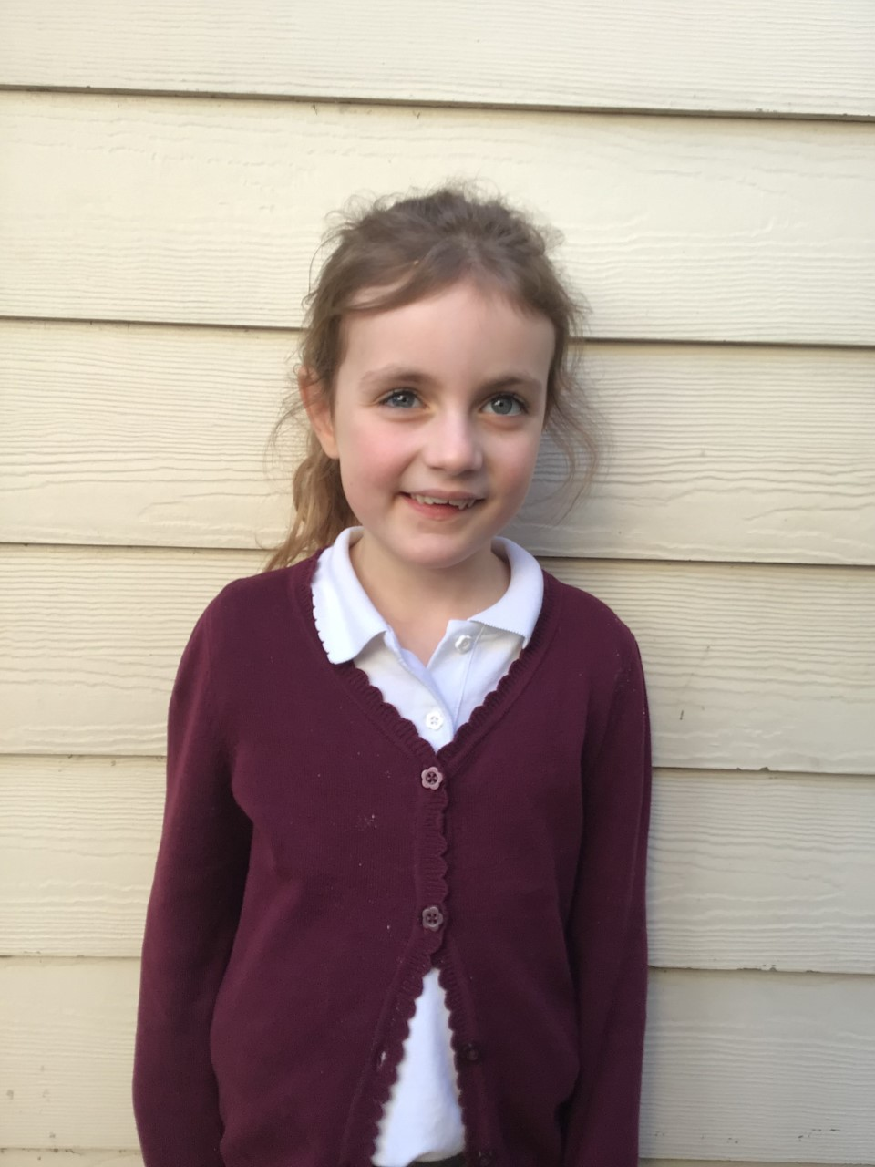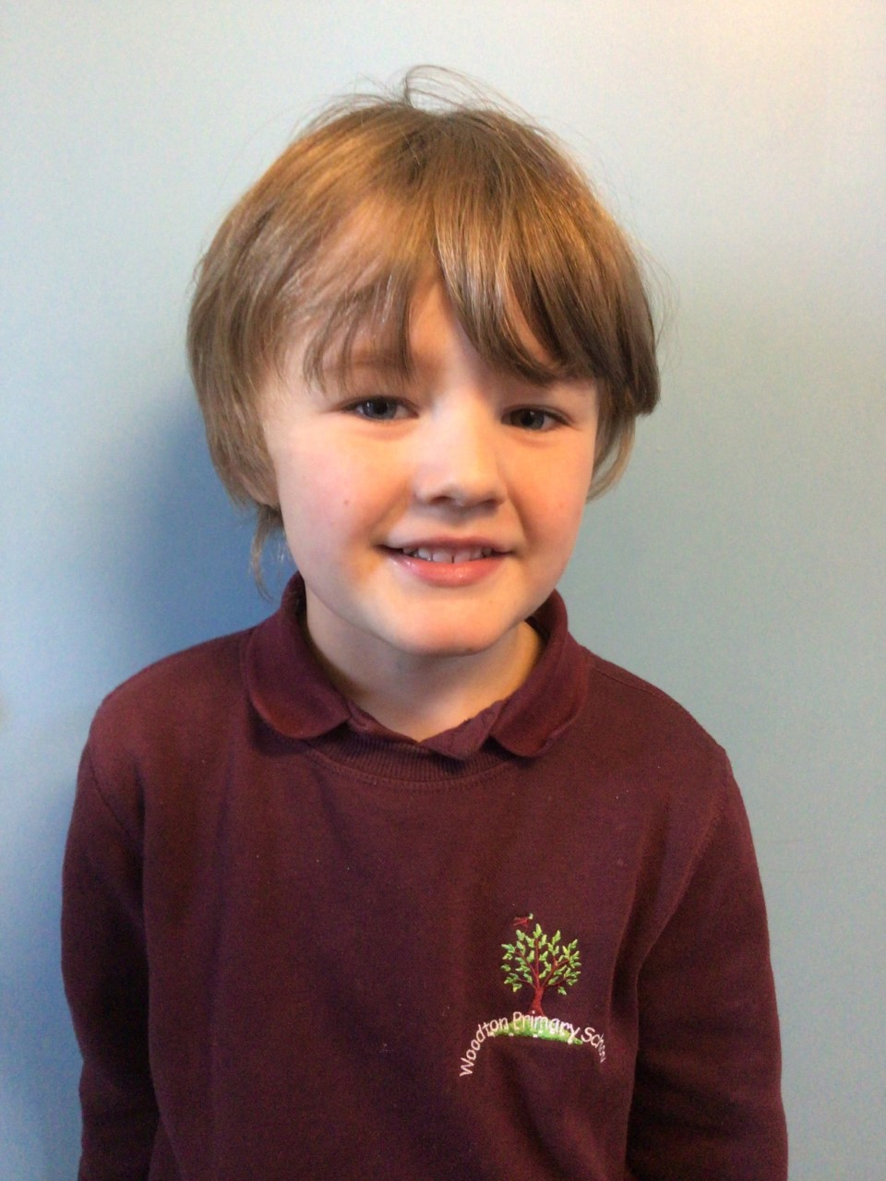

Ned has been a superstar since starting in Willows. Ned always aspires to do his best. Keep it up Ned.

Florence is always a star. She always sets a great example in Willows and tries her hardest in all her learning.

**Stars of the Week**

# Celebration Newsletter



**Class Attendance**

Willows – 94.8 %

Oaks - 92.92 %

**Well done to all of WILLOWS CLASS.**

House Point totals for this week

Stephen Hawkings – 32

Beatrix Potter – 32

Benjamin Britten – 38

Kelly Holmes – 36

Maths Whizz Wonders

**Brilliant progressions** -

Willows – Charlie L.

Oaks – Simran and Charlie C.

Overall Winner for this week is **Willows**

CONGRATULATIONS.

We would like to wish you all a very Merry Christmas and a Happy New Year, from all the staff at Woodton Primary School.



