Oaks

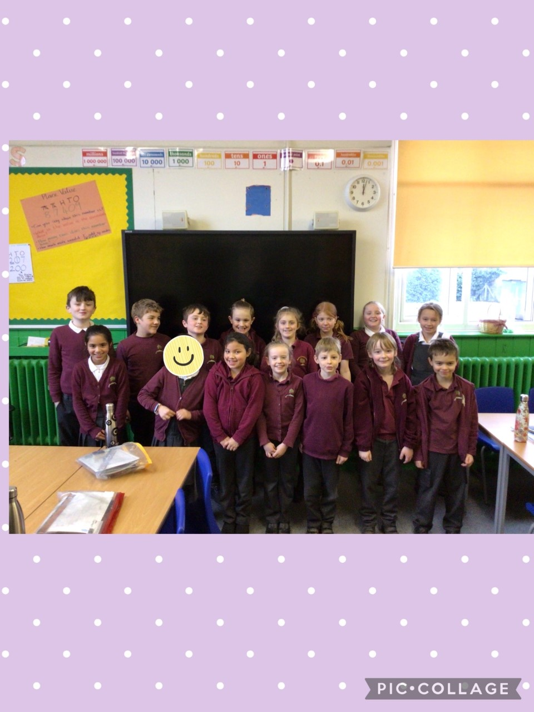

All of Oaks for outstanding effort this week.

Willows

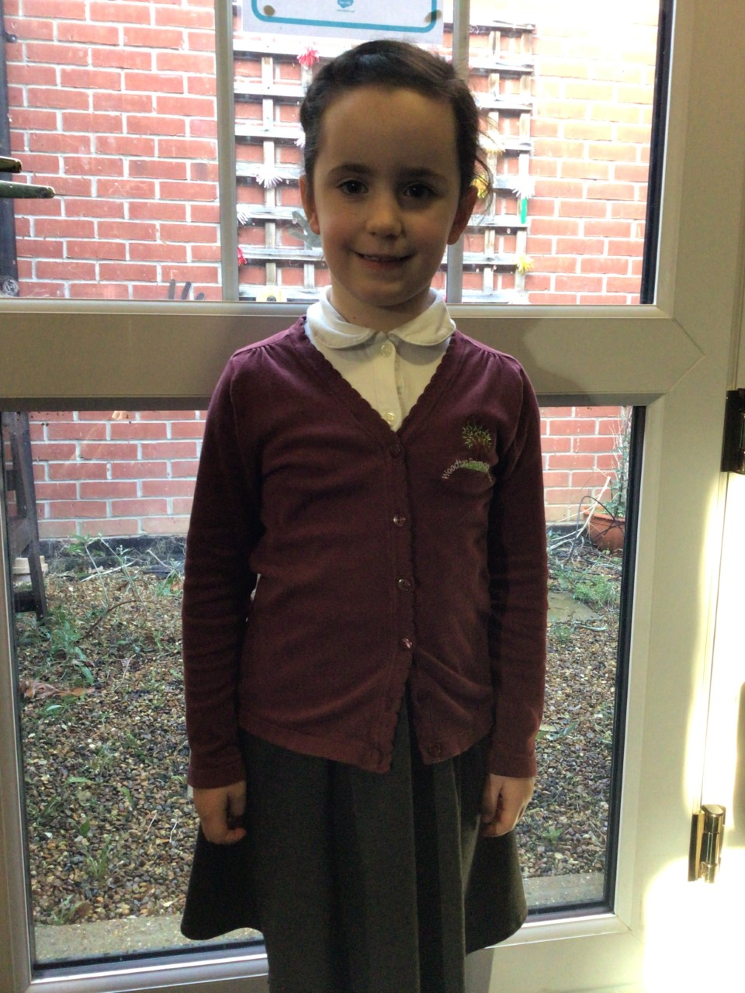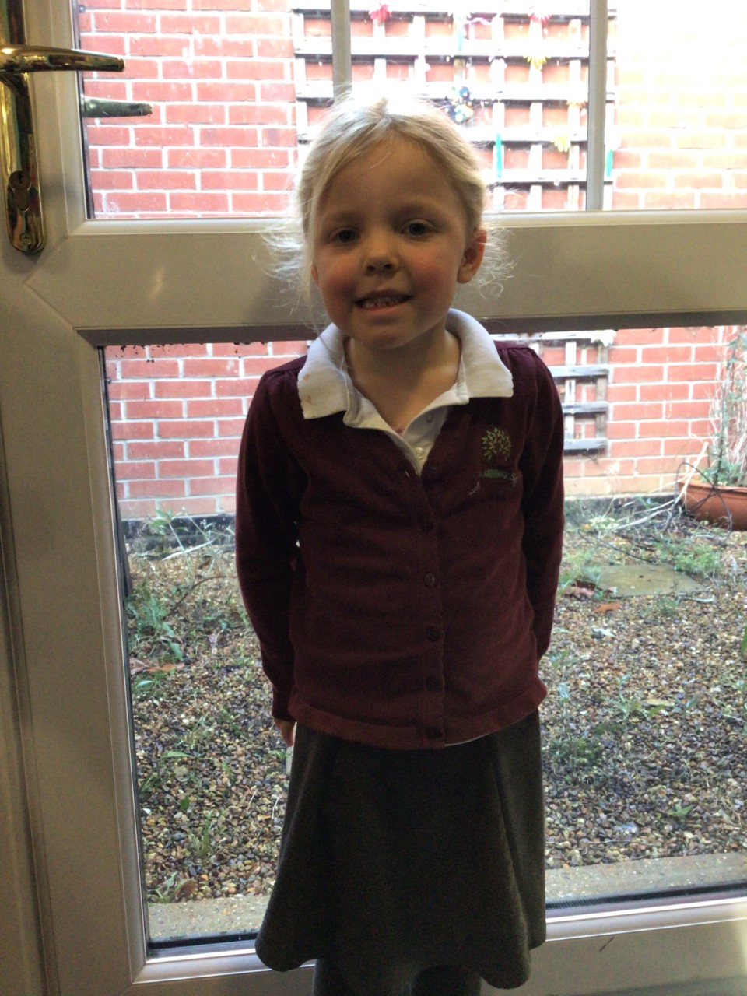

Willows stars of the week are Felicity R for carrying on as the only Reception and choosing to work with the year 1’s, and Paige for always participating in class discussion and sharing her amazing ideas with the class.

**Stars of the Week**

# Celebration Newsletter



House Point totals for this week

Stephen Hawkings – 168

Beatrix Potter – 273

Benjamin Britten – 155

Kelly Holmes – 164

Maths Whizz Wonders

**Brilliant progressions** -

Willows – Finlay, Hector & Kendall.

Oaks – Charlie T, Myles & Illiana

Overall Winner for this week is **Oaks**

CONGRATULATIONS.

Reading Challenge:

Keep up the reading to fill those jars in class!



