Oaks

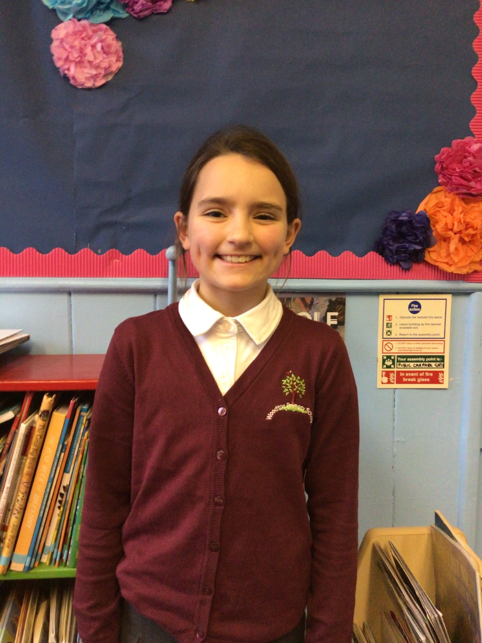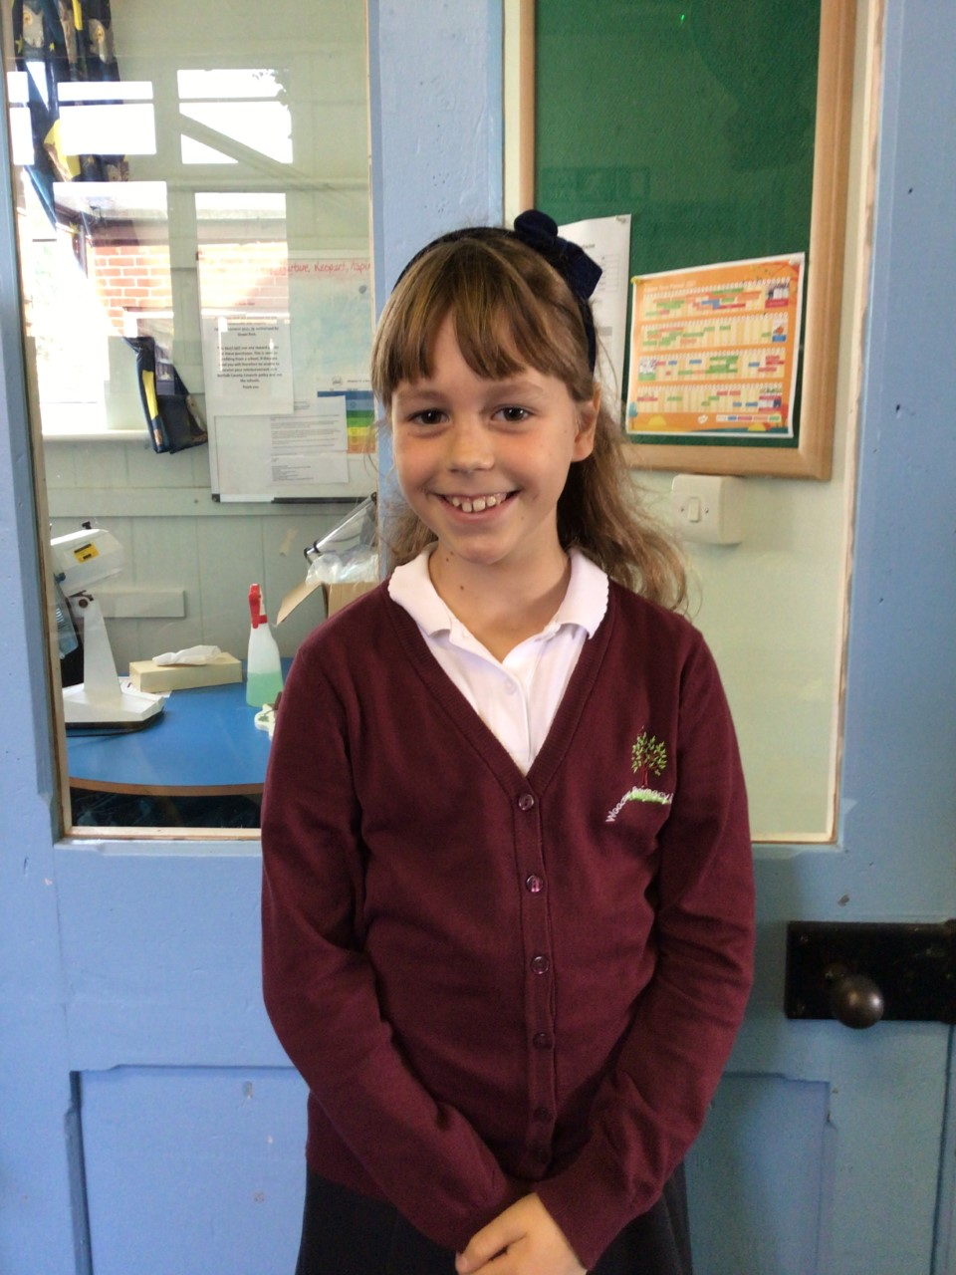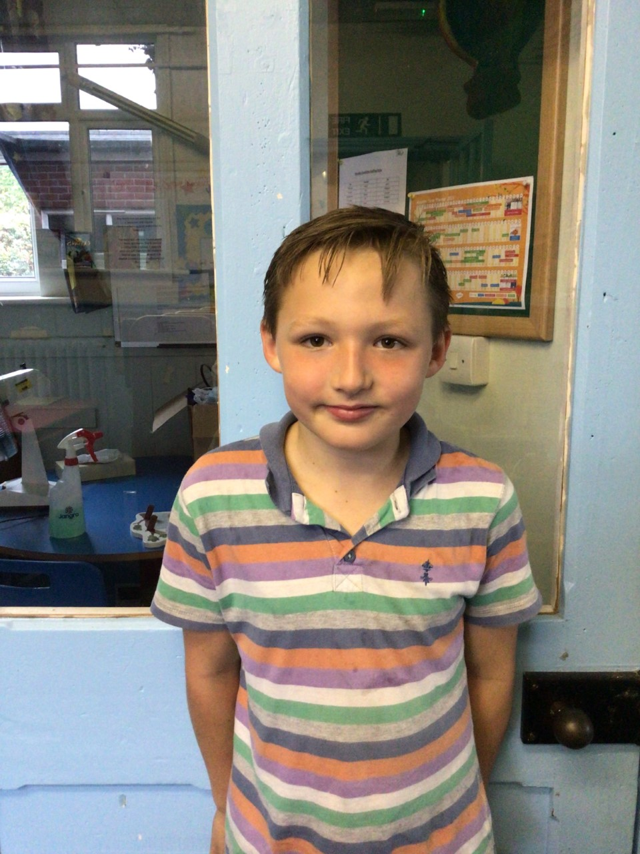

This week we have welcomed Phoebe to Oaks.

Our stars of the week are Phoebe S, Betty and Kian.

Phoebe has had a brilliant first week, and has settled in very well.

Betty is our second star of the week, Betty has been kind and extremely helpful by helping Phoebe to settle in.

Our third star is Kian, Kian has been an excellent team player in our P.E. Lessons

Willows

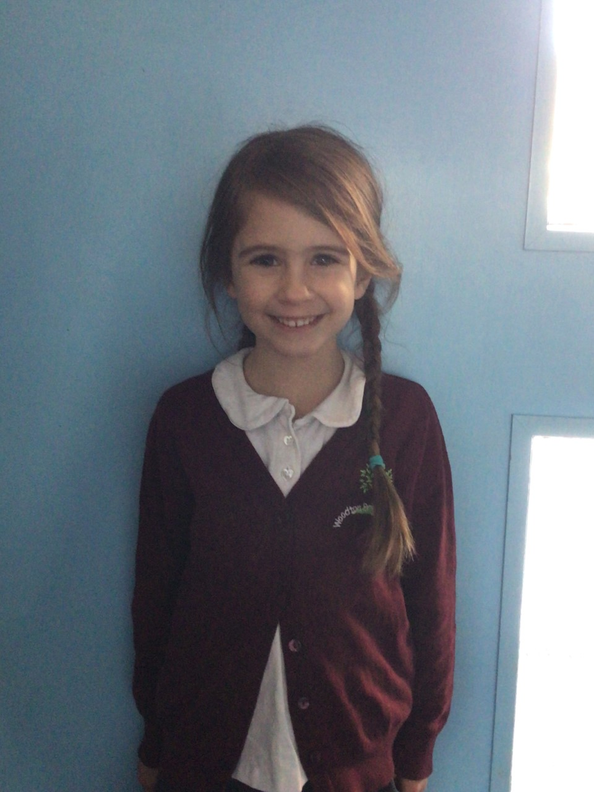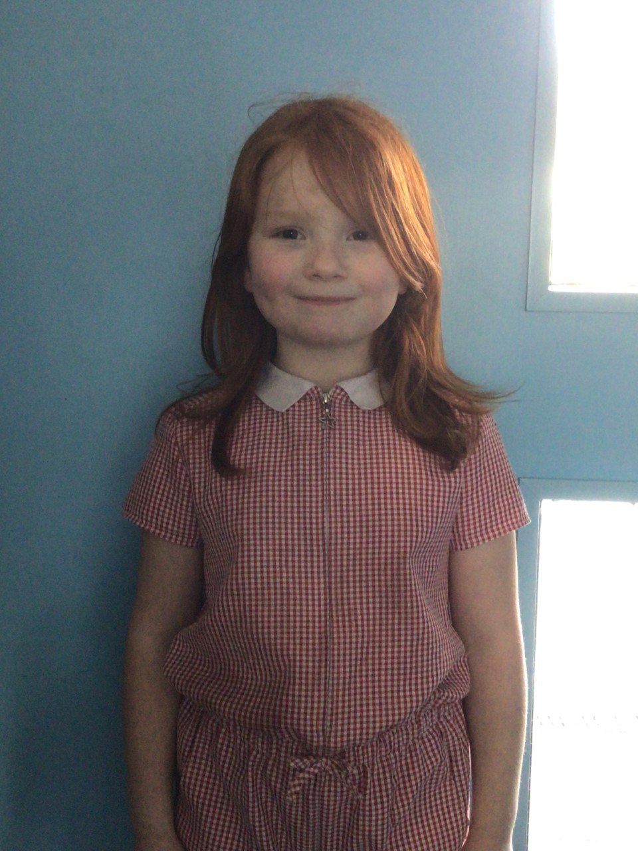

Willows stars of the week are Molly for settling really well into Willows and wowing us and Crystal has made amazing progress in all her learning and always tries her hardest. Keep it up Crystal.

# Celebration Newsletter

**Stars of the Week**

House Point totals for this week

Stephen Hawkings – 92

Beatrix Potter – 121

Benjamin Britten – 98

Kelly Holmes – 105

**Class Attendance**

Willows – 98.3 %

Oaks - 99.24 %

**Well done to all of Oaks CLASS.**

Maths Whizz Wonders

**Brilliant progressions** -

Willows – Finlay.

Oaks - Charlie T & Olivia L.

Overall Winner for this week is

**Willows**

CONGRATULATIONS.

Reading Challenge:

Keep up the reading!



