Willows

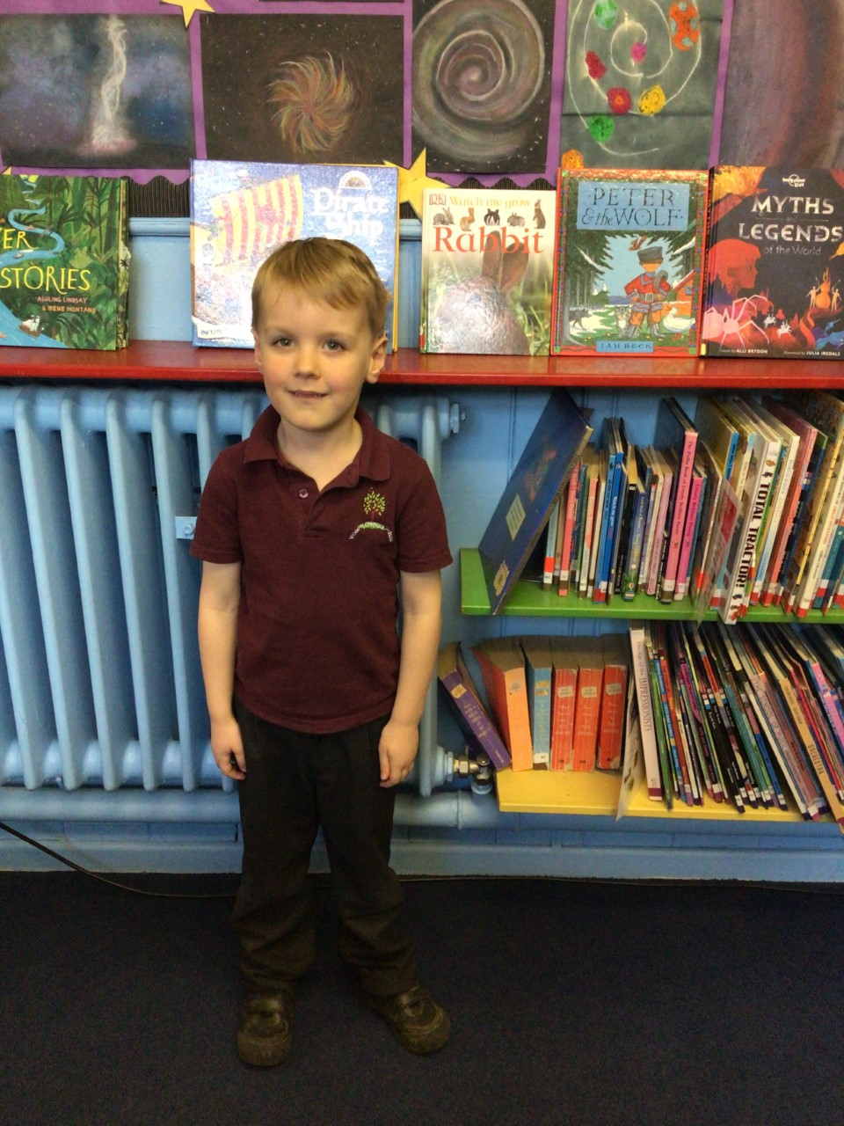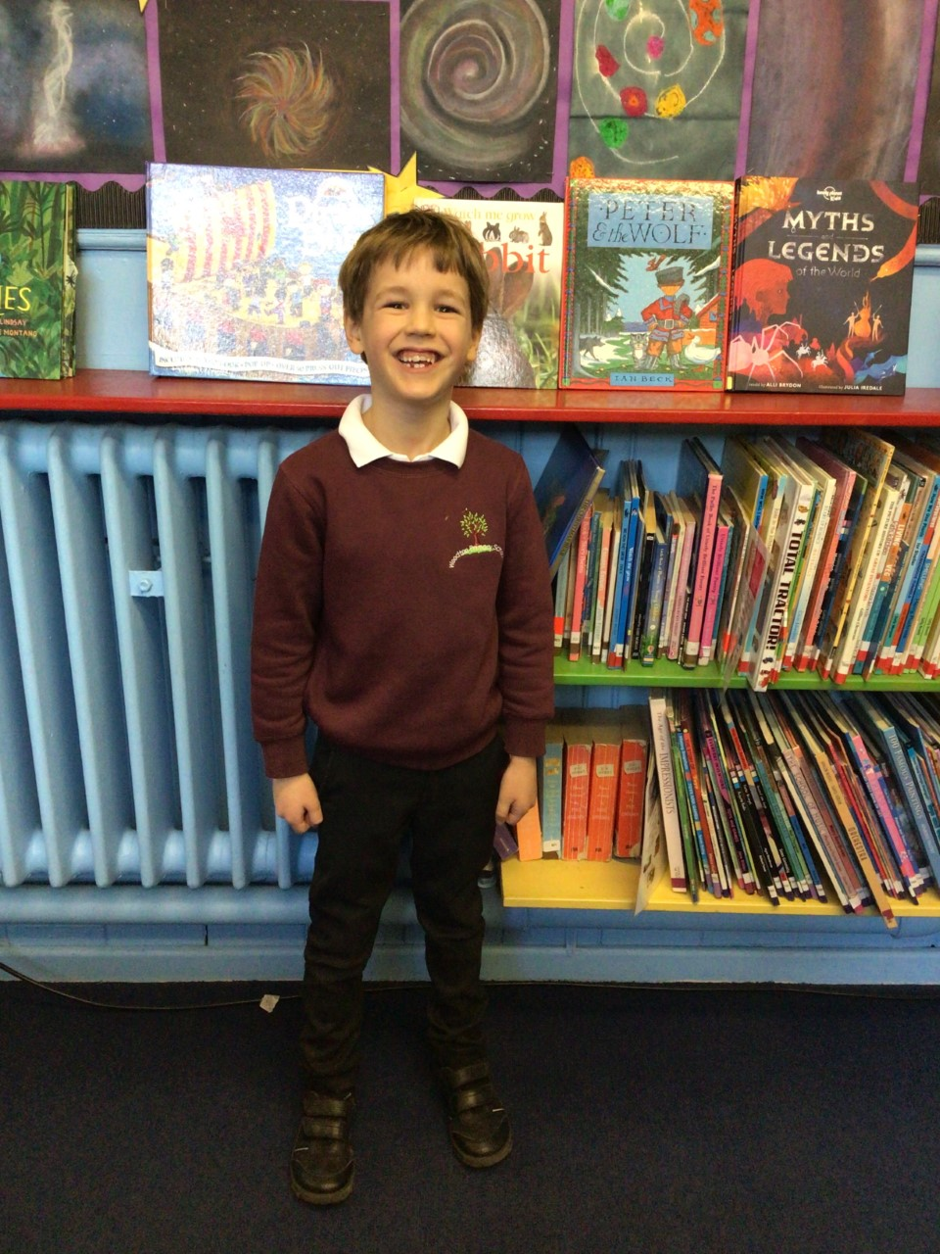

Finlay has returned to school with an amazing positive attitude and inspired us to try our hardest in our learning.  He wowed us with his polar writing.

Hector has been an inspiration this week with his times tables and challenging himself with his multiplication and recalling the number facts, he knows.

**Stars of the Week**

Oaks

Our stars of the week this week are Henry for showing a positive attitude towards his work and working hard across all subjects, and Phoebe for working hard, and showing a great understanding across all subjects.

# Celebration Newsletter

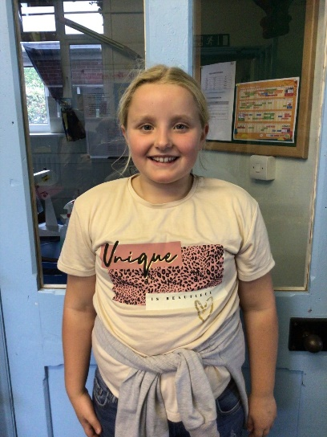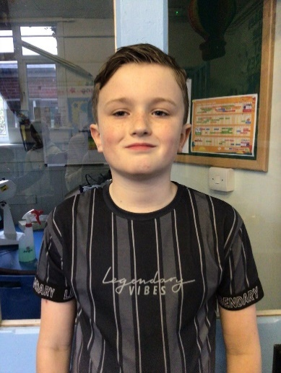

**Class Attendance**

Willows – 90.26 %

Oaks - 92.47 %

**Well done to all of OAKS CLASS.**

House Point totals for this week

Stephen Hawkings – 31

Beatrix Potter – 31

Benjamin Britten – 24

Kelly Holmes – 25

Reading Challenge:

Keep up the reading to fill those jars in class!





Maths Whizz Wonders

**Brilliant progressions** -

Willows – Aria, Maisy & Kendall.

Oaks – Solomon, Charlie C & Simran.

Overall Winner for this week is

**Willows**

CONGRATULATIONS.