Oaks

Our stars of the week are William and Woody.

William is always devoted to his work and supporting others in his class and Woody always has a positive attitude in class, and has shown great improvement with his schoolwork.

Willows

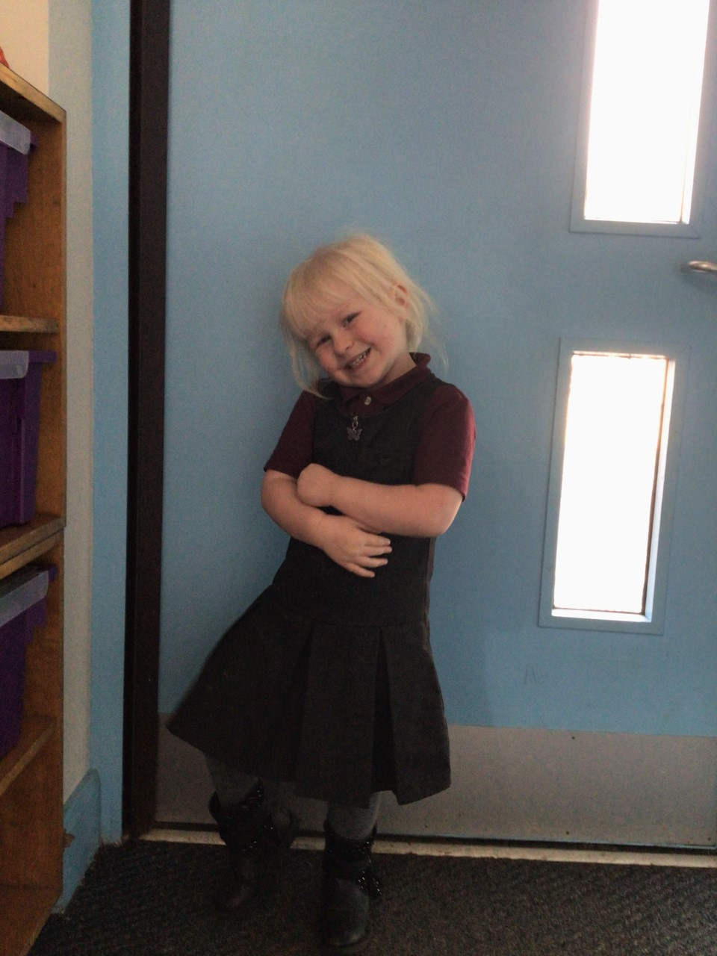

Millie is wowing us in her learning recently, always trying her hardest and making great progress with her reading.  Super work Millie.

Aria is making great progress in her reading and becoming more confident in her learning.  Keep it up Aria!

# Celebration Newsletter

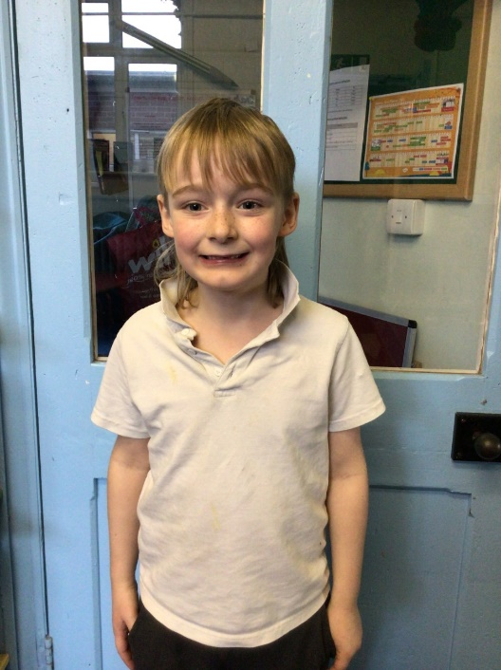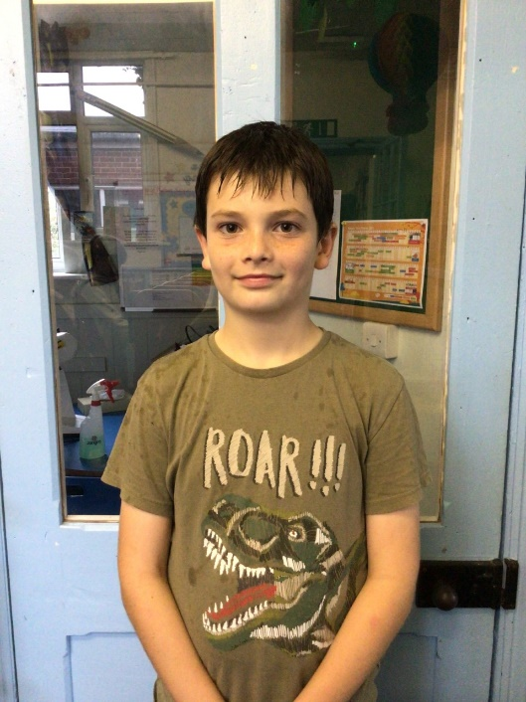

**Stars of the Week**

House Point totals for this week

Stephen Hawkings – 84

Beatrix Potter – 92

Benjamin Britten – 100

Kelly Holmes – 80

**Class Attendance**

Willows – 97.93 %

Oaks - 98.48 %

**Well done to all of Oaks CLASS.**

Maths Whizz Wonders

**Brilliant progressions** -

Willows – Hector.

Oaks - Georgina, Lily W & James.

Overall Winner for this week is

**Oaks**

CONGRATULATIONS.

Reading Challenge:

Keep up the reading!



