WELLNESS
Home Life

Hello from your Wellbeing team,

A thought

Poor Mental Health affects 1 in 4 people. To put that into perspective, that is 1 in 4 people looking for someone to care, for a reason to continue, for a sign of hope. Just be kind to everyone we come across; you never know what is going on.

Once again another term over and the children have all done so well. Please take time this half term to make sure and relax and spend that quality time with family. With Christmas just round the corner, we are going to need all the energy we can get. We are always here to help with advice or just listen so please do not hesitate to email us on wellbeing@woodton.norfolk.sch.uk for any extra support.

October 2021

Families in hardship and needing wider support

In addition to the offer of FSM vouchers for eligible families, there is support available for families who are facing hardship and need support.

Anyone experiencing hardship may be able to receive support through the Norfolk Assistance Scheme (NAS), which may be able to provide support for food, fuel, clothes and other essential household items to families experiencing hardship. Wider support from a range of partners can then also be made available with NAS working alongside the Children’s Services Community and Partnerships service.

Families may get in touch with NAS via their dedicated website which includes an online application form at Norfolk Assistance Scheme - Norfolk County Council or if they cannot access the internet, they can call 0344 800 8020.

Support for families:
Parents reaching out (Children 11-16): parents@kooth.com
Point 1: Support for young people and their families – 0800 977 4077 or point1-support@ormistonfamilies.org.uk
Early Help hub: South Norfolk – 01508 533933
Norfolk Just One Number – justonenorfolk.nhs.uk or 03003000123

Why labelling feelings is so important

Helping children put their feelings into words can help them navigate strong, negative emotional experiences. We tend to keep it simple when talking about feelings with young children and may often stick to the basics, such as angry, happy and sad. Once our children have mastered that, we can move on to a bigger variety of emotionally descriptive words. We can increase our child’s understanding of a bigger expanse of feelings by broadening the terms we use.

Brave Cheerful Worried Joyful Frightened Calm
Excited Confused Frustrated
Curious Friendly Shy Ignored Lonely Interested
Proud Embarrassed Jealous Angry Bored
Surprised Silly Uncomfortable
Stubborn Safe Relieved Peaceful
Overwhelmed Loving Cranky
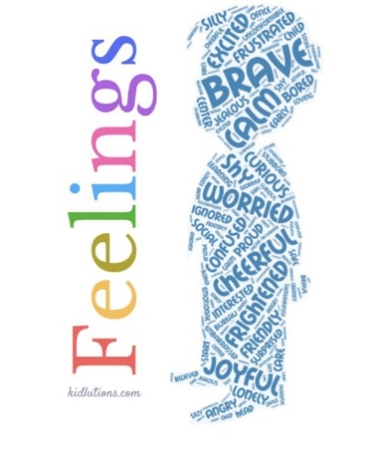
Wellness Tip
Let’s Talk – Try these simple things with your children or even with yourself, just spend 5 minutes each day discussing them.

Monday – The ‘Golden Rule’; treat others as you would like to be treated.
Tuesday – Compliment; the way you look, things you do, the way you are. Remember ‘Thank you’ and ‘You’re welcome’
Wednesday – Feelings; everyone has them, all are okay, it is a natural response to what we experience, can make us comfortable and uncomfortable, can have more than one at the same time, we own them, we control them.
Thursday – Self-Regulation; (3 steps) stop, take a deep breath, say the problem and how you feel.
Friday – Problem Solving; (3 steps) stop and calm down, think of some solutions, choose one and try it.

Just a thought;  Reassuring your friend that their feelings are valid, and that they are not alone, can be the most impactful way to support them if they are struggling. | The simple things;  When you notice your mental health declining, do one small thing that brings you peace. Take a shower, text a loved one, step outside. One little step is all you need to remind yourself that this is not permanent.  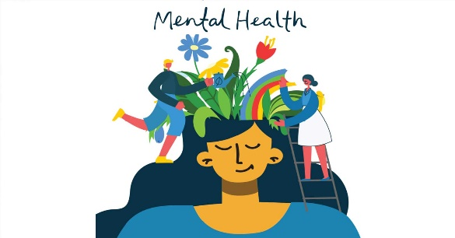
What is Mental Health?
We all have mental health. Mental health is about our feelings, our thinking, our emotions and our moods. Looking after our mental health is important.
We all have small feelings every day: These sometimes feel strong and overwelming, whether happy or sad, but they go away before too long.
Sometimes we experience big feelings: These feel strong and overwelming for a long time. They stop us doing what we want to in our lives.
It is so important to teach our children and even ourselves to talk about our feelings, here are some tips with how to help children express their feelings, respond appropriately, and prevent small problems from snowballing into bigger ones.
- Make a conversation about mental health a normal part of life: Anywhere is a good place to talk: in the car, walking the dog or cooking together. Model everyday talk about feelings such as by talking about TV character’s feelings.
- Give your full attention: We all know it’s horrible to be half listened to. Keep eye contact, focus on the child and ignore distractions.
- Check your body language: Try to keep it open and relaxed and make sure you come down to the child’s level.
- Take it seriously: Don’t downplay what the child is saying or tell them they’re “just being silly”. Resist the urge to reassure them that everything is fine.
- Ask open questions: Such as “How did your day go today?” This will help to extend the conversation.
- Calmly stay with the feelings that arise: It can be our automatic reaction to steer away from difficult emotions.
- Offer empathy rather than solutions: Show that you accept what they are telling you but don’t try to solve the problem.
- Remember we are all different: Respect and value the child’s feelings, even though they may be different to yours.
- Look for clues about feelings: Listen to the child’s words, tone of voice and body language.
- Some ways to start a conversation about feelings might be: “How are you feeling at the moment?”, “You don’t seem your usual self. Do you want to talk about it?”, “Do you fancy a chat?”, “I’m happy to listen if you need a chat.”

Importance of Self Care
Give yourself permission
It is very easy, as a parent or carer, to prioritise the needs of your family and others ahead of your own wellbeing. However, taking time for yourself is not selfish. Everybody needs space to unwind and relax, and giving yourself, permission to take some time to recharge your batteries means that you will hopefully have more energy and patience to meet the needs of your family. Start by trying to give yourself 10 minutes each day where you can just sit down, have a cup of tea and take a breather.
Being kind to yourself
We all struggle at times, maybe more so over the last year. We can put so much pressure on ourselves to do our best and sometimes feel that maybe our best is not good enough. If this is happening, it can help to have a think about how you ‘talk’ to yourself. We are sometimes so hard on ourselves in our own thoughts than we would be to anyone else we speak to. Imagine that it is a friend who is in your situation right now instead of you. How would you comfort them? How would you encourage them? We need to talk to ourselves more positively.
Make a to-do list
At times, you might find that your ‘list of things to do’ can build up. This could be general errands, shopping for vital items, or general admin. If these tasks are weighing on your mind, compile a to-do-list that you can tick off as you go along prioritising those activities, which need to be done that day or week. This includes setting aside quality time with your children and time for yourself. Just seeing everything written down may help make things seem more manageable and identify things, which really aren’t urgent. And remember it is fine and healthy to sometimes have a downday.
Ask for help
Asking for help from others can sometimes feel as if we’re failing as a parent or carer but parenting can be tough and reaching out for support is nothing to feel ashamed of. Whether it’s minding your child for a short time to allow you to get things done or running a small errand for you, friends and family will often be happy to help and children a dn young people can also benefit from knowing there are other trusted adults in their life that your family can turn to. Depending on the age of the child, you can also ask them to complete age-appropriate tasks to help around the house to relieve you of some of the everyday tasks.
Maintaining energy levels
Looking after physical health can have a positive impact on your mental and emotional wellbeing. A healthy and balanced diet can help how you feel physically and avoiding certain foods can help if you’re feeling low or anxious. Regular exercise doesn’t need to mean running long distances but may include regular walks, sit-down yoga or visualisation.
The importance of Sleep
Balanced sleep is really important for good mental health, but it can also be a really useful self-care tool for when you need a break to get away from your thoughts or situation for a bit. Trying to establish good sleep routines for your children can be the first step to giving you time at night to relax and allow you to get a good night sleep for yourself. This may be harder with babies and infants but even with older children you may benefit from allowing yourself a power nap in the daytime whilst they are at school.

