Oaks

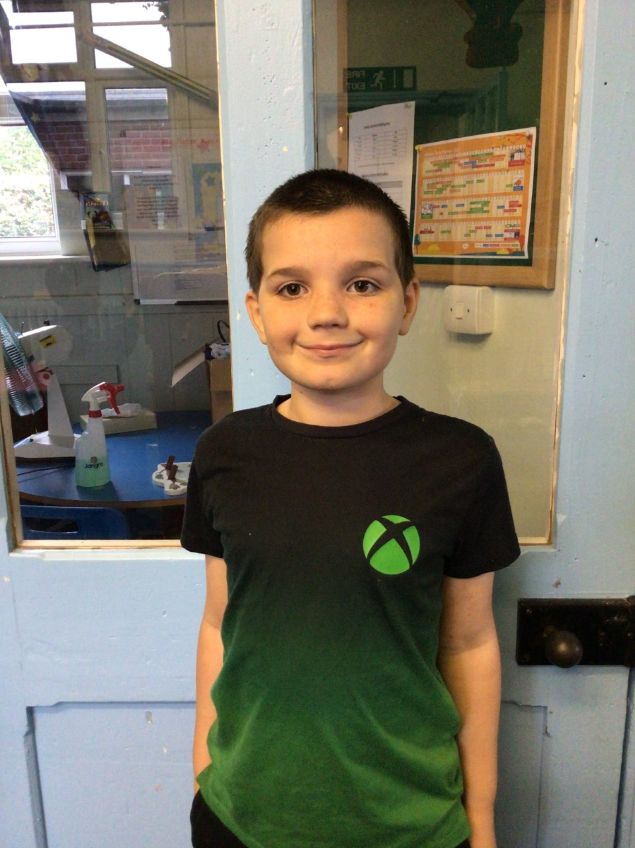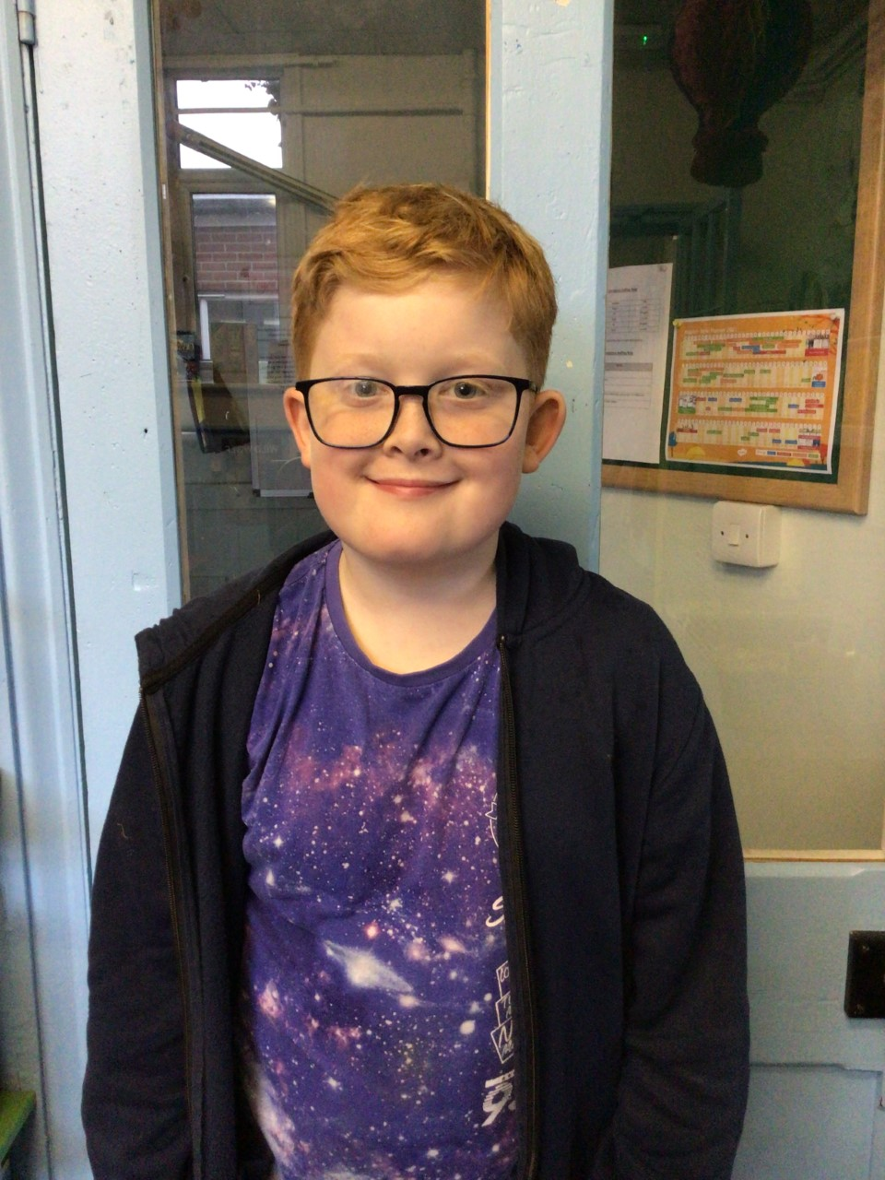

Ours stars of the week this week are George and Riley.

George has shown a brilliant attitude to learning and is showing great determination to do well with his work in class.

Riley has displayed brilliant knowledge about space, and has shown such enjoyment in this topic.

Willows

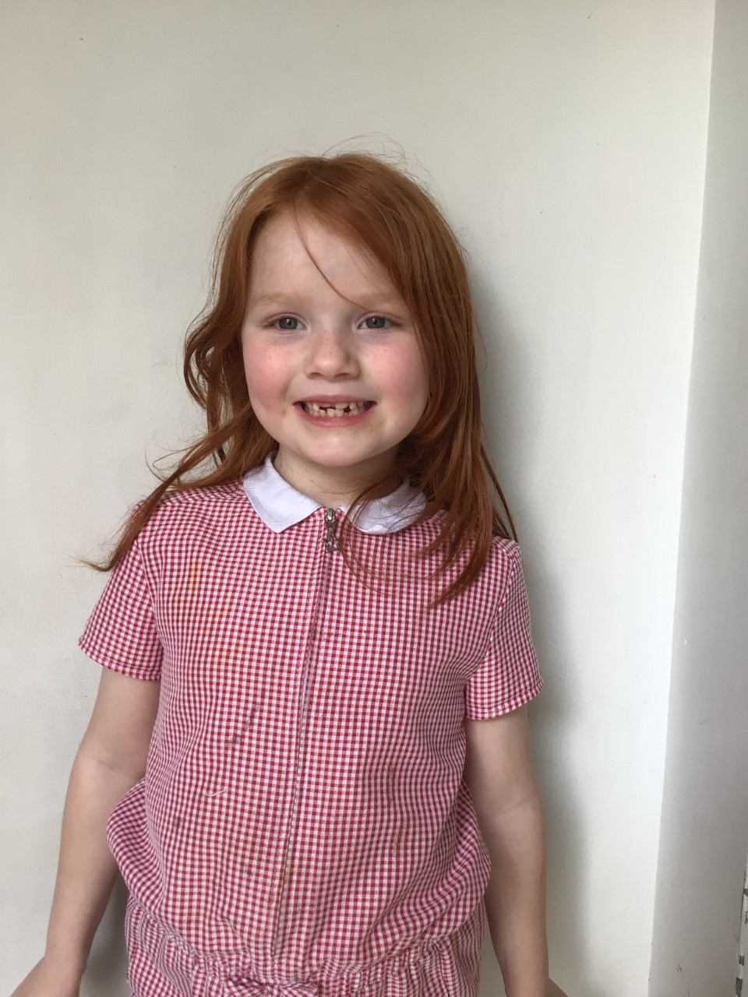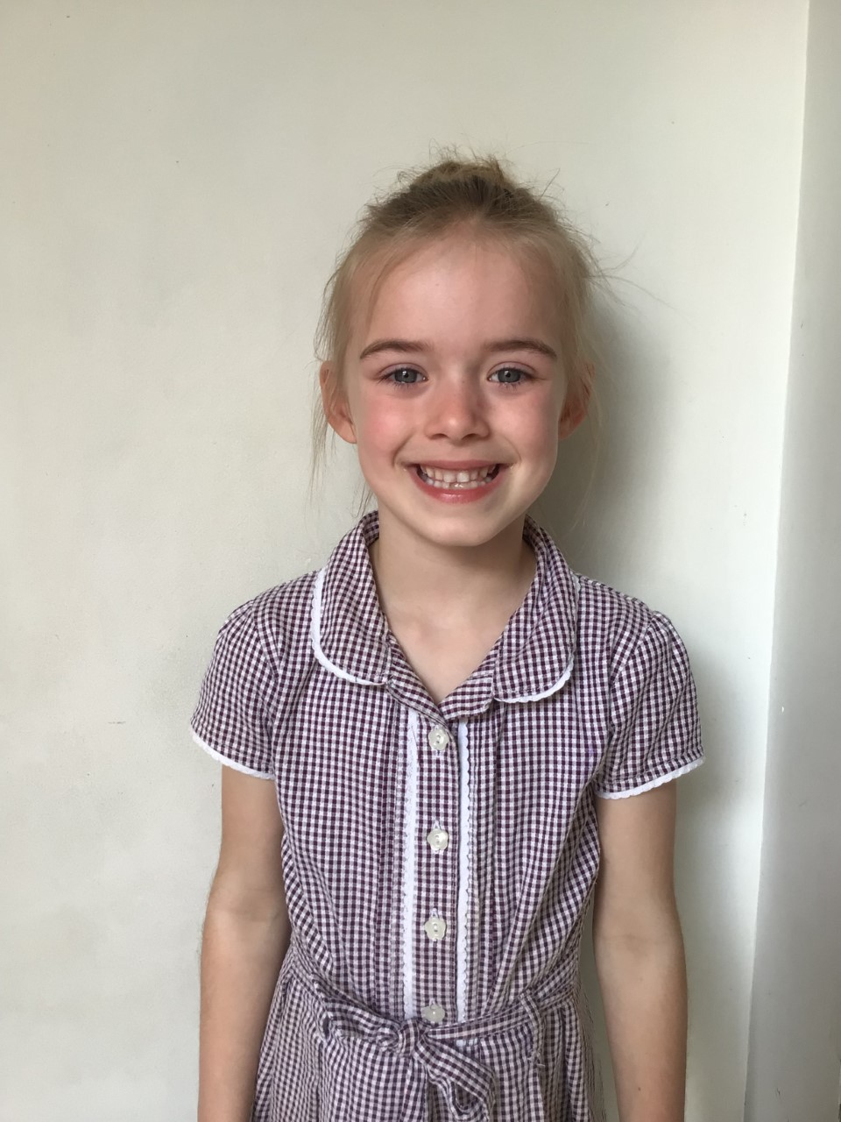

Our stars of the week this week are, Kendall for always being kind and helpful to everyone in Willows and Crystal for always challenging herself in her learning.

# Celebration Newsletter

**Stars of the Week**

House Point totals for this week

Stephen Hawkings – 33

Beatrix Potter – 36

Benjamin Britten – 31

Kelly Holmes – 52

**Class Attendance**

Willows – 93.18 %

Oaks - 94.44 %

**Well done to all of Oaks CLASS.**

Maths Whizz Wonders

**Brilliant progressions** -

Willows – Emmie & Charlie L.

Oaks – Lily W, Charlie T & Olivia L.

Overall Winner for this week is

**Oaks**

CONGRATULATIONS.

Reading Challenge:

Keep up the good reading!



