Oaks

Our stars of the week this week are Leila and Lily.

Leila has been doing brilliant with her times table work, and Lily is showing great determination to do well.

Willows

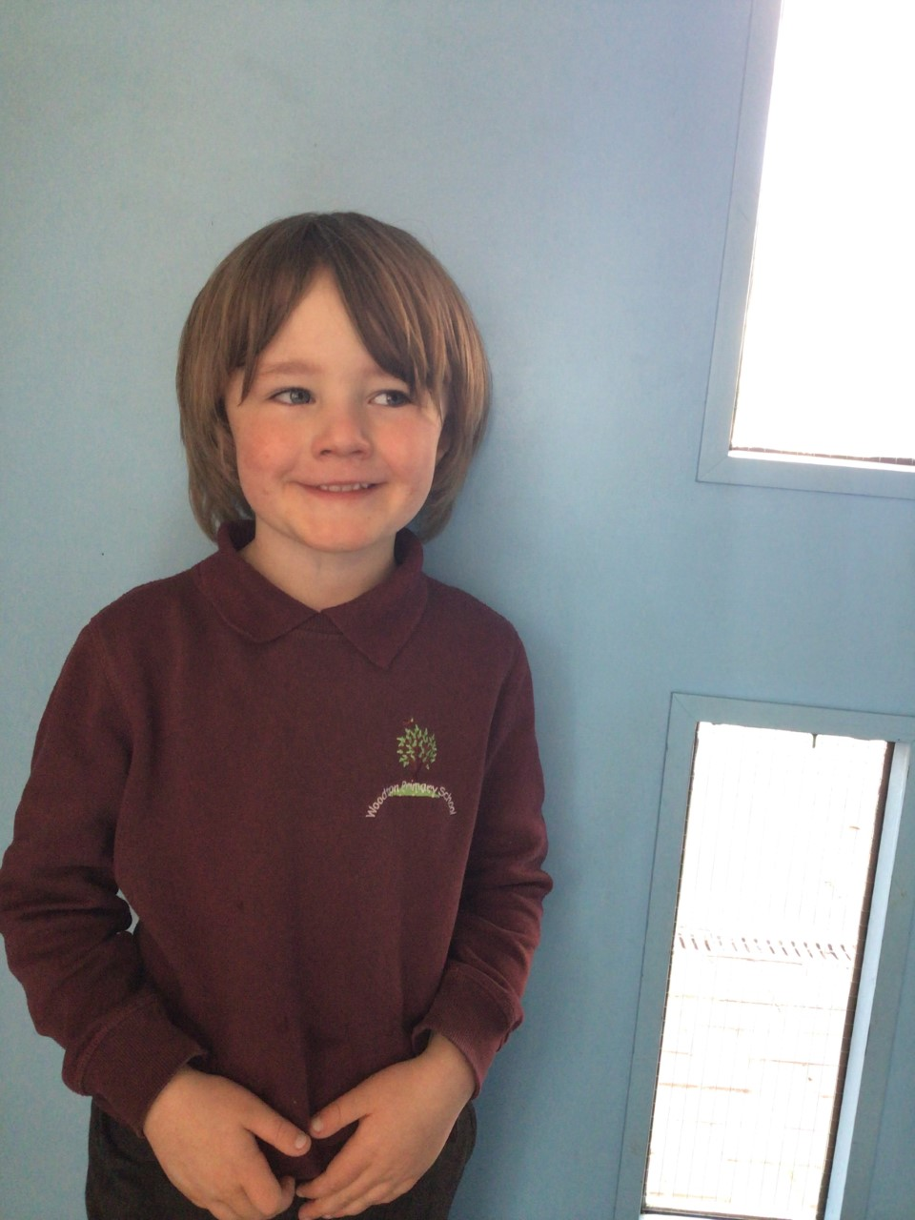

Willows stars of the week this week are Aria and Ned. Aria has been wowing us in her Maths making fractions and Ned has been trying really hard to write in sentences. Well done Aria and Ned!

# Celebration Newsletter

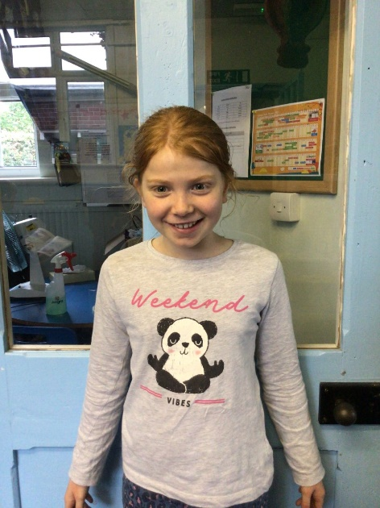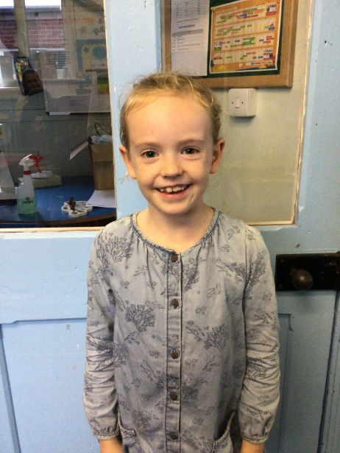

**Stars of the Week**

House Point totals for this week

Stephen Hawkings – 32

Beatrix Potter – 47

Benjamin Britten – 39

Kelly Holmes – 64

**Class Attendance**

Willows – 94.32 %

Oaks - 95.71%

**Well done to all of Oaks CLASS.**

Maths Whizz Wonders

**Brilliant progressions** -

Willows – Rupert, Maisy & Willow..

Oaks – Georgina, Lily W & Lily D.

Overall Winner for this week is

**Willows**

CONGRATULATIONS.

Reading Challenge:

Congratulations to Oaks for winning the Reading Challenge.



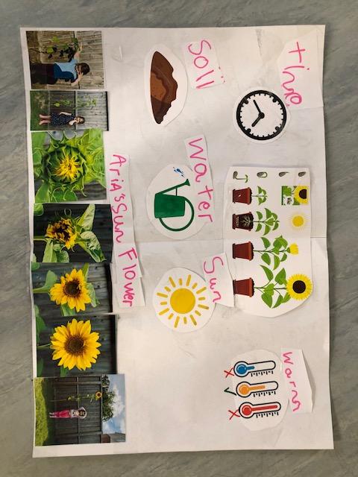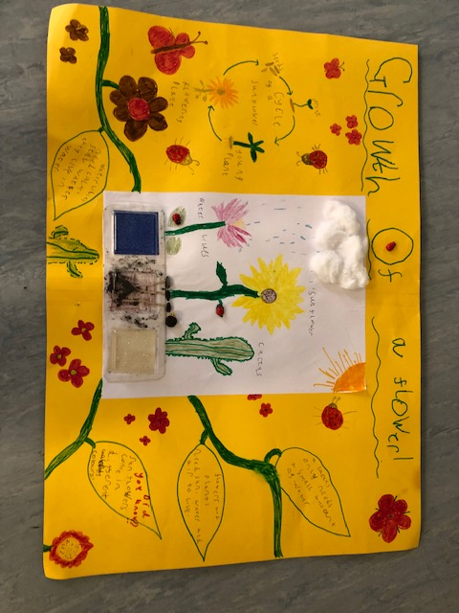 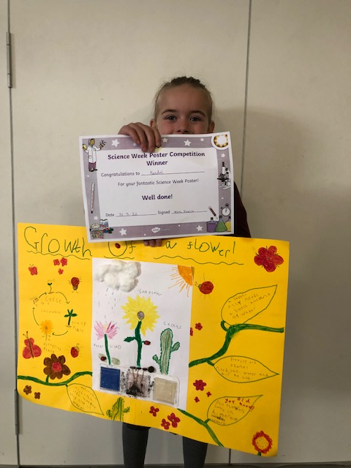

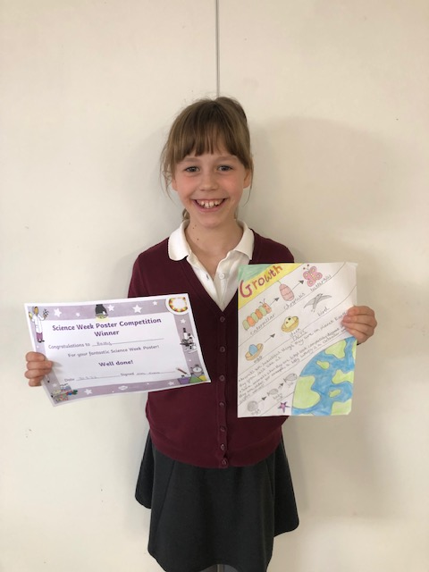

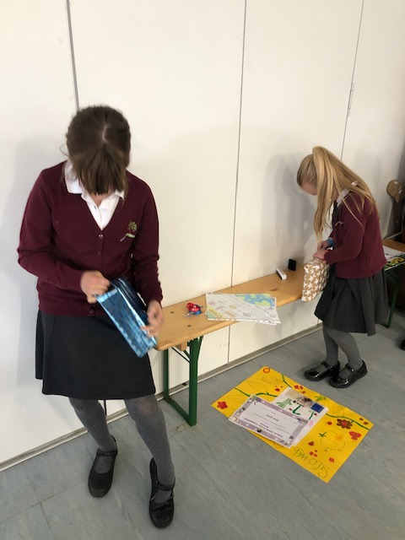

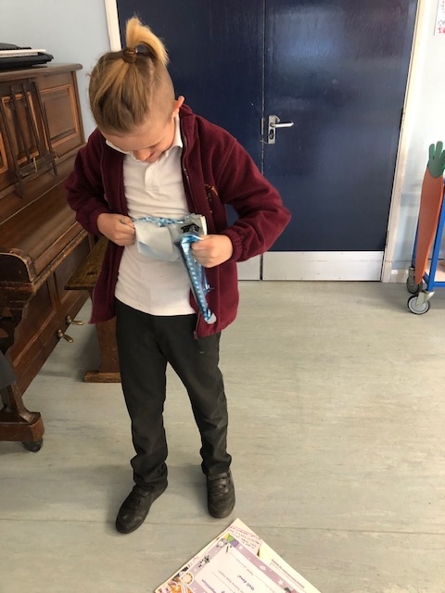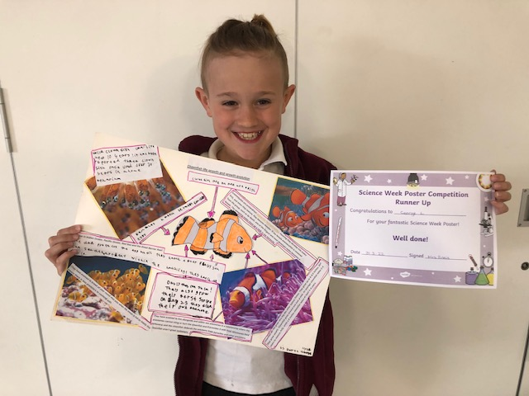**Congratulations to the Science Poster Winners – Aria C, Kendall, Betty and George L.**

Science Poster Competition