Oaks

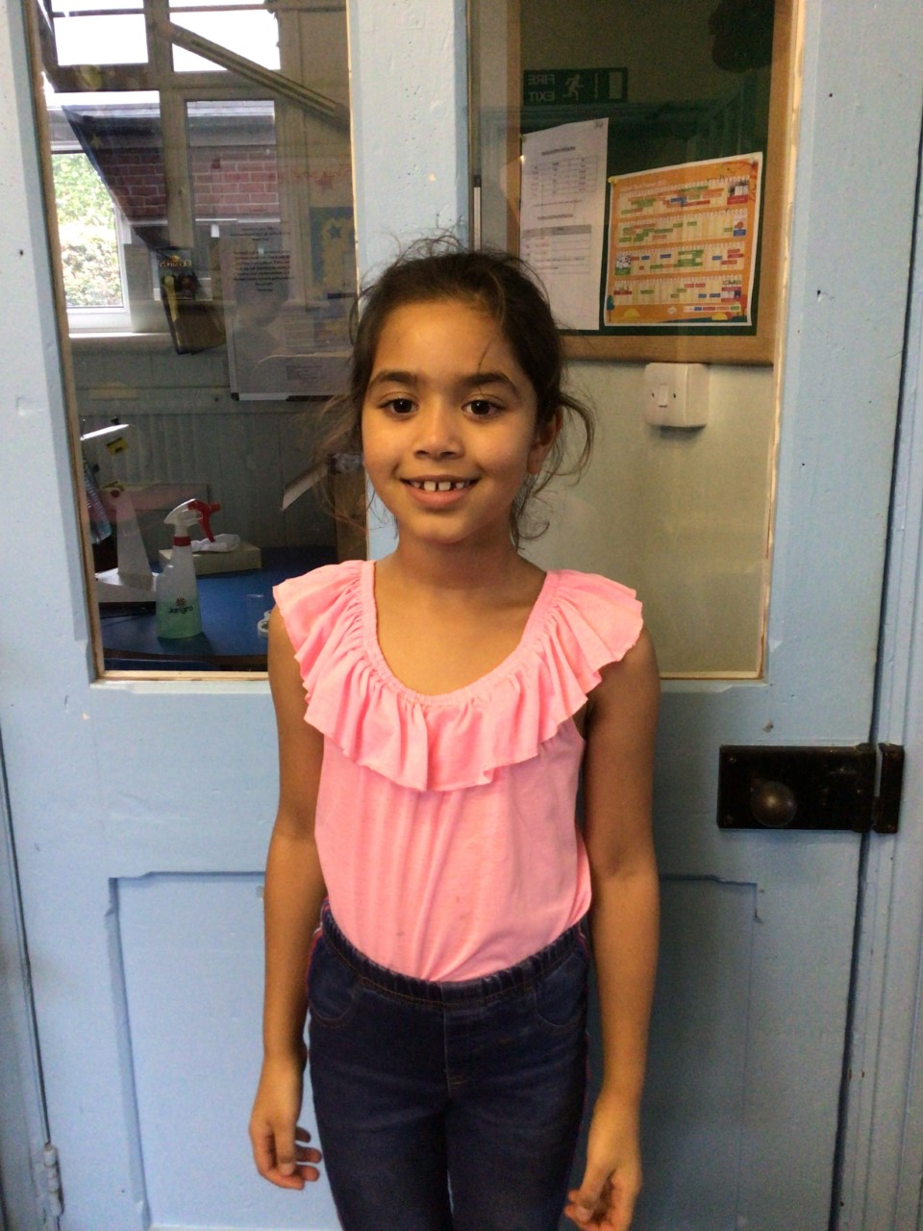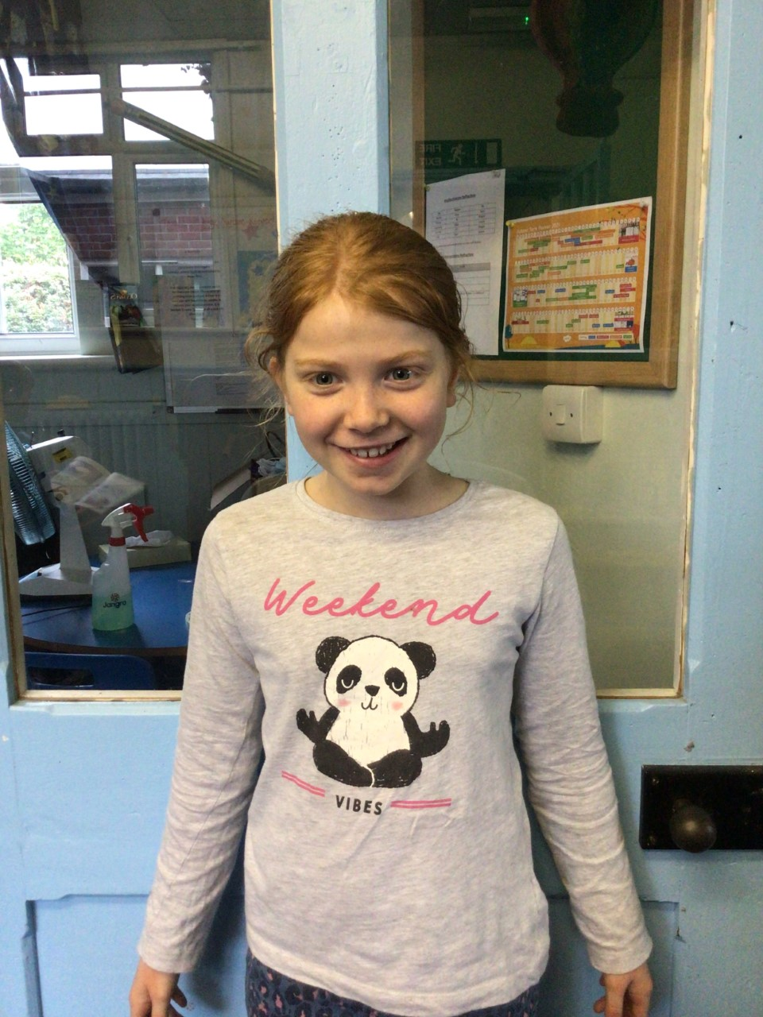

Our stars of the week are Lily D and Simran. Lily has shown great knowledge and determination on her grammar and Simran has had some lovely story ideas this week.

Willows

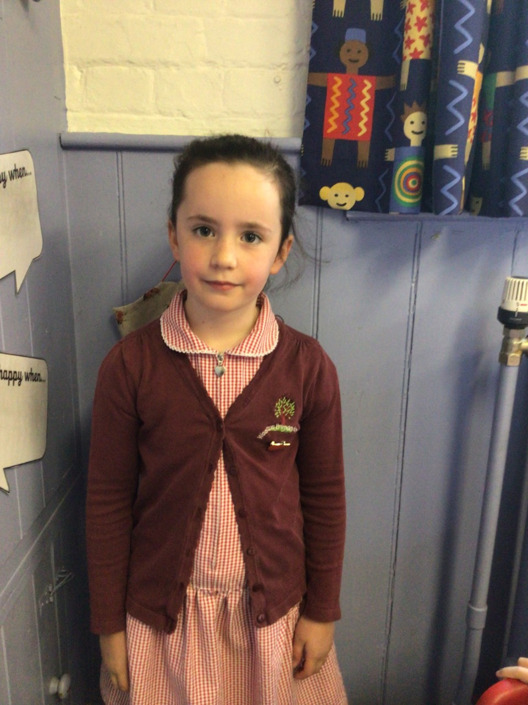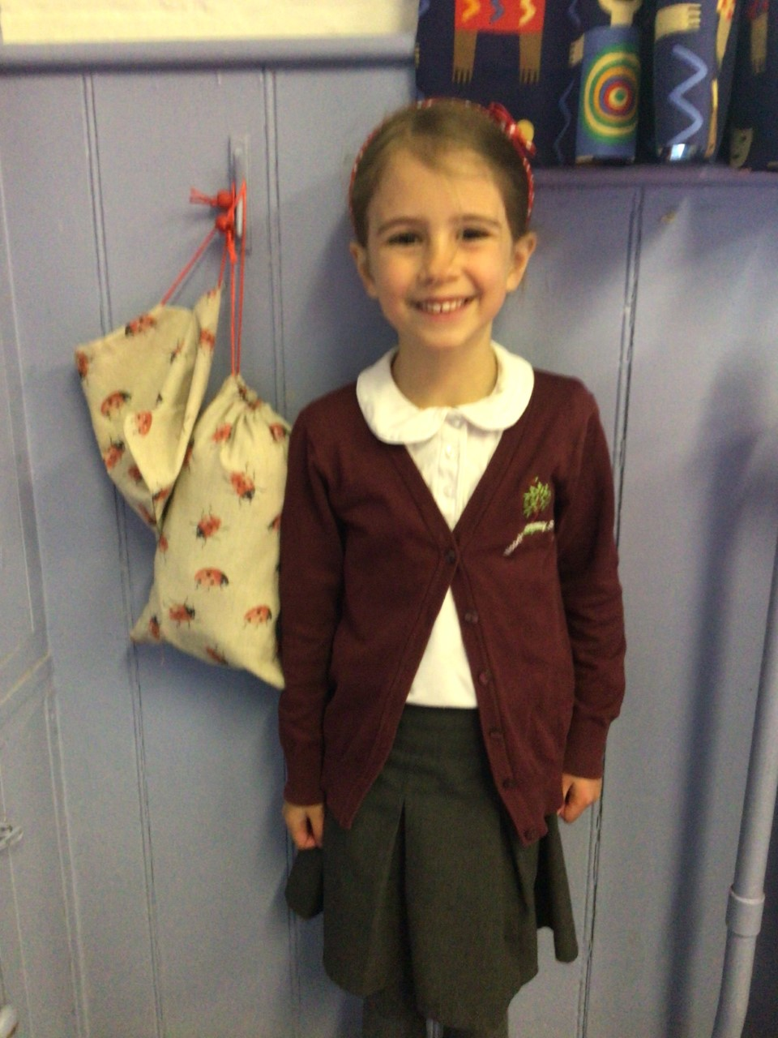

Our stars of the week this week are Molly and Paige. Molly for producing beautiful well thought out art work, especially her sunflower and Paige always perseveres in all her work and has wowed us recently with her lovely story writing.

# Celebration Newsletter

**Stars of the Week**

House Point totals for this week

Stephen Hawkings – 72

Beatrix Potter – 96

Benjamin Britten – 71

Kelly Holmes – 81

**Class Attendance**

Willows – 96.53 %

Oaks - 97.22%

**Well done to all of Oaks CLASS.**

Maths Whizz Wonders

**Brilliant progressions** -

Willows – Charlie L.

Oaks – Anya.

Overall Winner for this week is

**Willows**

CONGRATULATIONS.

Reading Challenge:

Keep up with the reading.



**Special News**

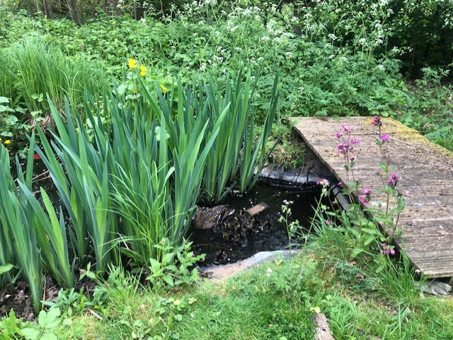We have had a duck nesting right next to the playground. The children have been so good with making sure she was given some quiet space. Today, we have some amazing news; she is now the proud mother to 13 little duckling. They have been gently guided to the pond enclosed area to be kept safe.

